WE ALL SCREAM FOR ICE CREAM!
MARKETING MIX WEBSITE COMPARISON
For this project you will go to three websites and fill in the answers to the questions regarding the Marketing Mix for each company. The websites are:
http://www.graeters.com/
http://www.mayfielddairy.com/
http://www.benjerry.com/

 | Graeter’s  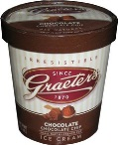 | Mayfield  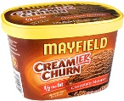 | Ben and Jerry’s  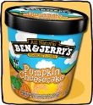
Product
(in detail describe packaging)

Product
What are the company’s specialty flavors? (Example: year round, core flavors) How many flavors are in each?

Product
Does the company sell other dairy products besides ice cream? If so list a few.
Product
What is the company’s slogan?

Product
List any new flavors that are in stores or coming soon.

Place
Where are the dairies, that make the ice cream located? (City & State)

Place
List three stores where you can find this product?

Place
How is the ice cream transported to the stores?

Price  How much does each product cost? (1/2 gallon & Pint)  You may have to fill in this question later by researching prices at a store. | Pint:  ½ Gallon: | Pint:  ½ Gallon: | Pint:  ½ Gallon:
Promotion  How did you like the website? List two strengths and two weaknesses of each | Strengths  Weaknesses | Strengths  Weaknesses | Strengths  Weaknesses
Promotion
Does the website offer any coupons? Specify if there are special requirements to receive the coupons.
Promotion
Where are the company’s tour facilities located? Besides, witnessing how the ice cream is made what other experiences will the visitors have during the tour?
Promotion
List the names of some of the receipts located on the website?
Promotion
What causes or charity does the company support?

Promotion
What games or fun facts does their website offer?

