Chinese Calligraphy
“Ancient for Everyday Use”
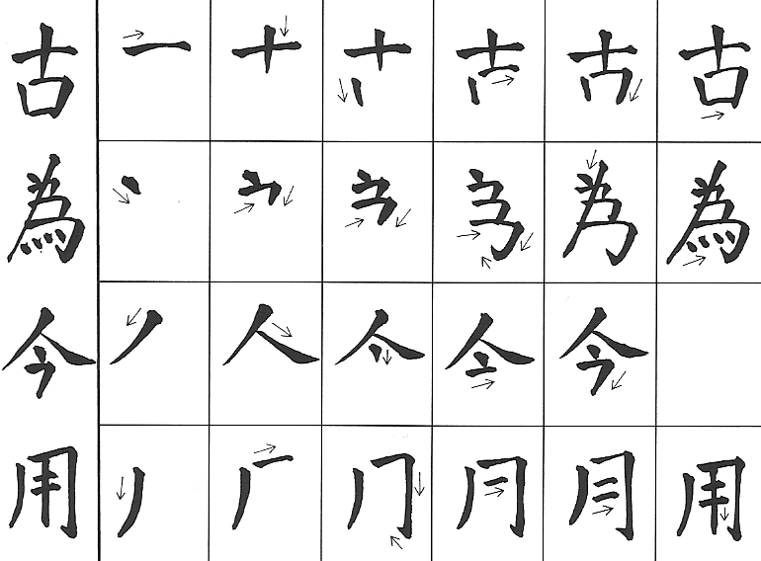

History: Fine artwork has been a tradition in China from as early as 4000 BC. (Schuman). The development of the arts was not interrupted by the rise and fall of dynasties, but the skills were honed and developed through the years. The earliest surviving artwork was in bronze, clay, stone, jade and turquoise. Writing appeared in the Shang Dynasty about the 17th century BC on shells and stone.
Assignment:
First: You will recreate “Ancient for Everyday Use” in well-practiced Chinese Calligraphy brush strokes.
Second: Your second part of this assignment will be to use Chinese painting/brush strokes to illustrate a short quote or poem, handwritten by you. Do use Haiku or a very short quote. The imagery you use should be reflected in the words you choose. Consider the Chinese symbols on page 3 for your own unique signature
- First day: Review what makes a good layout on paper with class. Practice the basic strokes of “Ancient for Everyday Use” on newsprint with Chinese or Round brush and India ink in various dilutions with water.
- Recreate “Ancient for Everyday Use” on your own piece of white 6 x 18” paper by
  - Carefully following the measurement requirements below for your final layout. Do not apply ink until you have shown your layout in pencil to Mrs. Slider (5/20 pts).
  - Keep practice newsprint handy to practice your strokes/control your ink quality before you apply the brush strokes to your final page.
  - You will be graded on the following criteria:
    - Practice on newsprint
    - Measuring and layout of final page
    - Handling of materials and brushes with respect, retrieving materials and proper clean-up
    - Final product (15/20 points)
  - Chinese brush painting of poem or quote – 20 points

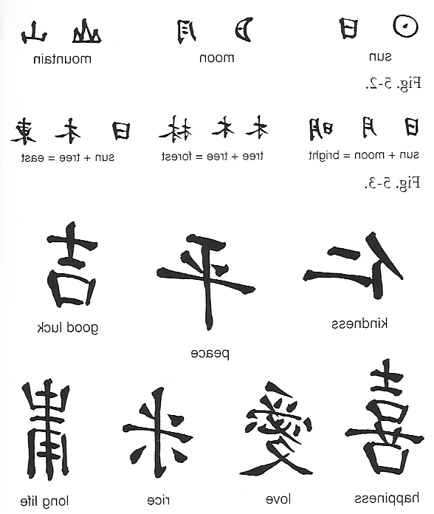

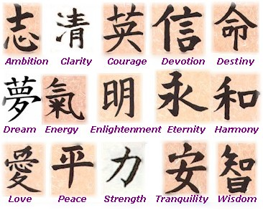
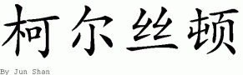
Here is the Chinese name for Kirsten:
Find you own name at
http://chineseculture.about.com/library/name/blname.htm

