LIGHT-CAPTURING CUT-PAPER DESIGNS
Lesson Objective: Create an alternating and repetitive design using at least two original designs.
Once completed, your cut paper design will be exposed to a direct source of light (spotlight) in order to form an overall pattern with structural and tonal counterchanges.
Beyond Geometry http://www.lacma.org/beyondgeometry/index.html
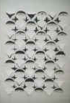
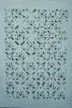
Paper folding techniques http://www.sgi.com/misc/grafica/huffman/index.html
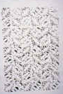
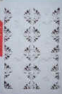
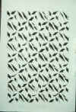

Look closely at the fourth relief to see delicately cut fish images.
Book: Sculpture In Paper by Nicholas Roukes http://tinyurl.com/4gs67ya
Materials Needed:
Rulers (12" (30.5 cm) T-square and 18"(45.7 cm) T-square)
Architectural Template (pre-cut manila folder with cut designs from below)
X-acto Knives
#2 Pencils
Drawing Paper 12" by 18" (30.5 x 46 cm)
Drawing Paper 18" by 24" -Cut to 15" by 22" (38 x 56 cm) we will use watercolor paper provided
Black Railroad Board (6-ply) for mounting
Spotlight - on work to show tonal shadows
- Set up: Use the designs on the paper provided to get started….this is to give you an idea how the designs are formed.
  - Tape the designs to your pre-cut template tagboard or folder
  - Cut only on the solid lines with the xacto knife on top of newspaper or magazine
First Stage:
1. Using the 12" T-square or ruler, divide the 12" by 18"(30.5 x 46 cm) piece of drawing paper into 2" by 2" (5 x 5 cm) squares with very lightly drawn lines.
2. With a pencil and the aid of the ruler and template of the designs cut from tagboard or folder cardboard, draw each of the designs pictured below. Your template is on the attached page. The dashed lines are where the paper should be folded; the solid lines are where the paper should be cut. The designs should be centered within the squares.
3. Using an X-acto knife, carefully cut the designs as shown in the diagrams.
4. Fold over the dotted lines carefully, forming the required creases.
5. Fold each tab to produce the relief effect.
6. Now, experiment with your own creative ideas using the preliminary designs as a springboard for your own ideas.
7. After deciding on at least two ideas, continue on to the second stage.
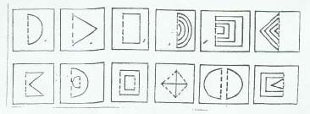
Second Stage:
1. Using the 18" T-square, measure and mark 1-1/2" (3.8 cm) in from the outside edges of the long sides of the 15" by 22" (38 x 56 cm) drawing paper. Now measure 2" (5 cm) in from each of the short ends. Use a pencil to connect these marks and create a border. The area within this bordered area should measure 12" by 18" (30.5 x 46 cm) .
2. Grid the inner area to create (horizontally) six 2" by 2" (5 x 5 cm) squares and (vertically) nine 2" by 2" (5 x 5 cm) squares.
3. Use the template, ruler and a pencil, to duplicate your own designs, alternating your designs square to square.
4. Carefully cut out your designs with the X-acto blade knife.
5. Turn over the paper and fold and crease where needed. Flipping over the paper to the back side eliminates the need to erase the pencil marks on the front of the paper.
6. Glue black railroad board or posterboard to the back of your project for more contrast and a more dramatic presentation.
7. Hang a spot light over the paper sculpture to enhance contrast and design.
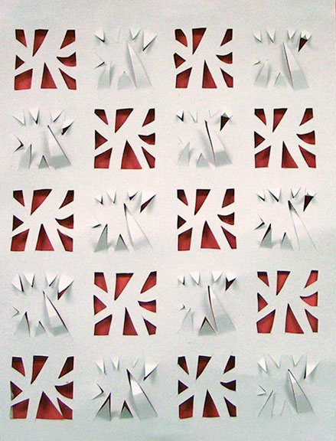 | 3-D paper Sculpture – short lesson for homebound students  Lesson Objective:  Students will create an alternating and repetitive design using two original designs. Design uses positive and negative shape. Contrast with bottom layer shows details. Paper is curled/raised for relief in alternating pattern.  Materials:  Card stock or (12 x 14 (30.5 x 35.5 cm) - or determined size), Rulers, Pencils, X-acto Knives, cutting boards, scrap foam core board, Glue, colored Posterboard (or heavy colored paper). 2' (5 cm) square paper
Procedures:
- Review/demonstrate safe use of X-acto knives. Demonstrate good care of knives
- Students plan two square designs (approximately 2" (5 cm) square).
- Mark off BACK side of cardstock for 2" (5 cm) squares - leaving about 1/2 (1.3 cm) to 3/4" (1.9 cm) between squares. Make LIGHT pencil guidelines
- Transfer designs to cardstock - alternate designs (stager rows). You can use pencil on back of design to transfer OR Saral Transfer Paper. Lines should be very light.
- Place cardstock on cutting board. Cut designs with X-acto Knife. For every other square - cut out the shapes completely. Alternating pattern. For the other squares, leave edge (one side of shape) attached. These shapes will be raised in relief.
- Turn over so pencil is on back. Mount onto contrasting colored paper or poster board using foam core spacers. Bend the positive shape designs to make interesting relief (bend up - curl).

