Reading Model: Poem
Build Background During the 1960s and 1970s, hundreds of thousands of people left Cuba for the United States and other countries. The Soviet Union had installed nuclear missile bases in Cuba in 1962, and many families fled their homes in fear of nuclear war. Shortages of food and fuel also made people leave the country. Virgil Suárez’s family left Cuba at this time, but as Suárez describes in this poem, one uncle decided to stay behind in his home country.
Read with a Purpose As you read “The Stayer,” think about what compels people to leave, or refuse to leave, their homes.
The Stayer
by Virgil Suárez
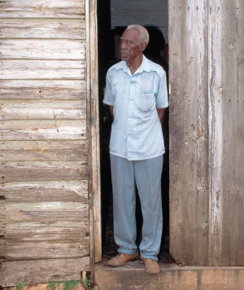
Simply, my uncle Chicho stayed

back in Cuba, against the family’s

advice, because everyone left

and he chose to stay, and this act

5 | of staying marked him as “crazy”

with most of the men, and he stayed

there in a shack behind my aunt’s

clapboard house, sat in the dark

of most days in the middle

10 | of the packed-dirt floor and nodded

at the insistence of light, the way

it darted through holes in the tin

roof where the rain drummed

like the gallop of spooked horses.

15 | This is where he was born, he chanted

under his breath to no one, why should

he leave, live in perpetual longing

within exile? He learned long ago

to count the passing of time

20 | in how motes²⁰ danced in the shaft

of white light, the chicharras²¹ echoed

their trill against the emptiness

of life, against the wake of resistance

in this place he knew as a child,

25 | as a man, un hombre, bend against the idea

of leaving his country, call him loco.²⁶

What nobody counted on was that answers
come on to those who sit in the

quiet of their own countries, tranquil

30 | in the penumbra,³⁰ intent on hearing the song

of a tomegüín³¹ as it calls for a mate

to come nest in the shrubs out there,

while in here, he witnesses how light

fills the emptiness with the meaning of stay.

- According to the poem, why did the uncle chose to stay in Cuba?

- How would you describe the poem’s tone? How does the tone complement the poem’s meaning?

- Where in the poem does the speaker’s diction evoke sympathy for his uncle?

- What is the literal meaning of loco? How does the speaker transform the meaning of the word in the course of the poem?

- Rate this poem’s difficulty 1-5 (5 being most difficult to understand/analyze). Explain your choice.

