Question 1:

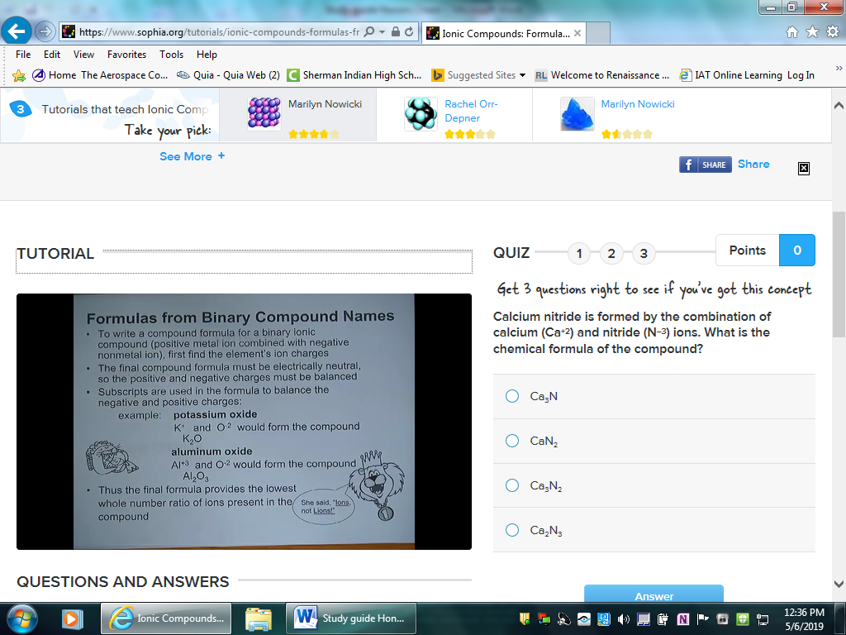

Question 2:

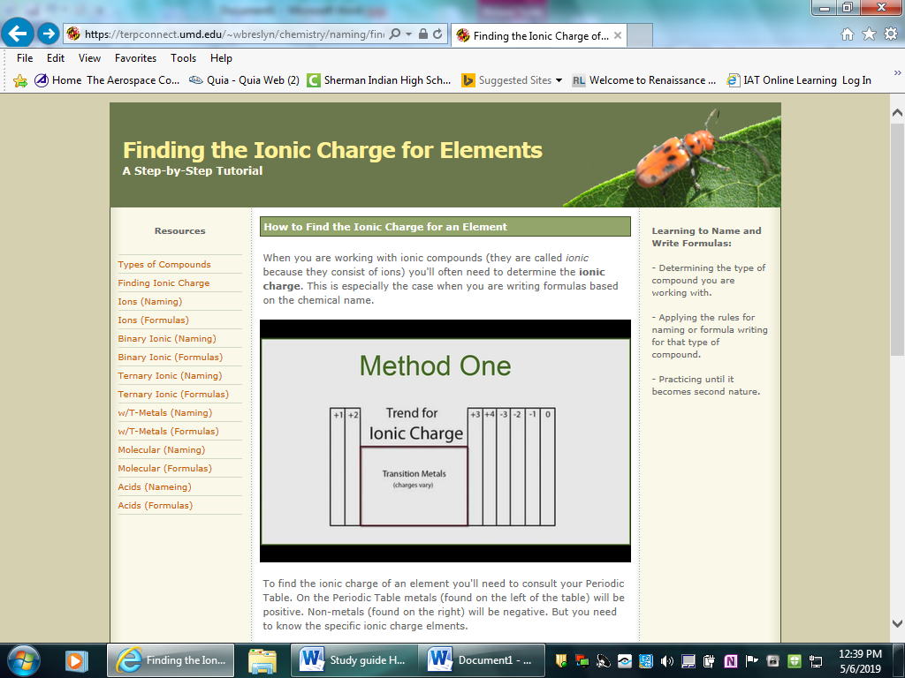Question 3:

Explain why metals tend to form cations, while nonmetals tend to form anions. With one, two, or three valence electrons metals tend to lose electrons to achieve a noble gas configuration. (It would require more energy to gain the 5 – 7 electrons needed to fill their valence shell.)

Question 4 The formula for baking soda, or NaHCO3, gives an example of a subscript. As this formula reflects, there is one atom each of the elements of sodium, or Na, hydrogen, or H, and carbon, or C. The subscript of 3 following the symbol for oxygen, or O, reveals that three atoms of oxygen are needed for every Na, H and C atom to make a complete molecule of baking soda.

Question 5

A formula unit indicates the lowest whole number ratio of ions in an ionic compound. Explanation: A molecule is composed of two or more elements that are covalently bonded.

Question 6

Ions bound together by electrostatic attraction form ionic crystals. Their arrangement varies depending on the ions’ sizes or the radius ratio (the ratio of the radii of the positive to the negative ion). A simple cubic crystal lattice has ions equally spaced in 3D at 90° angles.

Stability of ionic solids depends on lattice energy, which is released in the form of heat when two ions are brought together to form a solid. Lattice energy is the sum of all the interactions within the crystal.

The properties of ionic crystals reflect the strong interactions that exist between the ions. They are very poor conductors of electricity, have strong absorption of infrared radiation, and are easily cleaved. These solids tend to be quite hard and have high melting points.

Question 7:

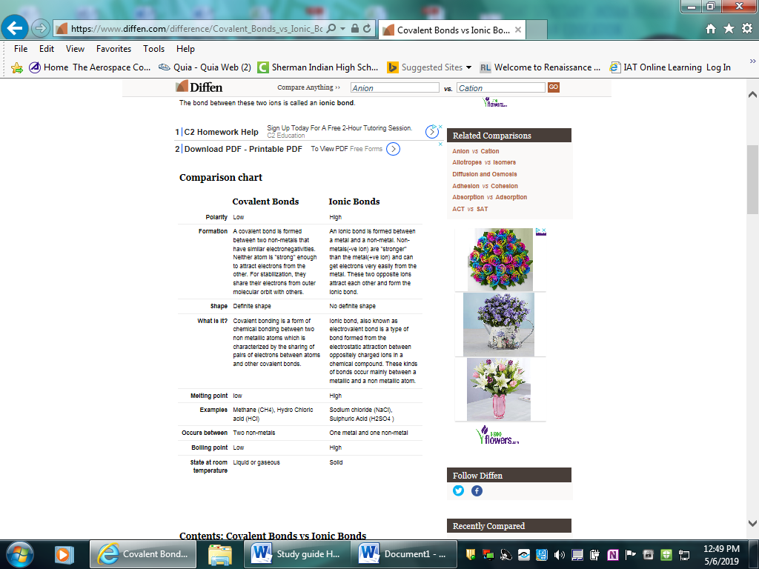

Question 8. Melting points are determined by the strength of the attractive forces holding atoms together in the solid. In a solid, each atom has its own place, and their motion consists of vibration, or rocking back and forth in place. When a solid melts to become a liquid, the forces holding atoms together must be overcome enough to allow the atoms to move about freely (while remaining close together).

Question 9. Salts do not conduct electricity at the solid state since the ions are in a fixed position in the lattice.

However, at the molten state or in solution, the ions are free and they can move within the liquid phase to serve as electrons shuttles and therefore, they become conductive.

Question 10 and 11.When a chemical reaction occurs, bonds in the reactants *break*, while new bonds *form* in the product. The following example explains this. Hydrogen reacts with oxygen to form water, according to the following equation:

2H 2 (g)+O 2 (g)→2H 2 O(g) 2H2(g)+O2(g)→2H2O(g)

In this reaction, the bond between the two hydrogen atoms in the H 2  H2 molecule will *break*, as will the bond between the oxygen atoms in the O 2  O2 molecule. New bonds will *form* between the two hydrogen atoms and the single oxygen atom in the water molecule that is formed as the product.

For bonds to *break*, energy must be *absorbed*. When new bonds *form*, energy is *released*. The energy that is needed to break a bond is called the bond energy or bond dissociation energy. Bond energies are measured in units of kJ⋅mol −1  kJ·mol−1 .

Question 12

Polyatomic Ions. A polyatomic ion is an ion composed of more than one atom. The ammonium ion consists of one nitrogen atom and four hydrogen atoms. ... The carbonate ion consists of one carbon atom and three oxygen atoms and carries an overall charge of 2−. The formula of the carbonate ion is CO32-.

Question 13:

Rules for Naming Ionic Compounds Containing Polyatomic Ions

Polyatomic ions are ions which consist of more than one atom. For example, nitrate ion, NO3-, contains one nitrogen atom and three oxygen atoms. The atoms in a polyatomic ion are usually covalently bonded to one another, and therefore stay together as a single, charged unit.

Rule 1. The cation is written first in the name; the anion is written second in the name.

Rule 2. When the formula unit contains two or more of the same polyatomic ion, that ion is written in parentheses with the subscript written outside the parentheses.

Note: parentheses and a subscript are not used unless more than one of a polyatomic ion is present in the formula unit (e.g., the formula unit for calcium sulfate is "CaSO4" not "Ca(SO4)").

Rule 3. If the cation is a metal ion with a fixed charge, the name of the cation is the same as the (neutral) element from which it is derived (e.g., Na+ = "sodium"). If the cation is a metal ion with a variable charge, the charge on the cation is indicated using a Roman numeral, in parentheses, immediately following the name of the cation (e.g., Fe3+ = "iron(III)").

Rule 4. If the anion is a monatomic ion, the anion is named by adding the suffix -ide to the root of the element name (e.g., I- = "iodide").

Question 15:

Sodium sulfate, NaSO4, is called **anhydrous** sodium sulfate when free of water, and is used as a drying material. That same compound **in** its decahydrate iteration is called "Glauber's **salt**," and is used to make glass.

Examples of hydrates are **gypsum** (commonly used in the manufacturing of wallboard, cement and plaster of Paris), Borax (used in many cosmetic, cleaning and laundry products) and **epsom salt** (used as a natural remedy and exfoliant). Hydrates are often used in skin care products to infuse moisture into the body.

Question 16

The **lattice energy** of a crystalline [solid](https://en.wikipedia.org/wiki/Solid) is a measure of the energy released when ions are combined to make a compound. It is a measure of the cohesive forces that bind ions.

Question 17.

The general formula of an oxyanion is AxOyz-, where A is an element symbol, O is an oxygen atom, and x, y, and z are integer values. ... Nitrate (NO3-), Nitrite (NO2-), sulfite (SO32-) and hypochlorite (ClO-) are all oxyanions.

Question 18.

**Metals** lose electrons in bonding and **non**-**metals** gain electrons during ionic bonding, hence **metals** for **cations** and **non**-**metals form anions**. It **is** difficult for a **non metal** such as oxygen to lose 6 electrons to **form** a **cation** since it **would** need a lot of energy.

Question 19.

A cation is formed when a metal ion loses a valence electron while an anion is formed when a non-metal gains a valence electron. They both achieve a more stable electronic configuration through this exchange.

Question 20.

So, for **noble gases**, they already have their outermost shells filled completely so they need not donate or accept any electrons. For example: Argon has atomic no 18 ,i.e E.C = 2,8,8. They are already stable. So, they **don't** need to **form ions**.

Question 21.

Some elements, especially transition metals, can form ions of multiple charges. there is a pattern to the charges on many of the main group ions, but there is no simple pattern for transition metal ions (or for the larger main group elements).

Question 22

A covalent bond, also called a molecular bond, is a chemical bond that involves the sharing of electron pairs between atoms.

Question 23.

An ionic bond essentially donates an electron to the other atom participating in the bond, while electrons in a covalent bond are shared equally between the atoms. The only pure covalent bonds occur between identical atoms.

Question 24.

Molecular orbitals are obtained by combining the atomic orbitals on the atoms in the molecule. Consider the H2 molecule, for example. One of the molecular orbitals in this molecule is constructed by adding the mathematical functions for the two 1*s* atomic orbitals that come together to form this molecule.

Question 25.

The **length** of the **bond** is determined by the number of bonded electrons (the **bond** order). The higher the **bond** order, the stronger the pull between the two atoms and the shorter the **bond length**. Generally, the **length** of the **bond** between two atoms is approximately the sum of the covalent radii of the two atoms

Question 26.

**Bond energy** is the energy required to break a covalent bond between two atoms.  A high bond energy means that a bond is strong and the molecule that contains that bond is likely to be stable and less reactive.  More reactive compounds will contain bonds that have generally lower bond energies.  Some bond energies are listed in the table below.

Question 27.

Bonds between the same type of atom are **covalent bonds**, and bonds between atoms when their electronegativity differs by a little (say 0.7) are also predominantly covalent in character. The rule is that when the **electronegativity** difference is greater than 2.0, the **bond** is considered ionic. ... If the **electronegativity** difference (usually called ΔEN) is less than 0.5, then the **bond** is nonpolar covalent.

Question 28.

Electronegativity difference allow the atoms to pull electrons from one atom to another and therefore make ions which then can form the lattice between positive and negative ions. Less than the 2:0 value of difference allow for partial or even full sharing of electrons.

29. Unlike polar molecules non-polar molecules are not attracted to each other and rarely form solids or liquids, usually are in gaseous form at room temperature. Lowest melting and boiling points.

30. Polar covalent compounds tend to have partial charges on each side of the molecule due to electronegativity difference. This results in attraction between the polar sides of the molecules.

31. Lewis symbols (also known as Lewis dot diagrams or electron dot diagrams) are diagrams that represent the valence electrons of an atom. Lewis structures (also known as Lewis dot structures or electron dot structures) are diagrams that represent the valence electrons of atoms within a molecule. These Lewis symbols and Lewis structures help visualize the valence electrons of atoms and molecules, whether they exist as lone pairs or within bonds

32. The following is a list of rules that can be used to determine the Lewis structure of a molecule:

1.Count up the total number of valence electrons. First add up the group numbers of all atoms in the molecule. If the molecule is an anion, add one electron for each unit of charge on the anion. If it is a cation, subtract one electron for each unit of charge on the cation.

2.Calculate the total number of electrons that would be needed for each atom to have an octet (or doublet for H).

3.Subtract the result of step 1 from the result of step 2. This is the total number of shared or bonding electrons.

4.Assign two bonding electrons to each bond.

5.If bonding electrons remain, assign them in pairs making some of the bonds double or triple bonds. (Usually, only C,N,O, and S can form double bonds, and only C and N can form triple bonds). There may be more than one way to do this. Keep all possible structures that result.

6.Assign remaining electrons as lone pairs, **giving octets to all atoms except H. (Very important rule)**

7.Determine the formal charges and put them next to the appropriate atoms. (A formal charge of 0 need not be written explicitly). Check that the formal charges add up to the total charge on the molecule/ion. Do this for all structures obtained in step 5. The structure with the smallest formal charges should be considered as the preferred structure.

Question 33

A **Lewis dot structure** is a quick and easy diagram that shows the valence electrons in an element. In a Lewis dot structure, the nucleus of the element is represented by its symbol. The valence electrons are represented by dots placed around the symbol in pairs. This type of diagram helps to identify how an element may react in a chemical reaction. When we know that all atoms need octet except hydrogen it is much easier to draw these model to show connection between atoms in molecules.

Question 34.

**Resonance structures** are a set of two or more Lewis **Structures** that collectively describe the electronic bonding a single polyatomic species including fractional bonds and fractional charges.5 days ago

Question 35.

1. Remove the ending of the second element, and add “ide” just like in ionic compounds.
2. When naming molecular compounds prefixes are used to dictate the number of a given element present in the compound. ” mono-” indicates one, “di-” indicates two, “tri-” is three, “tetra-” is four, “penta-” is five, and “hexa-” is six, “hepta-” is seven, “octo-” is eight, “nona-” is nine, and “deca” is ten.
3. If there is only one of the first element, you can drop the prefix. For example, CO is carbon monoxide, not monocarbon monoxide.
4. If there are two vowels in a row that sound the same once the prefix is added (they “conflict”), the extra vowel on the end of the prefix is removed. For example, one oxygen would be monooxide, but instead it’s monoxide. The extra o is dropped.

Question 36.

To predict the shape of a covalent molecule, follow these steps:

1. Draw the molecule using a Lewis diagram. Make sure that you draw *all* the valence electrons around the molecule's central atom.
2. Count the number of electron pairs around the central atom.
3. Determine the basic geometry of the molecule using the table below. For example, a molecule with two electron pairs (and no lone pairs) around the central atom has a *linear* shape, and one with four electron pairs (and no lone pairs) around the central atom would have a *tetrahedral* shape.

The table below gives the common molecular shapes. In this table we use **A** to represent the central atom, **X** to represent the terminal atoms (i.e. the atoms around the central atom) and **E** to represent any lone pairs.

|  |  |  |  |
| --- | --- | --- | --- |
| **Number of bonding electron pairs** | **Number of lone pairs** | **Geometry** | **General formula** |
| 1 1 or 2 2 | 0 0 | linear | AX AX or AX 2  AX2 |
| 2 2 | 2 2 | *bent or angular* | AX 2 E 2  AX2E2 |
| 3 3 | 0 0 | trigonal planar | AX 3  AX3 |
| 3 3 | 1 1 | *trigonal pyramidal* | AX 3 E AX3E |
| 4 4 | 0 0 | tetrahedral | AX 4  AX4 |
| 5 5 | 0 0 | trigonal bipyramidal | AX 5  AX5 |
| 6 6 | 0 0 | octahedral | AX 6  AX6 |

*Table 3.1: The effect of electron pairs in determining the shape of molecules. Note that in the general example* A A *is the central atom and* X X *represents the terminal atoms.*

*Question 37.*

<http://butane.chem.uiuc.edu/pshapley/genchem1/l20/1.html>

Question 38.

The **intermolecular forces** increase with increasing polarization of bonds. The strength of **intermolecular forces** (and therefore impact on **boiling points**) is ionic > hydrogen bonding > dipole dipole > dispersion. **Boiling point** increases with molecular weight, and with surface area.

*Question 39.*

The London dispersion force is the weakest intermolecular force. The London dispersion force is a temporary attractive force that results when the electrons in two adjacent atoms occupy positions that make the atoms form temporary dipoles.

Question 40.

A **double** covalent **bond is** where two pairs of electrons **are** shared between the atoms rather than just one pair. Two oxygen atoms can both achieve stable structures by sharing two pairs of electrons as in the diagram.

Question 41.

Allotropes are different forms of the same element. Different bonding arrangements between atoms result in different structures with different chemical and physical properties  
  
Read more: <http://www.chemistryexplained.com/A-Ar/Allotropes.html#ixzz5nBQfJL7C>

Questin 42.

A **network solid** or **covalent network solid** is a chemical compound (or element) in which the atoms are bonded by **covalent** bonds in a continuous**network** extending throughout the material. In a**network solid** there are no individual molecules, and the entire crystal or amorphous **solid** may be considered a macromolecule.

Question 43.

An **organic compound** is any member of a large class of gaseous, liquid, or solid chemical **compounds** whose molecules contain carbon. Carbonates, simple oxides of carbon, and cyanide molecules do have carbon, but they are not regarded as **organic**.

Question 44.

<https://www.chemguide.co.uk/basicorg/conventions/names.html>

Question 45

Isomers are compounds that contain exactly the same number of atoms, i.e., they have exactly the same empirical formula, but differ from each other by the way in which the atoms are arranged. Examples of [isomers](https://www.sciencedirect.com/topics/earth-and-planetary-sciences/isomer) with the formula C8H10 are ethyl [benzene](https://www.sciencedirect.com/topics/agricultural-and-biological-sciences/benzene), *m*-xylene, *p*-xylene, and *o*-xylene.

Question 46.

1. The **molar mass** is the **mass** of a given chemical element or chemical compound (g) divided by the amount of substance (mol).
2. The **molar mass** of a compound can be calculated by adding the standard atomic **masses** (in g/mol) of the constituent atoms.

Question 47.

The two main reason we balance chemical equations is to find the molar ratios and to reflect conservation of mass.

Question 48. Just write an example equation answering the questions.

Question 49.

| **Steps for Problem Solving** | **Example \(\PageIndex{1}\)** |
| --- | --- |
| Identify the "given"information and what the problem is asking you to "find." | Given: 249 g AlCl3 Find: moles HCl |
| List other known quantities | 1 mol AlCl3 = 133.33 g/mol 6 mol of HCl to 2 mol AlCl3 |
| Prepare a concept map and use the proper conversion factor. | https://chem.libretexts.org/@api/deki/files/114083/8.4.1.PNG?revision=2&size=bestfit&width=431&height=136 |
| Cancel units and calculate. | \(249\, \cancel{g\, AlCl_{3}}\times \dfrac{1\, \cancel{mol\, AlCl_{3}}}{133.33\, \cancel{g\, AlCl_{3}}}\times \dfrac{6\, mol\, HCl}{2\, \cancel{mol\, AlCl_{3}}}=5.60\, mol\, HCl\) |
| Think about your result. | Since 249 g of AlCl3 is less than 266.66 g,  the mass for 2 moles of AlCl3  and the relationship is 6 mol of HCl to 2 mol AlCl3 ,the answer should be less than 6 moles of HCl. |

Question 50 covered in number 47

Question 51

|  |
| --- |
| **The coefficients in a balanced chemical equation can be used to determine the relative number of molecules, formula units, or moles of a compound involved in a chemical reaction.** |
|

Question 52.

The **molar mass** of a compound can be **calculated** by adding the standard atomic **masses** (in g/mol) of the constituent atoms.

54. We need to convert to moles because this is the unit we have in equations from the molar ratios (using the coefficents).

55. Write an example of your own.

56.Duplicate question

57.This I know you can do already

58. Write several example equations

59.You know why.

60. Already cover from number 52.

63. See numbers from above that have to do with naming compounds.

64. Using this chart you can determine if one element will replace another in single displacement reactions.

. 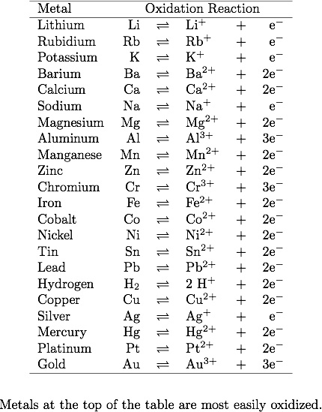

64. This is a repeat of 54 (sorry).

65. <https://www.wikihow.com/Calculate-Percent-Yield-in-Chemistry>

66. Try this one as an example

1. Step 1: Identify reactants and products and place them in a **word equation**.
2. Step 2: Convert the chemical names into chemical **formulas**. ...
3. Step 3: Balance the chemical **equation**.
4. Step 1: Convert the chemical names into chemical **formulas**. ...
5. Step 2: Balance the chemical **equation**.
6. 