Jack Sprat

Mrs. Steinmiller

Honors Biology

18 September 2013

The Effects of Caffeine as a Mold Inhibitor in Coffee

Purpose: Does the caffeine in coffee inhibit the growth of mold?

Abstract: This experiment was conducted to determine if caffeine acts as a mold inhibitor in coffee. To determine this, the experimenter brewed Casper’s caffeinated and decaffeinated coffee and then created five, 40 mL samples of each coffee by pouring the coffees into identical paper cups. The cups were observed for signs of mold growth every day for ten days. Mold appeared in most of the cups by the tenth day of the experiment, indicating that caffeine does not inhibit mold growth in Casper’s coffee.
Background: After a few weeks of drinking a lot of coffee and doing a lot of studying, the
investigator decided to clean his dorm room. When he picked up cups of leftover coffee, he found white fuzzy mold growing in most of the paper cups that he picked up from under the bed and sitting on top of various pieces of furniture. However, there was one cup of caffeinated coffee that he bought by mistake and did not drink. It was mold free. This caused the investigator to wonder if caffeine is a mold inhibitor.
Mold is a member of the kingdom Fungi, a group of heterotrophic

saprobes that grow from spores commonly found in the air both outside and inside

buildings. Mold grows in any appropriate food supply, and it prefers a dark and

warm environment. (3) Caffeine is a central nervous system stimulant that can

be lethal in large doses. In moderate doses, caffeine can increase alertness, reduce

fine motor coordination, cause insomnia, cause headaches, nervousness, and

dizziness. Caffeine also acts to increase heart rate, constrict blood vessels,

relax air passages to improve breathing and allow some muscles to contact more

easily. (2)

There are no published studies found by the investigator about whether or

not caffeine is a mold inhibitor.

Hypothesis: If mold growth is inhibited by caffeine, then mold will not grow in caffeinated

coffee, but mold will grow in decaffeinated coffee.

Materials: 10 paper cups, Casper’s caffeinated coffee, Casper’s decaffeinated coffee, 50 mL

graduated cylinder, distilled water, coffeemaker

Procedure:

- Brew 5 cups of Casper’s decaffeinated coffee in distilled water according to package

directions.

- Brew 5 cups of Casper’s caffeinated coffee in distilled water according to package
directions.

- Label 10 identical paper cups 1-10.

- In each of the cups numbered 1-5, place 40 ml of Casper’s decaffeinated coffee. (control)

- In each of the cups numbered 6-10, place 40 ml of Casper’s caffeinated coffee.

- Place all cups on top of the dresser in the investigator’s dorm room.

- Observe each cup daily for signs of mold growth (fuzzy, circular patches) and record whether or not mold is present in each cup on every day for 10 days. (dependent variable)
Data:
Growth of Mold in Caffeinated and Decaffeinated Coffee

Date | Number of Cups of Caffeinated Coffee Displaying Mold Growth | Number of Cups of Decaffeinated Coffee Displaying Mold Growth
May 25, 2012 | 0 | 0
May 26, 2012 | 0 | 0
May 27, 2012 | 0 | 0
May 28, 2012 | 0 | 0
May 29, 2012 | 0 | 0
May 30, 2012 | 0 | 0
May 31, 2012 | 0 | 1
June 01, 2012 | 2 | 1
June 02, 2012 | 4 | 2
June 03, 2012 | 4 | 3

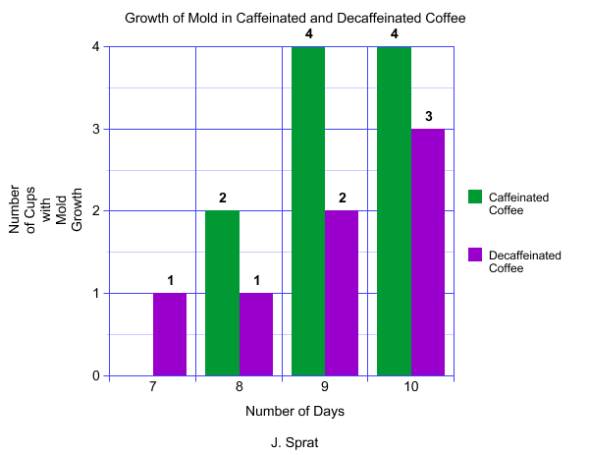

Discussion: Caffeine in Casper’s coffee does not apparently inhibit the growth of
mold. In this experiment, five cups of Casper’s caffeinated coffee and five cups of Casper’s decaffeinated coffee were brewed according to directions using distilled water taken from the same source. The ten cups were placed on the same dresser in the experimenter’s room where the coffee was exposed to the same amount of light, humidity and air temperature. On the seventh day of the experiment, mold was observed in one of the five cups of decaffeinated coffee, an indication that caffeine might be a mold inhibitor. However, on day eight, mold appeared in two cups of caffeinated coffee but had not shown up in any additional cups of decaffeinated coffee. On day nine and ten, four cups of caffeinated coffee showed signs of mold, and the decaffeinated coffee showed slower mold growth, increasing by only one cup per day. At the end of the experiment, four cups of caffeinated coffee showed signs of mold growth, but only three cups of decaffeinated coffee were moldy.
This experiment was conducted on a very limited scale and is only one indicator that caffeine may not be a mold inhibitor in coffee. In order to gather sufficient data, the experimenter will repeat the protocol using a number of brands of coffee and allow the cups to sit for a longer period of time. He will also add to his protocol caffeinated and decaffeinated tea to determine if caffeine and mold behave differently in beverages that have different chemical bases. Before conducting the next phase of the experiment, the investigator will also research the process of decaffeination in coffee and tea to determine if the process itself might have an effect on the growth of mold.
Works cited:

- "Fungi:Molds." <http://faculty.ccbcmd.edu/courses/bio141/lecguide/unit3/fungi/mold.html>.

- "National Center for Biotechnology Information.” U.S. National Library of Medicine, 17 May 1992. Web. 18 June 2012. <http://www.ncbi.nlm.nih.gov/pubmed/1356551>.

- Steinmiller, Deborah E.. "Fungi." Canon-McMillan High School, Pennsylvania. 15 Nov. 1995.

