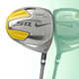


Nike Sasquatch Driver
Made with NexTI titanium, the Nike® SasQuatch 460cc Driver offers Nike® PowerBow Technology for more power and control applied to the ball without surpassing the 460cc limit. The center of gravity, placed in the heart of the SasQuatch, helps increase leverage, expands the sweet spot and resists twisting on off-center hits. The lightweight Diamana Shaft offers power and stability, and has an optimized profile for distance and accuracy.
$234 Item # 201

Ram Gforce 17 piece set
Graphite shafted 430cc 6061 Forged Ti matrix driver ,Graphite shafted oversized 3 & 5 woods One steel shafted 6061 alloy hybrid iron, woods Steel shafted 4-PW alloy iron Heel-toe weighted putter Stand bag ,4 deluxe long-neck head covers
$273 Item # 204

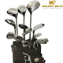

Adams 13 piece set

- 440cc titanim driver with maximum COR delivers easy-to-hit shots with incredible distance; premium headcover included
- 3 & 5 fairway woods with a low profile make tough approach shots easy-to-hit; premium headcovers included
- 3-PW & SW irons are easy-to-hit and feature an undercut cavity design that repositions the weight low and back for the optimum launch angle
- Mallet putter is black with a non-glare finish, engineered for easy alignment and face balanced for stability and control
- Stand bag made of lightweight Doby nylon features umbrella holder and rain hood included
- Supershaft™ on all woods, True Temper® steel shaft on irons, wedges and putter, Golf Pride™ Velvet Feel grip
$312 Item # 207

Golden Bear 17 piece set

- 456cc driver with graphite shaft
- 3-5 woods with graphite shafts
- 3-4-5 hybrid with graphite shafts
- 6-SW stainless irons with steel shafts
- Alignment putter
- Golden Bear All Weather rubber grips
- 3 covers for woods
- Golf bag
$360 Item # 210

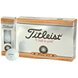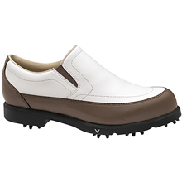

Callaway CG sport shoe

DrySport™ technology provides moisture management and breathability EVA rubber outsole for long-lasting performance Waterproof leather offers performance, comfort, style and durability Callaway Golf® Spike delivers high-performance traction and comfort 2-year manufacturer's waterproof warranty
$35.10 Item # 216
- Titelist Pro V1
- Soft and fast 1.550" diameter core formulation
- Speed enhancing and spin controlling ionomer casing
- Soft and thin 0.030" urethane elastomer cover
- New 392 multi-dimple high coverage icosahedral design
- Longer, more consistent distance from tee-to-green
- Straight, consistent ball flight
- Drop-and-Stop™ performance into the green
- Soft, high performance feel
- Shear and abrasion resistant cover durability
$29.50 Item # 213

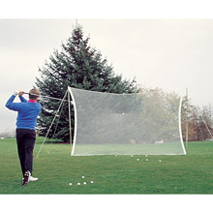
The Club Champ® Practice Net- is a large weather-resistant net that's designed to effectively stop your practice drives, so you can practice your big hits right at home.
$35.10 Item # 219
Extra-large 9-ft. x 20-in. putting surface Regulation-size cup is 'protected' by sand trap and water hazard Realistic cup and golf hazards return putts electronically High-quality, non-directional turf simulates real grass Electronic ball return; No batteries needed Have fun and improve your putting at the same time

$55 Item # 222

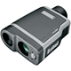

- The Bushnell® Pinseeker™ 1500 rangefinder -boasts a PinSeeker® Mode that allows for easy acquisition of the flag without inadvertently capturing background target distances. It's accurate to within +/- 1 yard of the flag from 5 to 1,000 yards away and reads distance in both yards and meters. It's completely waterproof and includes a Rainguard® lens coating to ensure a clear view through nasty weather.
$354.90 Item # 225

