Use the documents and your knowledge of the period 1750 to 1776 to answer the question.
Document A
Source: Pennsylvania Gazette, 1754
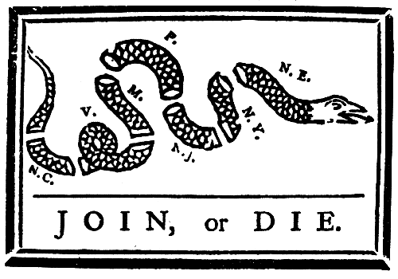
Document B
Source: Edmund Burke, "Notes for Speech in Parliament, 3 February 1766".
Govern America [?] as you govern an English town which happens not to be represented in Parliament [?] Are Gentlemen really serious when they propose this? Is there a single Trait of Resemblance between those few Towns, and a great and growing people spread over a vast quarter of the globe, separated from us by a mighty Ocean? . . . The eternal Barriers of Nature forbid that the colonies should be blended or coalesce into the Mass . . . of this Kingdom. We have nothing therefore for it, but to let them carry across the ocean into the woods and deserts of America the images of the British constitution.
Document C
Source: Richard Henry Lee to Arthur Lee, 24 February, 1774.
The wicked violence of [the] Ministry is so clearly expressed, as to leave no doubt of their fatal determination to ruin both Countries unless a powerful and timely check is interposed by the Body of People. A very small corrupted Junto in New York excepted, all N. America is now most firmly united and as firmly resolved to defend their liberties ad infinitum against every power on Earth that may attempt to take them away. The most effectual measures are everywhere taking to secure a sacred observance of the Association ó Manufactures go rapidly on and the means of repelling force by force are universally adopting.
Document D
Source: Mather Byles, Cotton Mather's grandson, to Nathaniel Emmons, Arthur Wentworth Hamilton Eaton, The Famous Mather Byles: The Noted Boston Tory Preacher, Poet and Wit, 1707-1788.
They call me a brainless Tory; but tell me, my young friend, which is better, to be ruled by one tyrant three thousand miles away, or by three thousand tyrants not a mile away. I tell you, my boy, there was just as much humbug in politics seventy years ago as there is today.
Document E
Source: Declaration for the Causes of Taking up Arms, Continental Congress, 6 July 1775.
A Declaration by the Representative of the United Colonies of North America, now met in Congress at Philadelphia, setting forth the causes and necessity of their taking up arms.
. . . the arms we have been compelled by our enemies to assume, we will, in defiance of every hazard, with unabating firmness and perseverance, employ for the preservation of our liberties; being with one mind resolved to die freemen, rather than live [like] slaves.
Lest this declaration should disquiet the minds of our friends and fellow-subjects in any part of the Empire, we assure them that we mean not to dissolve that union which has so long and so happily subsisted between us, and which we sincerely wish to see restored. . . We have not raised armies with ambitious designs of separating from Great Britain, and establishing independent states.
Document F
Source: The Origin and Progress of the American Revolution to the year 1776, a history by Peter Oliver of Massachusetts, 1781
We [saw] a Set of Men . . . under the Auspices of the english Government; & protected by it . . . for a long Series of Years . . . rising, by easy Gradations, to such a State of Prosperity & Happiness as was almost enviable, but we [saw] them also run mad with too much Happiness, & burst into an open Rebellion against that Parent, who protected them against the Ravages of their Enemies. . . . And why [was] the sudden Transition made, from Obedience to Rebellion, but to gratifye the Pride, Ambition & Resentment, of a few abandoned Demagogues, who were lost to all Sense of Shame & of Humanity? The generality of the People were not of this Stamp; but they were [weak], & unversed in the Arts of Deception.
Document G
Source: Hector St. John Crèvecoeur, Letters from an American Farmer, composed in the 1770's, published, 1781.
What then is the American, this new man? He is either an European, or the descendant of an European, hence that strange mixture of blood which you will find in no other country. I could point out to you a family whose grandfather was an Englishman, whose wife was Dutch, whose son married a French woman. . . . He is an American, who leaving behind him all his ancient prejudices and manners, receives new ones from the new mode of life he has embraced. . . . He becomes an American by being received in the broad lap of our great Alma Mater. Here individuals of all nations are melted into a new race of men, whose labours and posterity will one day cause great changes in the world. . . . This great metamorphosis has a double effect, it extinguishes all his European prejudices, he forgets that mechanism of subordination, that servility of disposition which poverty had taught him.

Document H
Source: | Contributors of Donations for the Relief of Boston, 1774 and 1775, Collections, Massachusetts Historical Society
 | Connecticut
 | Windham | a small flock of sheep
 | Groton | 40 bushels of grain
 | Farmington | 300-400 bushels of Indian corn and rye
 | Glastonbury | "subscription for the relief of the poor"
 | Wethersfield | 248 1/2 bushels of rye, 390 bushels of Indian corn
 | Hartford | 1,400 bushels of grain
 | Middletown | 600 bushels of grain
 | Middle Hampton | 600 bushels of grain
 | Massachusetts
 | Wrentham | 31 bushels of grain
 | Pepperall | 40 bushels of grain
 | Charlemont | 2 barrels of flour
 | Roxbury | 258 sheep
 | New Jersey
 | Provincial Assembly | "Cash or articles of provision or other necessaries we can furnish"
 | Committees of Correspondence,  several counties of New Jersey | "moneys from subscriptions or other benefactions"
 | North Carolina
 | Cape Fear | sloop with provisions
 | Wilmington | £2,000
 | South Carolina
 |  | shipload of rice

www.exampleessays.com/essay_search/sense_identity_unity.html

