Document A
Source: Letter from George Washington to John Jay, May 18, 1786

I coincide perfectly in sentiment with you, my dear Sir, that there are errors in our National Government which call for correction; loudly I will add; but I shall find my self happily mistaken if the remedies are at hand. We are certainly in a delicate situation, but my fear is that the people are not yet sufficiently misled to retract from error! To be plainer, I think there is more wickedness than ignorance, mixed with our councils. Under this impression, I scarcely know what opinion to entertain of a general Convention. That it is necessary to revise, and amend the articles of Confederation, I entertain no doubt; but what may be the consequences of such an attempt is doubtful. Yet, something must be done, or the fabrick must fall. It certainly is tottering!

Document B
Source: Thomas Jefferson, Letter to James Madison, from Paris, January 30, 1787
“I hold it that a little rebellion now and then is a good thing, and as necessary in the political world as storms in the physical. Unsuccessful rebellions, indeed, generally establish the encroachments on the rights of the people which have produced them. An observation of this truth should render honest republican governors so mild in their punishment of rebellions as not to discourage them too much. It is a medicine necessary for the sound health of the government.”
Source: Chief Justice William Cushing, Supreme Judicial Court, in the Hampshire Gazette, June 6, 1787
“[I fear] evil minded persons, leaders of the insurgent . . .[waging war] against the Commonwealth, to bring the whole government and all the good people of this state, if not continent, under absolute command and subjugation to one or two ignorant, unprincipled, bankrupt, desperate individuals.”

Document C
Source: Thomas Paine, Common Sense (1776)
Society is produced by our wants, and government by our wickedness; the former promoted our happiness Positively by uniting our affections, the latter negatively by restraining our vices. The one encourages intercourse, the other creates distinctions. The first is patron, the last a punisher.
Society in every state is a blessing, but government even in its best state is but a necessary evil in its worst state an intolerable one; for when we suffer, or are exposed to the same miseries by a government, which we might expect in a country without government, our calamities is heightened by reflecting that we furnish the means by which we suffer! Government, like dress, is the badge of lost innocence; the palaces of kings are built on the ruins of the bower for paradise. For were the impulses of conscience clear, uniform, and irresistibly obeyed, man would need no other lawgiver; but that not being the case, he finds it necessary to surrender up a part of his property to furnish means for the protection of the rest; and this he is induced to do by the same prudence which in every other case advises him out of two evils to choose the least. Wherefore, security being the true design and end of government, it unanswerably follows that whatever form thereof appears most likely to ensure it to us, with the least expense and greatest benefit, is preferable to all others.

Document D
Source: 3rd Article form the Articles of Confederation
The said States hereby severally enter into a firm league of friendship with each other, for their common defense, the security of their liberties, and their mutual general welfare, binding themselves to assist each other, against all force offered to, or attacks made upon them, or any of them, on account of religion, sovereignty, trade, or any other pretense whatever.

Document E
Source: The Massachusetts Centinel (January-August 1788)
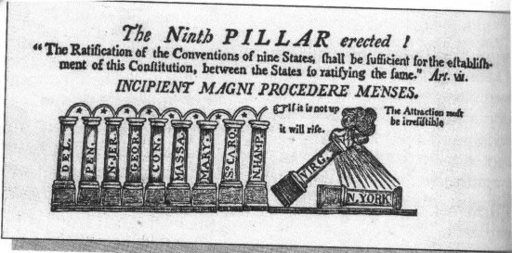

Document F
Source: W. Cleon Skousen, The Making of America (1985)
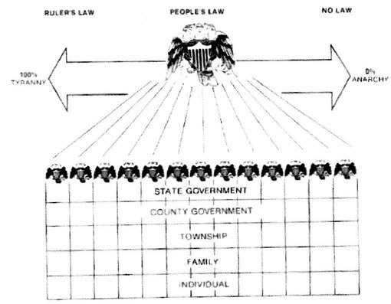

Document G
Source: Declaration of Independence, July 4, 1776

WE, therefore, the Representatives of the UNITED STATES OF AMERICA, in GENERAL CONGRESS Assembled, appealing to the Supreme Judge of the World for the Rectitude of our Intentions, do, in the Name, and by Authority of the good People of these Colonies, solemnly Publish and Declare, That these United Colonies, are, and of Right ought to be, FREE AND INDEPENDENT STATES; that they are absolved from all Allegiance to the British Crown, and that all political Connection between them and the States of Great-Britain, is and ought to be Peace, contract Alliances, establish Commerce and to do all other Acts and Things which INDEPENDENT STATES may of right do. And for the support of this Declaration, with a firm Reliance on the Protection of divine Providence, we mutually pledge to each other our Lives, our Fortunes, and our sacred Honor.

Document H
Source: Constitution of the United States, 1787

We the People of the United States, in order to form a more perfect union, establish justice, insure domestic tranquility, provide for the common defense, promote the general welfare, and secure the blessings of liberty to ourselves and our posterity, do ordain and establish this Constitution for the United States of America.

Document I
Source: Thomas A. Bailey & David M. Kennedy, The American Spirit (Date unknown)
The Grand Constitution: A New Federal Song
From scenes of affliction -- Columbia opprest --
Of credit expiring -- and commerce disrest,
Of nothing to do-and of nothing to pay --
From such dismal scenes let us hasten away.
Our Freedom we’ve won and the Prize let’s maintain,
Our Hearts are all right,
Unite, Boys, Unite,
And our EMPIRE in glory shall even remain.
The Muses no longer the cypress shall wear.
For we turn our glad eyes to a prospect more fair:
The Solder return’d to his small cultur’d farm,
Enjoys the reward of his conquering arm,
Our Freedom, &c.
Our trade and our commerce shall reach far and wide,
And riches and honour flow in with each tide,
Kamschatka and China with wonder shall stare,
That the Federal stripes shou’d wave gracefully there.
Our Freedom, &c.
With gratitude let us acknowledge the worth,
Of what the Convention has call’d into birth,
And the Continent wisely confirm what is done
By Franklin the Sage, and by brave Washington.
Our Freedom, &c.
The wise Constitution let’s truly revere,
It points out the course four our Empire to steer,
For Oceans of bliss, do they hoist the broad sail,
And Peace is the current, and Plenty the gale.
Our Freedom, &c.
With gratitude fill’d – let the great Commonweal
Pass round the full glass to Republican zeal –
From ruin – their judgment and wisdom well aim’d,
Our Liberties, Laws, and our Credit reclaim’d.
Our Freedom, &c.
Here Plenty and Order, and Freedom shall dwell,
And your Shayses and Dayses won’t dare to rebel –
Independence and culture shall graciously smile,
And the Husbandman reap the full fruit of his toil.
Our Freedom, &c.
That these are the blessing Columbia knows –
The blessings the Fed’ral Convention bestows;
O! Then let the People confirm what is done
By Franklin the Sage, and by brave Washington.
Our Freedom we’ve won, and the prize let’s maintain,
By Jove we’ll Unite,
Approve and Unite –
And huzza for Convention again and again.

http://www.mury.k12.ut.us/MHS/apus/dbq/1999/default.htm

