Sample DBQ - 1

Using the documents and your understanding of the Revolutionary War period, analyze the extent to which the American Revolutionary War was truly "revolutionary?"
Document A

The Boston Massacre
By Paul Revere
(C) 1995 --American Antiquarian Society
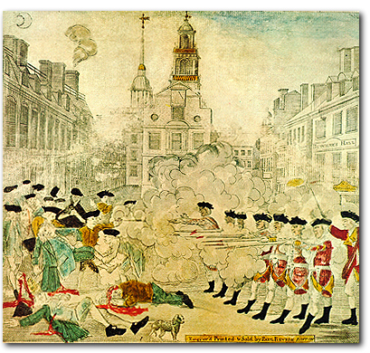Document B
The Boston Tea Party
By Sarony Major
(C) 1999 National Archives Administration
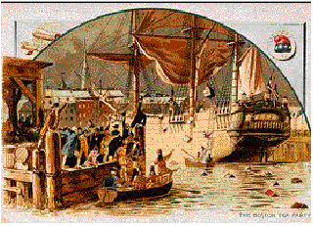
Document C
Treaty of Paris Article V - Written by: D. Hartley, John Adams, B. Franklin and John Jay - (C)1995 --Facts on File, Inc.
It is agreed that the Congress shall earnestly recommend it to the legislatures of the respective states, to provide for the restitution of all estates, rights and properties, which have been confiscated, belonging to real British subjects, and also of the estates, rights and properties of persons resident in districts in the possession of his Majesty’s arms, and who have not borne arms against the said United States. And that persons of any other description shall have free liberty to go to any part or parts of any of the thirteen United States, and therein to remain twelve months, unmolested in their endeavors to obtain the restitution of such of their estates, rights and properties, as may have been confiscated; and that Congress shall also earnestly recommend to the several states a reconsideration and revision of all acts or laws regarding the premises, so as to render the said laws or acts perfectly consistent, not only with justice and equity, but with that spirit of conciliation, which on the return of the blessings of peace should universally prevail. And that Congress shall also earnestly recommend to the several states, that the estates, rights and properties of such last mentioned persons, shall be restored to them, they refunding to any persons who may be now in possession, the bona fide price (where any has been given) which such persons may have paid on purchasing any of the said lands, rights or properties, since the confiscation. And it is agreed, that all persons who have any interest in confiscated lands, either by debts, marriage settlements, or otherwise, shall meet with no lawful impediment in the prosecution of their rights.Document D
Galloway’s Plan of Union, 1774 - (C)1995--Facts on File
That there shall be a new election of members for the Grand Council every three years; and on the death, removal or resignation of any member, his place shall be supplied by a new choice, at the next sitting of Assembly of the Colony he represented.
That the grand Council shall have power to choose their Speaker, and shall hold and exercise al the like rights, liberties and privileges, as are held and exercised by and in the House of Commons of Great Britain.
That the President-General, by and with the advice and consent of the Grand-Council, hold and exercise all the legislative rights, powers, and authorities, necessary for regulating and administering all the general police and affairs of the colonies, in which Great-Britain and the colonies, or any of them, the colonies in general, or more than one colony, are in any manner concerned, as well civil and criminal as commercial.
That in time of war, all bills for granting aid to the crown, prepared by the Grand Council, and approved by the President General, shall be valid and passed into a law, without the assent of the British Parliament.Document E
First Continental Congress -October 1774
Resolved, That the following acts of Parliament are infringements and violations of the rights of the colonists; and that the repeal of them is essentially necessary, in order to restore harmony between Great Britain and the American colonies, viz.:
The several Acts which impose duties for the purpose of raising a revenue in America, extend powers of the admiralty courts beyond their ancient limits, deprive the American subject of trial by jury, authorize the judges’ certificate to indemnify the prosecutor from damages that he might otherwise be liable to, requiring oppressive security from a claimant of ships and goods seized before he shall be allowed to defend his property; and are subversive of American rights.
Document F
Give Me Liberty Speech by Patrick Henry, 1775 (Letter to the President) - (C)1995 -Facts on File
They tell us, sir, that we are weak; unable to cope with so formidable an adversary. But when shall we be stronger? Will it be the next week, or the next year? Will it be when we are totally disarmed, and when a British guard shall be stationed in every house? Shall we gather strength by irresolution and inaction? Shall we acquire the means of effectual resistance, by lying supinely on our backs, and hugging the delusive phantom of hope, until our enemies shall have bound us hand and foot? Sir, we are not weak, if we make a proper use of those means which the God of nature hath placed in our power. Three millions of people, armed in the holy cause of liberty, and in such a country as that which we possess, are invincible by any force which our enemy can send against us. Besides, sir, we shall not fight our battles alone. There is a just God who presides over the destinies of nations; and who will raise up friends to fight our battles for us. The battle, sir, is not strong alone; it is to the vigilant, the active, the brave. Besides, sir, we have no election. If we were base enough to desire it, it is now too late to retire from the contest. There is no retreat, but in submission and slavery! Our chains are forged! Their clanking may be heard on the plains of Boston! The war is inevitable - and let it come! I repeat, sir, let it come!Document G
The Radicalism of the American Revolution, by Gordon S. Wood
In the decades following the Revolution, American society was transformed. By every measure there was a sudden bursting forth, and explosion - not only of geographical movement but of entrepreneurial energy, of religious passion, and of pecuniary desires. Perhaps no country in the Western world has ever undergone such massive changes in such a short period of time. The Revolution resembled the breaking of a dam, releasing thousands upon thousands of pent-up pressures. There had been seepage and flows before the Revolution, but suddenly it was as if the whole traditional structure, enfeebled and brittle to begin with, broke apart, and people and their energies were set loose in an unprecedented outburst.
Nothing contributed more to this explosion of energy than did the idea of equality. Equality was in fact the most radicals and most powerful ideological force let loose in the Revolution. Its appeal was far more potent than any of the revolutionaries realized. Once invoked, the idea of equality could not be stopped, and it tore through American society and culture with awesome power. It became what Herman Melville called "the great God absolute! The center and circumference of all democracy!" The "Spirit of Equality" did not merely cull the "selectest champions from the kingly commons," but is spread "one royal mantle of humanity" over all Americans and brought "democratic dignity" to even "the arm that wields a pick or drives a spike." Within decades following the Declaration of Independence, the United States became the most egalitarian nation in the history of the world, and it remains so today, regardless of its great disparities of wealth.

Document H
The Thirteen Colonies in 1763 - (C) 1995 --McGraw-Hill, Inc.
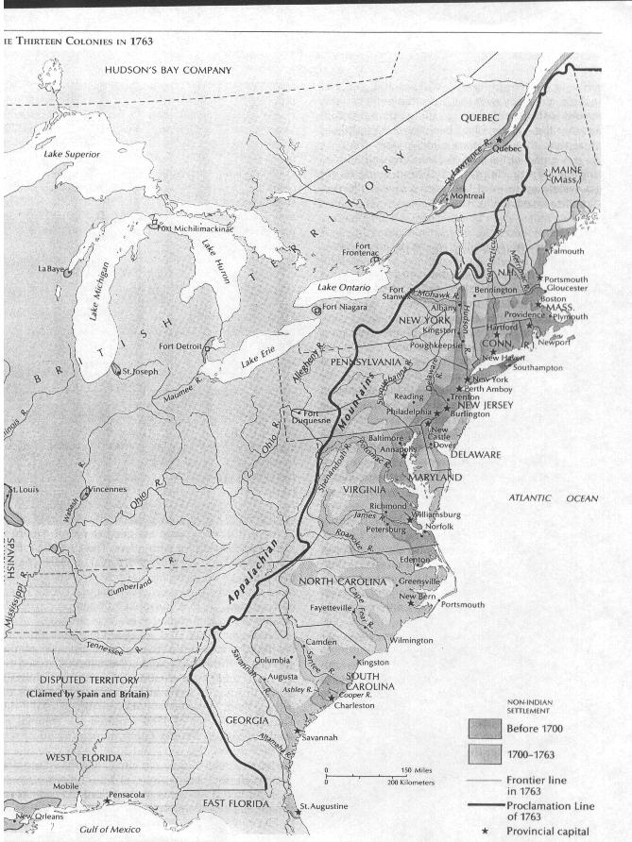

Document I
State Claims to Western Lands and Cessions to National Government, 1782 - (C) 1995 --McGraw-Hill, Inc.
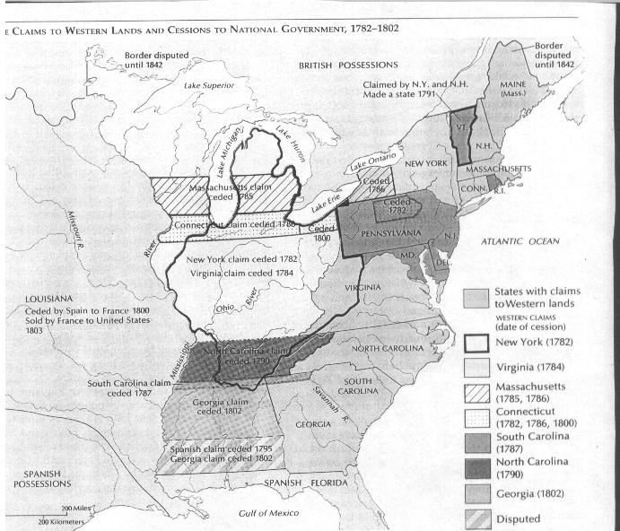

SAMPLE ESSAY
A revolution is an event that forever changes the life and politics of a certain people. These revolutions often have different degrees that they go to, from little change at all to very radical. The Revolutionary War that occurred in the United States is an example of a revolution that was very radical. This war forever altered the social, political, and economic structure of the colonies, illustrating how radical the revolution really was. The American Revolution was actually a very radical revolution that completely changed all aspects of society.
The Revolutionary War was a social revolution because the colonies began to see themselves as interdependent rather than being subject to the will of the British government. The historian Gordon Wood said "The Revolution resembles the breaking of a dam, releasing thousands upon thousands of pent up pressures. There had been seepage and flow before the Revolution, but suddenly it was as if the whole traditional structure, enfeebled and brittle to begin with, broke apart, and people and their energies were set loose in an unprecedented outburst." This completely changed all of the social culture that had existed before the revolution. It altered the complete structure of the relationship between England and America, illustrating how radical the revolution really was. For example in Thomas Paine’s Common Sense he used the metaphor of a satellite that was no more fit to rule the sun than England was to rule the American continent. It didn’t make sense to the people that such a small country like Britain would be controlling them when they were so much larger and so far away. Most of the governors that were in charge of America had never even set foot on the continent. Patrick Henry made an important statement when he said "The war is inevitable--and let it come! I repeat it, sir, let it come!" He is saying that breaking from England is a natural course to follow. The colonists were just obeying human nature in their wants to be independent and self-ruling. For the first time in history the colonists began to think for themselves and unite as one power and stand up against English rule.
The colonists were tired of being used by Britain for monetary gain. They were ready to make major changes in their economic system. This was evident in the engraving of the Boston Massacre done by Paul Revere. The colonists chaffed under the constant array of acts, such as the Stamp Act and the Sugar Act, and went to do the customs houses to protest their oppression. This showed how badly they wanted to change what they considered the unjust taxation that Britain had forced upon them. Another open revolt based on economics was the Boston Tea Party. This was caused solely by what the colonists saw as a tax used only to save an English company. Another example of how greatly the economy was altered was the huge change in the borders of the colonies. Previously, Britain had limited how far the colonists could expand. With the end of the revolution, the colonists rapidly began to expand westward, not stopping until they reached another ocean to hem them in. This change in borders completely altered the entire economy of the colonies. It allowed them much greater land to farm in and also helped their population expand. Not only that, it was a complete break from the Proclamation of 1763 which had set the western border on the colonies. The Boston Massacre and the rapid expansion of the colonies illustrate how much the colonists chaffed under England’s rule and how radical the economic revolution in America really was.
The government of the colonies was also completely altered after the revolution. The complete alteration of the form of government can be seen in Galloway’s Plan of Union. Previously, the colonists had absolutely no say in the election of the Parliament that ruled them. They now had formed a plan that called for the open election of their own ruling body, one that would not be affected by the Parliament in England. This illustrates what a complete reversal the governing style that the colonists had gone through. Another example of the political change that the colonists experienced were the resolves passed by the First Continental Congress. This departure from previous governing style can be seen when the Congress said, "The several Acts which impose duties for the purpose of raising a revenue in America, extend powers of the admiralty courts beyond their ancient limits, deprive the American subject of trial by jury, authorize the judges’ certificate to indemnify the prosecutor from damages that he might otherwise be liable to, requiring oppressive security from a claimant ships and goods seized before he shall be allowed to defend his property; and are subversive of American rights." The colonists also feared the power of Parliament as was stated in the Declaration of the Causes and Necessity of Taking up Arms. This said that there had to be some limiting of the power that the government could hold over an individual. These complete departures from the previous governing style that England had used illustrate how radical the political revolution that occurred in America really was.
The structure of America was forever changed by the Revolutionary War. This was exemplified socially by things like Thomas Paine’s Common Sense, and the radicalism of Patrick Henry. The desire for economic change was illustrated by The Boston Massacre and the Boston Tea Party. And the change in political life was demonstrated by things like Galloway’s Plan of Union, and the resolves of the First Continental Congress. The revolution in America was actually very radical, with their belief that "you can’t let the tail wag the dog."
http://www.belleville.k12.wi.us/bhs/history/Sample%20DBQ%20-%20American%20Revolution.doc

Sample DBQ – 2
To what extent and in what ways was the year 1763 a turning point in American History?
Document 1
Declaration of the Rights of the Stamp Act Congress
October 19, 1765
DECLARATION OF RIGHTS
The members of this congress, sincerely devoted, with the warmest sentiments of affection and duty to His Majesty's person and government, inviolably attached to the present happy establishment of the Protestant succession, and with minds deeply impressed by a sense of the present and impending misfortunes of the British colonies on this continent; having considered as maturely as time would permit, the circumstances of said colonies, esteem it our indispensable duty to make the following declarations, of our humble opinions, respecting the most essential rights and liberties of the colonists, and of the grievances under which they labor, by reason of several late acts of Parliament.
1st. That His Majesty's subjects in these colonies owe the same allegiance to the crown of Great Britain that is owing from his subjects born within the realm, and all due subordination to that august body, the Parliament of Great Britain.
2d. That His Majesty's liege subjects in these colonies are entitled to all the inherent rights and privileges of his natural born subjects within the kingdom of Great Britain.
3d. That it is inseparably essential to the freedom of a people, and the undoubted rights of Englishmen, that no taxes should be imposed on them, but with their own consent, given personally, or by their representatives.
4th. That the people of these colonies are not, and from their local circumstances cannot be, represented in the House of Commons in Great Britain.
5th. That the only representatives of the people of these colonies are persons chosen therein, by themselves; and that no taxes ever have been or can be constitutionally imposed on them but by their respective legislatures.
6th. That all supplies to the crown, being free gifts of the people, it is unreasonable and inconsistent with the principles and spirit of the British constitution for the people of Great Britain to grant to His Majesty the property of the colonists.
7th. That trial by jury is the inherent and invaluable right of every British subject in these colonies.
8th. That the late act of Parliament entitled, "An act for granting and applying certain stamp duties, and other duties in the British colonies and plantations in America, etc.," by imposing taxes on the inhabitants of these colonies, and the said act, and several other acts, by extending the jurisdiction of the courts of admiralty beyond its ancient limits, have a manifest tendency to subvert the rights and liberties of the colonists.
9th. That the duties imposed by several late acts of Parliament, from the peculiar circumstances of these colonies, will be extremely burthensome and grievous, and, from the scarcity of specie, the payment of them absolutely impracticable.
10th. That as the profits of the trade of these colonies ultimately center in Great Britain, to pay for the manufactures which they are obliged to take from thence, they eventually contribute very largely to all supplies granted there to the crown.
11th. That the restrictions imposed by several late acts of Parliament on the trade of these colonies will render them unable to purchase the manufactures of Great Britain.
12th. That the increase, prosperity, and happiness of these colonies depend on the full and free enjoyment of their rights and liberties, and an intercourse, with Great Britain, mutually affectionate and advantageous.
13th. That it is the right of the British subjects in these colonies to petition the king or either house of Parliament.
Lastly, That it is the indispensable duty of these colonies to the best of sovereigns, to the mother-country, and to themselves, to endeavor, by a loyal and dutiful address to His Majesty, and humble application to both houses of Parliament, to procure the repeal of the act for granting and applying certain stamp duties, of all clauses of any other acts of Parliament whereby the jurisdiction of the admiralty is extended as aforesaid, and of the other late acts for the restriction of the American

Document 2
Virginia Stamp Act Resolutions
May 30, 1765
Virginia Stamp Act Resolutions
The following four resolves were adopted by the House of Burgesses on May 30, 1765:
Resolved, that the first adventurers and settlers of His Majesty's colony and dominion of Virginia brought with them and transmitted to their posterity, and all other His Majesty's subjects since inhabiting in this His Majesty's said colony, all the liberties, privileges, franchises, and immunities that have at any time been held, enjoyed, and possessed by the people of Great Britain.
Resolved, that by two royal charters, granted by King James I, the colonists aforesaid are declared entitled to all liberties, privileges, and immunities of denizens and natural subjects to all intents and purposes as if they had been abiding and born within the Realm of England.
Resolved, that the taxation of the people by themselves, or by persons chosen by themselves to represent them, who can only know what taxes the people are able to bear, or the easiest method of raising them, and must themselves be affected by every tax laid on the people, is the only security against a burdensome taxation, and the distinguishing characteristic of British freedom, without which the ancient constitution cannot exist.
Resolved, that His Majesty's liege people of this his most ancient and loyal colony have without interruption enjoyed the inestimable right of being governed by such laws, respecting their internal policy and taxation, as are derived from their own consent, with the approbation of their sovereign, or his substitute; and that the same has never been forfeited or yielded up, but has been constantly recognized by the kings and people of Great Britain.

Document 3
October 7, 1763
By THE KING. A PROCLAMATION (excerpts)GEORGE R.
And whereas it will greatly contribute to the speedy settling of our said new Governments, that our loving Subjects should be informed of our Paternal care, for the security of the Liberties and Properties of those who are and shall become Inhabitants thereof, We have thought fit to publish and declare, by this Our Proclamation, that We have, in the Letters Patent under our Great Seal of Great Britain, by which the said Governments are constituted. given express Power and Direction to our Governors of our Said Colonies respectively, that so soon as the state and circumstances of the said Colonies will admit thereof, they shall, with the Advice and Consent of the Members of our Council, summon and call General Assemblies within the said Governments respectively, in such Manner and Form as is used and directed in those Colonies and Provinces in America which are under our immediate Government: And We have also given Power to the said Governors, with the consent of our Said Councils, and the Representatives of the People so to be summoned as aforesaid, to make, constitute, and ordain Laws. Statutes, and Ordinances for the Public Peace, Welfare, and good Government of our said Colonies, and of the People and Inhabitants thereof, as near as may be agreeable to the Laws of England, and under such Regulations and Restrictions as are used in other Colonies; and in the mean Time, and until such Assemblies can be called as aforesaid, all Persons Inhabiting in or resorting to our Said Colonies may confide in our Royal Protection for the Enjoyment of the Benefit of the Laws of our Realm of England; for which Purpose We have given Power under our Great Seal to the Governors of our said Colonies respectively to erect and constitute, with the Advice of our said Councils respectively, Courts of Judicature and public Justice within our Said Colonies for hearing and determining all Causes, as well Criminal as Civil, according to Law and Equity, and as near as may be agreeable to the Laws of England, with Liberty to all Persons who may think themselves aggrieved by the Sentences of such Courts, in all Civil Cases. to appeal, under the usual Limitations and Restrictions, to Us in our Privy Council.
And whereas it is just and reasonable, and essential to our Interest, and the Security of our Colonies, that the several Nations or Tribes of Indians with whom We are connected, and who live under our Protection, should not be molested or disturbed in the Possession of such Parts of Our Dominions and Territories as, not having been ceded to or purchased by Us, are reserved to them. or any of them, as their Hunting Grounds.--We do therefore, with the Advice of our Privy Council, declare it to be our Royal Will and Pleasure. that no Governor or Commander in Chief in any of our Colonies of Quebec, East Florida. or West Florida, do presume, upon any Pretence whatever, to grant Warrants of Survey, or pass any Patents for Lands beyond the Bounds of their respective Governments. as described in their Commissions: as also that no Governor or Commander in Chief in any of our other Colonies or Plantations in America do presume for the present, and until our further Pleasure be known, to grant Warrants of Survey, or pass Patents for any Lands beyond the Heads or Sources of any of the Rivers which fall into the Atlantic Ocean from the West and North West, or upon any Lands whatever, which, not having been ceded to or purchased by Us as aforesaid, are reserved to the said Indians, or any of them.
And We do further declare it to be Our Royal Will and Pleasure, for the present as aforesaid, to reserve under our Sovereignty, Protection, and Dominion, for the use of the said Indians, all the Lands and Territories not included within the Limits of Our said Three new Governments, or within the Limits of the Territory granted to the Hudson's Bay Company, as also all the Lands and Territories lying to the Westward of the Sources of the Rivers which fall into the Sea from the West and North West as aforesaid.
And We do hereby strictly forbid, on Pain of our Displeasure, all our loving Subjects from making any Purchases or Settlements whatever, or taking Possession of any of the Lands above reserved. without our especial leave and Licence for that Purpose first obtained.
And. We do further strictly enjoin and require all Persons whatever who have either willfully or inadvertently seated themselves upon any Lands within the Countries above described. or upon any other Lands which, not having been ceded to or purchased by Us, are still reserved to the said Indians as aforesaid, forthwith to remove themselves from such Settlements.
And whereas great Frauds and Abuses have been committed in purchasing Lands of the Indians, to the great Prejudice of our Interests. and to the great Dissatisfaction of the said Indians: In order, therefore, to prevent such Irregularities for the future, and to the end that the Indians may be convinced of our Justice and determined Resolution to remove all reasonable Cause of Discontent, We do. with the Advice of our Privy Council strictly enjoin and require. that no private Person do presume to make any purchase from the said Indians of any Lands reserved to the said Indians, within those parts of our Colonies where, We have thought proper to allow Settlement: but that. if at any Time any of the Said Indians should be inclined to dispose of the said Lands, the same shall be Purchased only for Us, in our Name, at some public Meeting or Assembly of the said Indians, to be held for that Purpose by the Governor or Commander in Chief of our Colony respectively within which they shall lie: and in case they shall lie within the limits of any Proprietary Government. they shall be purchased only for the Use and in the name of such Proprietaries, conformable to such Directions and Instructions as We or they shall think proper to give for that Purpose: And we do. by the Advice of our Privy Council, declare and enjoin, that the Trade with the said Indians shall be free and open to all our Subjects whatever. provided that every Person who may incline to Trade with the said Indians do take out a Licence for carrying on such Trade from the Governor or Commander in Chief of any of our Colonies respectively where such Person shall reside. and also give Security to observe such Regulations as We shall at any Time think fit. by ourselves or by our Commissaries to be appointed for this Purpose, to direct and appoint for the Benefit of the said Trade:

Document 4
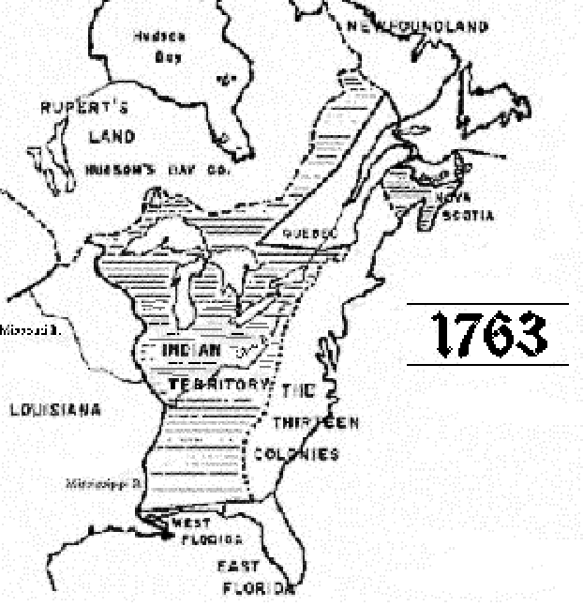

Document 5
Governor Glen,The Role of the Indians in the Rivalry Between France, Spain, and England, 1761 (excerpts)
The Situation, Strength, and Connections of the several Nations of Neighbouring Indians; the Hostilities they have committed on British Subjects, at the Instigation of the French, and lately upon those Instigators themselves; some Particulars relating to the French Forts, Forces and Proceedings in Louisiana and Mississippi.
The concerns of this Country are so closely connected and interwoven with Indian Affairs, and not only a great branch of our trade, but even the Safety of this Province, do so much depend upon our continuing in Friendship with the Indians, that I thought it highly necessary to gain all the knowledge I could of them.
However I think it expedient upon the present Occasion to give a general Account of the several Tribes and Nations of Indians with whom the Inhabitants of this Province are or may be connected in Interest: which is the more necessary as all we have to apprehend from the French in this part of the world, will much more depend upon the Indians than upon any Strength of their own; for that is so inconsiderable in itself, and so far distant from us that without Indian Assistance, it cannot if exerted, do us much harm.
The people of most experience in the affairs of this Country, have always dreaded a French war; from an apprehension that an Indian war would be the consequence of it; for which reasons, I have ever since the first breaking out of the war with France, redoubled my Attention to Indian Affairs: and I hope, not without Success.
This powerful Engine, which the French for many years past, played against us and our Indians, even in times of Peace, is now happily turned against themselves, and I believe they feel the force of it.
I shall be particularly cautious of doing any thing inconsistent with the peace so lately concluded: but I think it incumbent on me to say, that it will be impossible to retain those Indians, or any other, in his Majesty's interest unless we continue to trade with them.
And since war and hunting are the business of the lives, both Arms and Ammunition as well as Cloaths other necessaries, are the goods for which there is the greatest demand among them-I therefore hope to receive instructions in this particular, as a rule of my conduct.
However, this, and even the Tranquility of South Carolina will depend upon preserving our Interest with the Indians, which it will be very difficult to do, unless the presents are continued to them, and those Forts built which I have formerly proposed, or at least, one of them, and that to be in the Country of the Cherokees....

Document 6
Proclamation of Rebellion, August 23, 1775
Whereas many of our subjects in divers parts of our Colonies and Plantations in North America, misled by dangerous and ill designing men, and forgetting the allegiance which they owe to the power that has protected and supported them; after various disorderly acts committed in disturbance of the publick peace, to the obstruction of lawful commerce, and to the oppression of our loyal subjects carrying on the same; have at length proceeded to open and avowed rebellion, by arraying themselves in a hostile manner, to withstand the execution of the law, and traitorously preparing, ordering and levying war against us: And whereas, there is reason to apprehend that such rebellion hath been much promoted and encouraged by the traitorous correspondence, counsels and comfort of divers wicked and desperate persons within this realm: To the end therefore, that none of our subjects may neglect or violate their duty through ignorance thereof, or through any doubt of the protection which the law will afford to their loyalty and zeal, we have thought fit, by and with the advice of our Privy Council, to issue our Royal Proclamation, hereby declaring, that not only all our Officers, civil and military, are obliged to exert their utmost endeavours to suppress such rebellion, and to bring the traitors to justice, but that all our subjects of this Realm, and the dominions thereunto belonging, are bound by law to be aiding and assisting in the suppression of such rebellion, and to disclose and make known all traitorous conspiracies and attempts against us our crown and dignity; and we do accordingly strictly charge and command all our Officers, as well civil as military, and all others our obedient and loyal subjects, to use their utmost endeavours to withstand and suppress such rebellion, and to disclose and make known all treasons and traitorous conspiracies which they shall know to be against us, our crown and dignity; and for that purpose, that they transmit to one of our principal Secretaries of State, or other proper officer, due and full information of all persons who shall be found carrying on correspondence with, or in any manner or degree aiding or abetting the persons now in open arms and rebellion against our Government, within any of our Colonies and Plantations in North America, in order to bring to condign punishment the authors, perpetrators, and abetters of such traitorous designs.
GOD save the KING.

Document 7
Memoir on the English Aggression
French Document, October 1750
The restoration of peace has in no wise diverted the English from their constant design to get possession of all the commerce of America. It is only necessary to consider their actual conduct to be convinced of this truth.
No doubt Spain has good proof on its side. France's is but too certain, both from the publicly professed plans of the English and from the difficulties their commissaries are daily making in the settlement of the disputes of the two nations in America.
England, not content with having already encroached on the lands of France on the side of Hudson Bay, and with pushing its settlements in Acadia on the mainland of New France at the Bay of Fundy, despite the boundaries assigned that country by the Treaty of Utrecht, now plans the invasion of Florida and Louisiana.
It is true the English have already encroached on those provinces, but they have not hitherto pushed their claims to the extravagant extent revealed by the map just published at London, on which, under pretence of correcting one of our recent geographers, they extend their boundaries into Spanish Florida in such fashion as to seat themselves on waters flowing into the Gulf of Mexico.
As to Louisiana, they claim to extend their boundaries over all the lands of the Indians friendly to France as far as the Alabamas; they partially recompense Spain for what they took from Florida at the expense of Louisiana. Although this map is not made by express order of the government, it is well known to be by authority.
However there is no doubt that the English have no justification for such enterprises which have long been no secret. They wish to be in a position to invade Florida, and by that conquest, along with their possession of the Isle of Providence in the Bahamas, to make themselves masters of the outlet of the Bahama Channel, and as a result of the treasure of Europe.
To carry out this plan more easily they seek to put it out of the power of the French of Louisiana to give aid to the Spanish as formerly, and as they will never fail to do in all attempts of the English to work their hurt. In this they can best succeed by seeking to cut the communication of the French of Louisiana with New France and Florida; but is not the common danger resulting to France and Spain a warning to the two powers to concert measures as soon as possible that will insure the failure of this pernicious design? The king on his side is ready to enter into all the measures His Catholic Majesty may think most proper to protect himself from the ambitious projects of a nation with no other aim than to subjugate all the others by seizing on their colonies and their commerce, and which terms that the "balance of Europe."

Document 8
The Boston Gazette Describes the Boston Massacre, 1770
On the evening of Monday, being the fifth current, several soldiers of the 29th Regiment were seen parading the streets with their drawn cutlasses and bayonets, abusing and wounding numbers of the inhabitants.
A few minutes after nine o'clock four youths, named Edward Archbald, William Merchant, Francis Archbald, and John Leech, jun., came down Cornhill together, and separating at Doctor Loring's corner, the two former were passing the narrow alley leading to Murray's barrack in which was a solider brandishing a broad sword of an uncommon size against the walls, out of which he struck fire plentifully. A person of mean countenance armed with a large cudgel bore him company. Edward Archbald admonished Mr. Merchant to take care of the sword, on which the solider turned round and struck Archbald on the arm, then pushed at Merchant and pierced through his clothes inside the arm close to the armpit and grazed the skin. Merchant then struck the soldier with a short stick he had; and the other person ran to the barrack and brought with him two soldiers, one armed with a pair of tongs, the other with a shovel. He with the tongs pursued Archbald back through the alley, collared and laid him over the head with the tongs. The noise brought people together; and John Hicks, a young lad, coming up, knocked the soldier down but let him get up again; and more lads gathering, drove them back to the barrack where the boys stood some time as it were to keep them in. In less than a minute ten or twelve of them came out with drawn cutlasses, clubs, and bayonets and set upon the unarmed boys and young folk who stood them a little while but, finding the inequality of their equipment, dispersed. On hearing the noise, one Samuel Atwood came up to see what was the matter; and entering the alley from dock square, heard the latter part of the combat; and when the boys had dispersed he met the ten or twelve soldiers aforesaid rushing down the alley towards the square and asked them if they intended to murder people? They answered Yes, by G-d, root and branch! With that one of them struck Mr. Atwood with a club which was repeated by another; and being unarmed, he turned to go off and received a wound on the left .shoulder which reached the bone and gave him much pain. Retreating a few steps, Mr. Atwood met two officers and said, gentlemen, what is the matter? They answered, you'll see by and by. Immediately after, those heroes appeared in the square, asking where were the boogers? where were the cowards? But notwithstanding their fierceness to naked men, one of them advanced towards a youth who had a split of a raw stave in his hand and said, damn them, here is one of asking him why he fired without orders, I was struck with a club on my arm, which for some time deprived me of the use of it, which blow had it been placed on my head, most probably would have destroyed me. On this a general attack was made on the men by a great number of heavy clubs and snowballs being thrown at them, by which all our lives were in imminent danger, some persons at the same time from behind calling out, damn your bloods--why don't you fire. Instantly three or four of the soldiers fired, one after another, and directly after three more in the same confusion and hurry.... On my asking the soldiers why they fired without orders, they said they heard the word fire and supposed it came from me. This might be the case as many of the mob called out fire, fire, but I assured the men that I gave no such order; that my words were, don't fire, stop your firing. In short, it was scarcely possible for the soldiers to know who said fire, or don't fire, or stop your firing.

Document 9
John Holt's Account of the Stamp Act Riots in New York, 1765
The Matter was intended to be done privately, but it got wind, and by ten o Clock I suppose 2000 people attended at the Coffee House, among them most of the principal men in Town--The Culprits apologies did not satisfy the people, they were highly blamed and the Sons of Liberty found it necessary to use their Influence to moderate the Resentments of the People. Two Men were dispatch'd to the Collector for the Stamp'd Bonds of which he had 30 in all, he desired Liberty to confer with the Governor, which was granted. The Governor sent Word, it the Stamps were deliver'd to him, he would give his Word and Honour they should not be used; but that if the people were not satisfied with this, they might do as they pleased with them--The message being returned to the gathering Multitude, they would not agree to the Governors Proposal, but insisted upon the Stamps being deliver'd and burnt, one or two men attended by about a thousand others were then sent for the Stamps, which were brought to the Coffee House, and the Merchant who had used them was order'd himself to kindle the Fire and consume them, those filled in and all, this was accordingly done amidst the Huzza's of the people who were by this Time swell'd to the Number I suppose of about 5000, and in another hour I suppose would have been 10,000--The people pretty quietly dispersed soon After, but their Resentment was not allay'd, Toward the Evening... tho' the Sons of Liberty exerted themselves to the utmost, they could not prevent the gathering of the Multitude, who went to Mr. Williams's house, broke open the Door and destroyed some of the Furniture ....

SAMPLE ESSAY
The people were generally satisfied and soon dispersed--but many of those of inferior Sort, who delight in mischief merely for its own sake, or for plunder, seem yet to be in such a turbulent Disposition that the two mortified Gentlemen are still in some Danger, but the Sons of Liberty intend to Exert themselves in their Defense.
While there are many influential years in American history, it is rare to have a dramatic turning point. A turning point is a time in which the policies and events of that year cause a radical change in the feelings and views of the people. Such is the case with the year 1763. 1763 was a dramatic turning point in American history because it was a time that in which the British substantially changed their colonial policy, planting the seeds of rebellion in the hearts of colonists.
British colonial policy prior to 1763 was controlled by the salutary neglect. Salutary neglect is the idea set forth by Great Britain’s first prime minister, Robert Walpole. It stated that the colonies were only for commercial reasons, and thus trade restrictions and taxes would just hinder growth. The French wrote in Memoir of English Aggression, "The restoration of peace has in no wise diverted the English from their constant design to get possession of all the commerce of America." The colonies were allowed freedom in exchange for production. Another significant difference before 1763 compared to after it is the western border. From the beginning when the king offered deeds to certain companies, they did not have a western border. This allowed colonists to move as far west as they dared. Unfortunately, in the early 1760s during the French and Indian War, the British learned the importance of keeping settlers out in order to maintain good relations with the Indians. Governor Glen wrote "The concerns of this Country are so closely connected and interwoven with Indian Affairs, and not only a great branch of our trade, but even the Safety of this Province, do so much depend upon our continuing in Friendship with the Indians." These policies that allowed the colonists to rule themselves, tax themselves, and set there own western boundaries were popular with the colonists.
Events in 1763 significantly changed these policies. In 1763, the French and Indian War ended with a victory for the British. In the Treaty of Paris, the French gave up most of their colonies to the British. In the Royal Proclamation of 1763, the British put forth a new ideal, "And We do further declare it to be Our Royal Will and Pleasure, for the present as aforesaid, to reserve under our Sovereignty, Protection, and Dominion, for the use of the said Indians, all the Lands and Territories not included within the Limits of Our said Three new Governments, or within the Limits of the Territory granted to the Hudson's Bay Company, as also all the Lands and Territories lying to the Westward of the Sources of the Rivers which fall into the Sea from the West and North West as aforesaid." This western boundary set limits on the colonists in order to keep good Indian relations. In 1763, Prime Minister Grenville was also came to power. He took a different stance then his predecessors. Rather then support the idea of salutary neglect, he decided to tax the colonists. In 1764, he issued the Stamp Act. These events seriously and permanently changed the colonists opinion of the British.
The events of 1763 directly led to the revolution that would occur in subsequent years. Before this time the people did not care about being under English rule. Now, they formed new organizations to protect their liberty. The Stamp Act Congress was formed to directly combat the Stamp Act. In a resolution passed in 1765, they declared, "That it is inseparably essential to the freedom of a people, and the undoubted rights of Englishmen, that no taxes should be imposed on them, but with their own consent, given personally, or by their representatives." In Virginia, the Stamp Act Resolutions concurred with this statement, "Resolved, that the taxation of the people by themselves, or by persons chosen by themselves to represent them, who can only know what taxes the people are able to bear, or the easiest method of raising them, and must themselves be affected by every tax laid on the people, is the only security against a burdensome taxation, and the distinguishing characteristic of British freedom, without which the ancient constitution cannot exist." Not only did people bear the new taxes with written resolutions condemning "taxation without representation", but riots broke out against them as John Holt when he explained "2000 people" tried to get the stamps burned. These type of acts of violence were not uncommon. The policies Grenville had made in his administration were also expanded by his successors. The Townsend Duties were directly fought against because of the success that had come from rebelling against the Stamp Act. The Boston Gazette reported a highly flamboyant story on the Boston Massacre, an example of violence against these Townsend Duties. These uses of propaganda were used to unite the colonists against the British rule. The colonists also rebelled by moving west. This caused the Indians to become angry and later during the Revolutionary War the Native Americans often took the British side because to the promises to get rid of the colonists. The massive effects of the change of policy in 1763 and the violence and protest that followed was directly responsible for the rebellion. The Proclamation on Rebellion gave Officers any and all authority to "suppress the rebellion", however by now it was to late. The policy changes could not be taken back, and neither could the revolution that was short coming.
Before 1763, the colonists and British lived in a cooperative relationship under salutary neglect. With the changes that came that year through the Treaty of Paris and the policies of Prime Minister Grenville, the colonies were permanently altered. The acts and laws that followed were diplomatically and violently rebelled against, and the spirit of malice that spread directly caused the American Revolution that began in 1775 at Lexington and Concord.
http://www.mury.k12.ut.us/MHS/apus/dbq/1999/group9.htm

Sample DBQ - 3
Using your knowledge of the time period AND the documents provided, evaluate the Civil Rights movements of the 1960s and 1970s and their impact on American society.

Document A
Source: National Organization for Women (NOW), Statement of Purpose, 1966
The purpose of NOW is to take action to bring women into full participation in the mainstream of American society now, exercising all the privileges and responsibilities thereof in truly equal partnership with men... We reject the current assumptions that a man must carry the sole burden of supporting himself, his wife, and his family, and that a woman is automatically entitled to lifelong support by a man upon her marriage, or that marriage, home, and family are primarily woman's world and responsibility... We believe that a true partnership between the sexes demands a different concept of marriage, an equitable sharing of the responsibilities of home and children and of the economic burdens of their support... We will strive to ensure that no party, candidate, President, Senator, Governor, Congressman, or any public official who betrays or ignores the principle of full equality between the sexes is elected or appointed to office.

Document B
Source: The Big Lift. Karl Hubenthal, Los Angeles Examiner, March 18, 1965
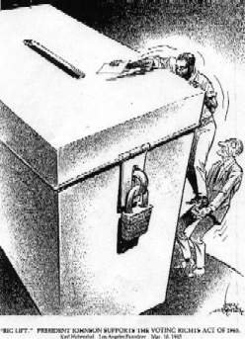

Document C
Source: The Feminine Mystique, Betty Friedan (1963).
The problem lay buried, unspoke, for many years in the minds of American women. It was a strange stirring, a sense of dissatisfaction, a yearning that women suffered in the middle of the twentieth century in the United States. Each suburban wife struggled with it alone. As she made the beds, shopped for groceries, matched slipcover material, ate peanut butter sandwiches with her children, chauffeured Cub Scouts and Brownies, lay beside her husband at night- she was afraid to ask even of herself the silent question- "Is this all?"

Document D
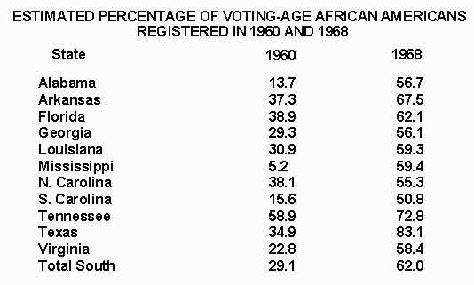

Document E
Source: Tinker V. Des Moines, 1965
In order for the state in the person of school officials to justify prohibition of a particular expression of opinion, it must be able to show that its action was caused by something more than a mere desire to avoid the discomfort and unpleasantness that always accompany an unpopular viewpoint. Certainly where there is no finding and no showing that engaging in the forbidden conduct would "materially and substantially interfere with the requirements of appropriate discipline in the operation of the school", the prohibition cannot be sustained.
It is also relevant that the school authorities did not purport to prohibit the weaning of all symbols of political and controversial significance... Clearly, the prohibition of expression of one particular opinion, at least without evidence that it is necessary to avoid material and substantial interference with schoolwork or discipline, is not constitutional.

Document F
Source: A Symbol of Hope for California's Rural Workers, c. 1960s
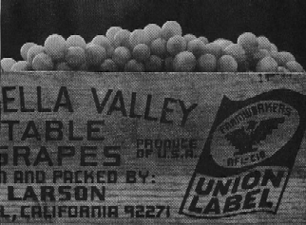

Document G
Source: Michael Abramson, Black Star, Wounded Knee, 1973
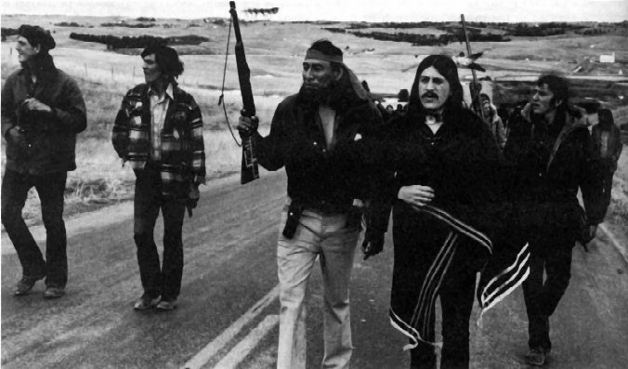

Document H
Source: Black Panther Party Platform (October 1966)
3. We want an end to the robbery by the white man of our Black Community.
We believe that this racist government has robbed us and now we are demanding the overdue debt of forty acres and two mules. Forty acres and two mules were promised 100 years ago as restitution for slave labor and mass murder of black people. We will accept the payment in currency which will be distributed to our many communities. The Germans are now aiding the Jews in Israel for the genocide of Jewish people... The American racist has taken part in the slaughter of over fifty million black people; therefore, we feel that this is a modest demand that we make.
6. We want all black men to be exempt from military service.
We believe that Black people should not be forced to fight in the military service to defend a racist government that does not protect us. We will not fight and kill other people of color in the world who, like black people, are being victimized by the white racist government of America. WE will protect ourselves from the force and violence of the racist police and the racist military, by whatever means necessary.

Essay
The 1960’s were a tumultuous time in American History. Amidst the swirling controversies of this decade were the Civil Rights movements. Several groups that had previously been overlooked by the American Society used these times to fight for their rights. Although more for some than others, the Civil Rights movements generally increased the status of those disregarded groups.
By far African Americans were the most prominent and successful group during the civil rights movements. There were extremist groups such as Malcolm X’s "Nation of Islam" and the Black Panther party, whose demands went to such extremes as seeking to "exempt blacks from military service." (Doc H) However, these groups were the exception, not the norm, and at any rate the image of violence they created in the black movement hurt their cause more than they helped it. The much more common- and effective- groups such as the "freedom riders" and those lead by Martin Luther King, Junior, were characterized by their commitment to passive resistance. This method allowed these groups to enlist the aide of government authorities in their cause; for example, the aid given by President Johnson regarding the Civil Rights Act of 1965, better known as the Voting Rights act (Doc. B). As can be seen by the substantial increase of registered African-American voters from 1960 to 1968 (Doc D), the African-American Civil Rights movement was a resounding success.
Another prominent group in the fight for rights were the women. The women’s rights movement was spearheaded by such women as Betty Friedan, the leader and founder of the National Organization for Women (NOW) and the author of the Feminine Mystique. In that book, Friedan stated that the women simply wanted more from life than to "chauffeur brownies and Cub Scouts" (Doc C). These women worked to get the passage of such legislation as the Equal Pay Act of 1963, which guaranteed equal pay to women, and Title VII of the Civil rights Act, which promised legal protection similar to that promised to the African-Americans. Although overshadowed by the African-American rights movement, the women’s Civil Rights activists still accomplished a great deal.
There were also several other groups during this decade that fought for their rights. Cesar Chavez was the leader of the United Farm Workers (UFW), which demanded recognition of their union and increased benefits. By 1970, half of California’s table grape growers signed contracts with the UFW (Doc F.) An especially notable group were the Native Americans. The American Indian Movement (AIM) was founded in 1968 by a group of young militant Indians. Later that year, congress passed the Indian Civil Rights Act which guaranteed reservation Indians to many of the rights guaranteed to other citizens under the Bill of Rights. There was also a 1973 seizure of the town of Wounded Knee, in which the raiders demanded changes in the Administration of the reservations (Doc G). Even more effective, however, were the results of later Supreme Court cases such as US v. Wheeler and County of Oneida v. the Oneida Indian Nation. A third movement was conducted by students across the nation, who fought for Freedom of Speech. In the Tinker v. Des Moines case, the Supreme Court ruled that a student’s right to free speech could not be infringed (Doc E). These, and other groups, though not as prominent, still enjoyed varying degrees of success in their movements.
The 1960’s proved to be a groundbreaking decade for Civil Rights activists. Many minority groups cleared preverbal hurdles that had stood in their way for many years. These rapid changes showed to be a great boon for the status of these groups in American Society.

http://www.mury.k12.ut.us/MHS/apus/dbq/2001/default.htm

