Name___________________ Per____ Date___________
Chapter 17 Notes The Rock Record
Rocks Record Earth History
Rocks record __________________ events and changing life forms of the past.
We have learned that Earth is much _____________ than anyone had previously imagined and that its surface and interior have been changed by the same geological _____________________ that continue today.
A Brief History of Geology
Uniformitarianism means that the ______________ and processes that we observe ________________ have been at work for a very ___________ time.
- This theory was proposed by a Scottish physician and farmer named _______________________________
- Before Hutton’s work most people thought that the earth was only about ____________________________ years old
- Geologists now estimate the earth to be about ______ billion years old.
Relative Dating—Key Principles
Relative dating tells us the ____________________ in which events occurred, not how long ago they occurred.
The _______________________________________ states that in an undeformed sequence of sedimentary rocks, each bed is _________ than the one _________________ it and ___________________ than the one ____________ it.
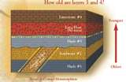
The principle of original horizontality means that layers of ___________________ are generally deposited in a ______________________ position.
Disturbed Rock Layers
With disturbed rock layers due to ________________movements this law cannot be easily applied
Clues:
1. _____________ _________ in sedimentary rock
- largest particles are in the _______________ layer
- study or particle size may reveal whether the
layer has been __________________ (upside down etc.)
2. ______________ ___________ should lie with their peaks turned up
3. Principle of Cross-Cutting Relationships
The principle of cross-cutting relationships states that when a _________ cuts
through rock layers, or when magma intrudes other rocks and crystallizes, we
can assume that the ________________or ______________________ is
______________________than the rocks affected.
4. Inclusions
- _________________are rocks contained ____________ other rocks
- Rocks containing inclusions are ______________ than the inclusions they contain.

Relative Dating—Key Principles
Unconformities
An unconformity represents a long period during which ________________ stopped, __________________ removed previously formed rocks, and then deposition _____________________.
Three types of unconformities
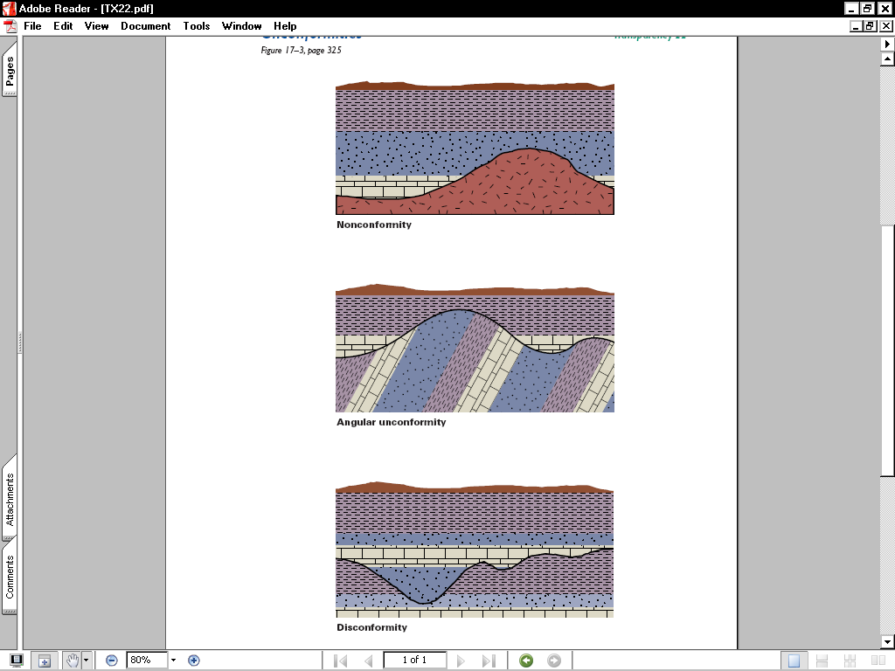
1. An ____________ unconformity indicates that during the pause in deposition, a period of deformation (folding or tilting) and erosion occurred

2. . A ______________________ is when the erosional surface separates older metamorphic or intrusive igneous rocks from younger sedimentary rocks
3. A ________________________ is when two sedimentary rock layers are separated by an erosional surface

Correlation of Rock Layers
Correlation is establishing the ____________________ of rocks of ____________________ age in different areas.
17.3 Fossils: Evidence of Past Life
Fossils are the ____________________ or ___________________ of prehistoric life. They are important components of ____________________ and ________________________rocks.
The type of fossil that is formed is determined by the ___________________ under which an organism ___________ and how it was _________________.

Unaltered remains
Some remains of organisms—such as ____________, ________________, and ______________—may not have been altered, or may have changed hardly at all over time.
_____________ Remains
The remains of an organism are likely to be changed over time.
Fossils often become ________________or turned to stone
____________ and _______________ are another common type of fossil. (empty cavities behind)
______________________ (imprints)is particularly effective in preserving leaves and delicate animals. It occurs when an organism is buried under fine sediment .
Indirect Evidence
______________ _______________ are indirect evidence of prehistoric life.
Conditions Favoring Preservation
Two conditions are important for preservation: ______________
_______________ and the possession of _____________ parts.
Three kinds of fossil remains
1. _________________ of Organisms
2. Petrification
3. ____________ of Organisms
Preservation of Organisms
- ___________________ – preserved by drying- there is no decay because bacteria cannot survive without __________________(desert climates)
- _____________ - hardened tree sap preserves many insects- even DNA has been recovered from amber
- ________________ – thick petroleum oozing to the surface preserves the remains of animals that get trapped
(La Brea Tar Pits in Southern California
- _________________ – bacteria cannot survive freezing temperatures.(need bacteria for decomposition)
Process of Petrification
- Mineral solutions such as __________________ remove the original ______________________ materials and replace them with petrifying materials such as ____________, _______________, and ___________.
- This process takes a long time and results in the nearly perfect _______________replica of the original organism (____________ or ___________________)
Traces of Organisms
- ____________ ___________ – footprints hardened into sedimentary rock
- Imprints, Molds and Casts
Imprints – ______________ imprints of leaves, stems, flowers ,fish
Molds – shells of snails leave empty __________________
Casts – ___________ or __________ filled mold
- _______________ - fossilized dung or _____________ materials or _________________of worms, snails or crabs
- ________________ –stones in dinosaurs __________________ systems (just like chickens)

Fossils and Correlation
The principle of fossil succession states that fossil organisms succeed one another in a __________________ and determinable order. Therefore, any ____________ ______________ can be recognized by its fossil content.
_________________ fossils are widespread geographically, are limited to a ______________ span of geologic time, and occur in _____________ numbers
Interpreting Environments
Fossils can also be used to ______________ and _____________ ancient environments.

17.2 Determining Absolute Age
- Rates of _____________ and __________________
- only practical with geologic features formed within the past ____________ to
20,000 years (only a rough estimate)
- determine the ____________ at which erosion is taking place you can give an
approximate date to features
- estimate the ____________ __________ of deposition for limestone, shale
and sandstone (what about flood rates?)
- Varve Count
- some sedimentary layers show definite _________ layers( like tree rings)
-A varve consists of a light colored band of __________ particles
and a dark colored band of _____________ particles ( glacial lakes)
Basic Atomic Structures
Orbiting the nucleus are ___________, which are negative electrical charges.
Atomic number is the number of _____________ in the atom’s nucleus.
Mass number is the number of _______________plus the number of _______________ in an atom’s nucleus.

Dating With Radioactivity

Radioactivity is the spontaneous _____________ of certain unstable atomic nuclei.
A half-life is the amount of time necessary for ______-_________of the nuclei in a sample to decay to a stable isotope

Radiometric Dating
Each radioactive isotope has been decaying at a _________________ rate since the formation of the rocks in which it occurs.
Radiometric dating is the procedure of calculating the ___________________ ages of rocks and minerals that contain ___________________ isotopes.
As a radioactive isotope decays, atoms of the ______________ product are formed and accumulate.
An accurate radiometric date can be obtained only if the mineral remained in a __________________ system during the entire period since its formation.

Dating with Carbon-14
__________________ dating is the method for determining age by comparing the amount of ______________ to the amount of _______________ in a sample.
When an organism dies, the amount of carbon-14 it contains gradually _______________ as it decays. By comparing the ___________ of carbon-14 to carbon-12 in a sample, radiocarbon dates can be determined.
Importance of Radiometric Dating
Radiometric dating has supported the ideas of _________ ____________, Charles Darwin, and others who inferred that geologic time must be ________________.

