Name___________________ Per_____ Date________

Chapter 18
A View of Earth’s Past
18.1 The Geologic Time Scale
Structure of the Time Scale
- Based on their interpretations of the __________record, geologists have divided Earth’s 4.56-billion-year history into _________ that represent specific amounts of time. Taken together, these time spans make up the ____________ time scale.
- ____________ represent the greatest expanses of time. Eons are divided into ________. Each era is subdivided into ___________. Finally, periods are divided into smaller units called ____________.
- There are three eras within the Phanerozoic eon:
1. ____________, which means “ancient life”
2. ____________, which means “middle life”
3. ____________, which means “recent life”

- Each __________within an era is characterized by somewhat less profound changes in life forms as compared with the changes that occur during an ________.
- The periods of the Cenozoic era are divided into still smaller units called ___________, during which even less profound changes in life forms occur.
- During ______________ time, there were fewer life forms. These life forms are more difficult to identify and the rocks have been disturbed often.
Difficulties With the Geologic Time Scale
- A sedimentary rock may contain particles that contain ________________ isotopes, but these particles are ____ the same ________ as the rock in which they occur.
- The age of a particular _______________ in a metamorphic rock does ____ necessarily represent the _______ when the rock was first formed. Instead, the date may indicate when the rock was _____________________.
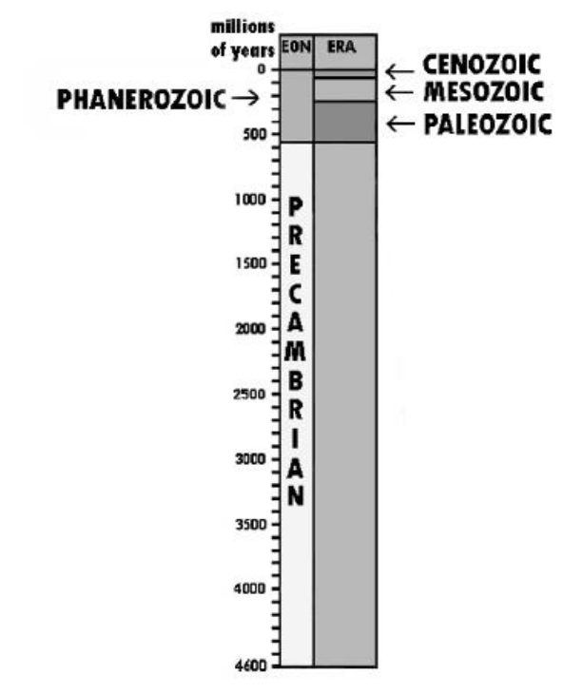
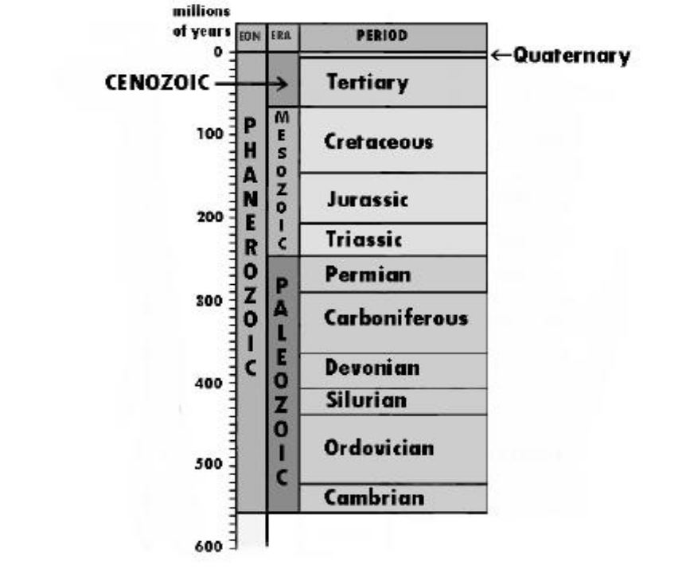
QUESTIONS
1. How was the geologic column developed?

2. What are the three main divisions of geologic time?

3. Why is the geologic column useful to earth scientists?

Historical Geology : A Glimpse of the Earth’s Past
(video)

18.2 Geologic History
Precambrian Time: Vast and Puzzling
The ________________ encompasses immense geological time, from Earth’s distant beginnings 4.56 billion years ago until the start of the Cambrian period, over _______________ years later.
Precambrian Rocks
_______________ are large, relatively flat expanses of ancient __________________ rock within the stable continental interior.
Much of what we know about Precambrian rocks comes from ________ mined from shields.

Earth’s Atmosphere Evolves
Earth’s original ________________ was made up of gases similar to those released in volcanic eruptions today—water vapor, carbon dioxide, __________________, and several trace gases, but ____ ________.
Later, primary plants evolved that used __________________ and released oxygen.
Oxygen began to accumulate in the atmosphere about ______ ______________years ago.
Precambrian Fossils
The most common Precambrian fossils are _____________________.
Stromatolites are distinctively layered mounds or columns of _____________ ______________. They are not the remains of actual organisms but are the material deposited by _____________.
Many of these ancient fossils are preserved in ___________—a hard dense _________________ sedimentary rock.
Early Paleozoic (Cambrian, Ordovician, Silurian Periods)
Following the long Precambrian, the most recent 540 million years of Earth’s history are divided into three _____________: Paleozoic, Mesozoic, and Cenozoic
Early Paleozoic History
During the Cambrian, Ordovician, and Silurian periods, the vast southern continent of __________________ encompassed ___________ continents (South America, Africa, Australia, Antarctica, and part of Asia).
Early Paleozoic Life
Life in early Paleozoic time was restricted to the _____________.

Late Plaeozoic
Late Paleozoic History (Devonian, Carboniferous, Permian Periods)
_______________ is the continental mass that formed the northern portion of Pangaea, consisting of present-day _____________ _____________and ____________
By the end of the Paleozoic, all the continents had fused into the supercontinent of ________________.
Late Paleozoic Life
Some _________ million years ago, plants that had adapted to survive at the water’s edge began to move _________, becoming ________ plants.
The _______________ rapidly diversified because they had minimal competition from other land dwellers.
The Great Paleozoic Extinction
The world’s climate became very _______________, probably causing the dramatic ______________ of many species
The late Paleozoic extinction was the ______________ of at least ___________ mass extinctions to occur over the past 500 million years
Mesozoic Era (Triassic, Jurassic, Cretaceous Periods) (Age of Reptiles)
___________________ were land-dwelling ________________ that thrived during the Mesozoic era. (Jurassic Period)
Mesozoic History
A major event of the Mesozoic era was the _______________ of Pangaea.
Mesozoic Life
Gymnosperms are _____________-bearing plants that do not depend on free-standing __________ for fertilization.
The _________________ quickly became the dominant plants of the Mesozoic era.
Canadian Rockies are formed throughout the Cretaceous (last part of Mesozoic)
The Shelled Egg
Unlike amphibians, _____________ have shell-covered eggs that can be laid on the __________.
The elimination of a ____________ - _____________ stage (like the _____________ stage in frogs) was an important evolutionary ___________.
_____________ Dominate
With the perfection of the shelled egg, ________________ quickly became the ______________ land animals.
At the end of the Mesozoic era, many reptile groups became ________________. (end of the Cretaceous)
Cenozoic North America (Tertiary, Quaternary Periods) (Age of mammals)
The Cenozoic era is divided into ______periods of very unequal duration, the ____________ period and the _______________ period.
Plate interactions during the Cenozoic era caused many events of _______________ building, ______________, and ____________________ in the West.
Cenozoic Life
Mammals—animals that bear _____________ young and maintain a _________________body temperature— replaced reptiles as the ________________ land animals in the Cenozoic era.
Angiosperms—____________________ plants with covered seeds—replaced _____________________ as the dominant land ____________.
Mammals Replace Reptiles
Adaptations like being ___________ blooded, developing insulating body _____________, and having more efficient _______________ and ______________ allow mammals to lead more ___________ lives than reptiles.
Large Mammals and Extinction
In North America, the __________________ and ______________, both huge relatives of the ______________, became extinct. In addition, saber-toothed cats, giant ____________, large ground _____________, horses, camels, giant _______________, and others died out on the North American continent.
The reason for this recent wave of extinctions ____________ scientists.

Paleozoic Era (six periods) (means “ancient life”)
Cambrian Period (marine invertebrates) (540 mya)
__________________
___________________
Ordovician Period (primitive fish) vertebrates (490 mya)
_________________ (bony plated fish)
No ____________ __________ on land
Silurian Period (marine vertebrates and invertebrates) (443 mya)
__________________
Earliest _________plants and animals such as
_____________and ___________________
Devonian Period (Age of Fishes)(417 mya)
__________ fish
Ichthyostega (first true ____________)
Land plants such as giant horsetails, ferns and
________bearing plants
Carboniferous Period (Mississippian 354 mya, Pennsylvanian 323 mya)
__________ and ___________ cover much of the land
_________ formation begins
______________ and ________ thrive
Crinoids (relative of modern ______ ______) thrive
__________ appear at the end of this period
Permian Period (290 mya)
Mass ____________ of numerous life forms
______________ Mountains form
______________ become extinct
_______________comes together
The Mesozoic Era (three periods)
Triassic Period ( 248 mya)
_____________ (Terrible Lizards)
Ranged in size from small squirrel to 30 ________ long
_________________
____________ (shellfish similar to the nautilus)
1st ______________ appear
Jurassic Period (206 mya)
Apatosaurus, Stegosaurus, pterosaurs(________ reptiles)
First ________ appear
Cretaceous Period
______________ Rex
______________ (flowering plants)
Mass ____________ of the ______________
The Cenozoic Era (The Age of Mammals)(two periods)
Tertiary Period (65 mya until 5.3 mya)
Paleocene and Eocene Epochs
_______________
Hyracotherium (ancestor of the ____________)
Flying ___________, bats, ____________
Oligocene and Miocene Epochs (golden age of Mammals)
__________ known land animals existed at this time
Raccoons, wolves, foxes, __________ toothed cat
Modern polar _____ ______ began to form
Pliocene Epoch
Bear, dog, cat became fully evolved
______________ ice sheets began to spread
Bering ________ bridge appeared as sea levels fell
Quaternary Period (1.8 mya – 0.011 mya)
Pleistocene Epoch
_____________ over Eurasia and North America
Large mammal ____________ as humans entered the
Holocene Epoch
_____ ____ ends, sea levels rise 140 meters
Great _______ form
Humans developed ________________.

