Chapter 23 The Atmosphere Name________________ Per____
23.1 Characteristics of the Atmosphere
Composition of the Atmosphere
- Nitrogen - ______
- Oxygen - ______
- Argon - _________
- Water Vapor – _________
- Carbon Dioxide - _________
- Other gases make up the rest
- gases are different now compared to the ____________ earth’s atmosphere
- early atmosphere was developed by the _____________ of volcanoes
- composition of gas in a volcanic eruption
50% ____________ ___________
CARBON DIOXIDE AND SULFUR GASES
______ FREE OXYGEN
- So where did free oxygen come from? we think….
1. the breakup of ___________molecules in the upper atmosphere
2. when simple green __________ appeared they gave us free oxygen by
________________________
- Oxygen is ____________by
-animals, bacteria and plants _______________ oxygen as part of their life
processes
-forest fires, burning fossil fuels, weathering of rocks
- Oxygen is __________________by
- land and ocean plants through ______________________
- Oxygen- Carbon dioxide remains balanced

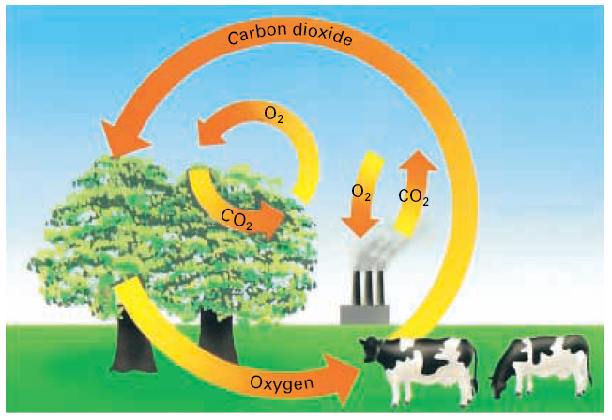
Nitrogen in the Atmosphere
- Nitrogen taken from the air by nitrogen ______________bacteria (make nitrogen compounds used by plants)
- Denitrification (taking nitrogen from dead organisms or waste products) _________________ nitrogen into atmosphere again
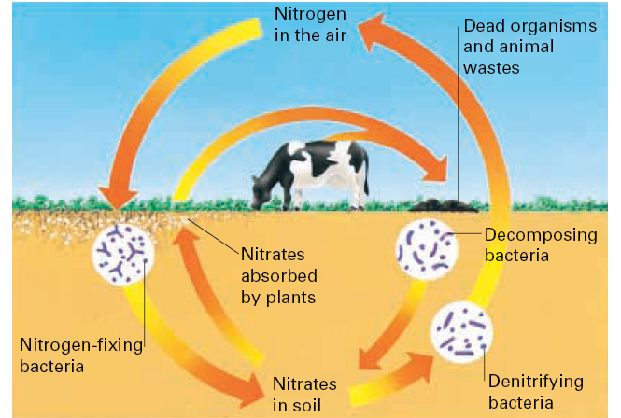
Atmospheric Pressure
Air Pressure- is the force caused by weight of the air.
- The _____________ air above an area, the greater the amount of air ____________on that area.
Air pressure _________________with _________________.
- Due to the pull of ________________ 99 % of the total mass of atmospheric gases is found within _______ km of earth’s surface
Measuring Atmospheric pressure
- Mercurial Barometer- atmospheric pressure presses on the liquid _______________in a well at the base of the barometer.
- The greater the atmospheric pressure the __________________ the mercury rises
- Standard atmospheric pressure or ______ mm of mercury(1 atmosphere ) is the _____________ atmospheric pressure at _____ level
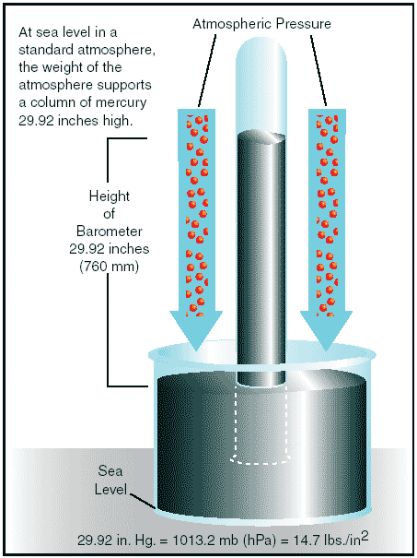

- Aneroid Barometer (means “without ____________”) sealed metal container from which the ____________has been removed
- When the pressure increases the sides bend ________________
- When the pressure decreases the sides ______________ out again
- Measured by the movement of the pointer along the _________________

Layers of the Atmosphere
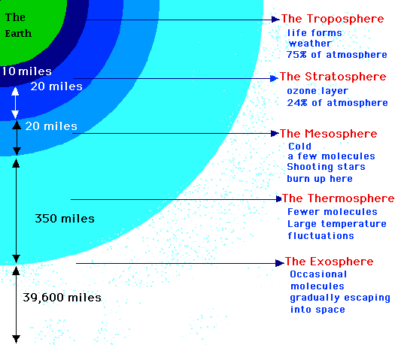
Troposphere – (greek word meaning change)
- All weather __________ occurs here
- Water ________ and carbon _____________ found here
- Temperature _________ by 6.5 degrees C/km until 10 km then remains ___________ in the tropopause (upper boundary of the troposphere)
- Tropopause has an ______________ of 17 km at ___________ and 6 - 8 km at the _____________
Stratosphere – extends to an altitude of 50 km.
- All of the __________ concentrated here
- At its base it is -60 degrees C but it is _____________ as altitude increases at the ozone layer
- Stratopause has the ______________ temperature of the stratosphere
Thermosphere –temperature increases with altitude
- No real __________ boundary
- Very ________ air
- Temps of more than ______________ degrees C
- Lower region is the ionosphere which reflects _________ waves back to earth
- Ionosphere blends into the _________________ and then the vacuum of interplanetary _____________
Air Pollution
- Main source –_____________ fossil fuels ( sulfur dioxide, carbon monoxide, lead, and hydrocarbons
- Acid precipitation – gases combine with ________ in the air
- __________ air can trap polluted cool air (temperature inversion) Los Angeles has frequent temperature _______________
- Mountains can _____________ the occurrence of temperature inversions

Exploring Weather: The Atmosphere in Motion

1. The sun’s heat reaches Earth through _____.
A) radiation B) conduction
C) convection D) solar wind

2. The most abundant gas in the atmosphere is_____.
A) oxygen B) helium
C) nitrogen D) water vapor

3. The THICKEST layer of the atmosphere is the stratosphere.
A) true B) false

4. As air heats up, it rises, allowing cold air to flow in from elsewhere. This causes _____.
A) a wind B) a front C) a thunderstorm D) a frost

5. During the water cycle, some moisture enters the atmosphere through the release of water vapor by plants. This process is called_____.
A) transpiration B) evaporation C) precipitation D) condensation

6. A specific volume of warm air weighs less than an equal volume of cold air because_____.
A) warm air is less dense B) cold air is full of moisture
C) warm air forms over the ocean D) cold air is under higher pressure

7. The Coriolis effect is caused by_____.
A) the rotation of Earth on its axis B) the revolution of the Earth around the Sun
C) the gravitational pull between the Earth and Moon
D) the difference in density between warm and cold air

8. Which of the following fronts is MOST OFTEN associated with steady rain that lasts a day or more?
A) a cold front B) a warm front C) a stationary front D) an occluded front

23.2 Solar Energy and the Atmosphere
Radiation
- Energy reaching the earth from the sun is in the form of _________________ waves
- All _____________ wavelengths are absorbed in the upper atmosphere (X rays, gamma rays, UV rays)
- UV rays act upon _____________ molecules to form ozone
- Longer wavelengths – most _________ gets through and most _______________ is absorbed by carbon dioxide, water vapor and other molecules in the troposphere
Scattering
- Clouds, __________ and ____________ molecules affect the path of radiation from the sun causing _________________
- Reflecting and ______________ the rays in all directions
- This is what makes the sky appear ___________ and makes the ______ appear __________ at sunrise and sunset
- Short wavelength rays such as _____________ are scattered more easily – the sun is __________ because the blue is scattered
Reflection
Solar energy reaching the earth
- _______ absorbed by atmosphere
- ______ scattered into space or reflected from clouds or the earth’s surface
- ______ absorbed by the surface
- Albedo – fraction of solar radiation reflected by a particular surface
Earth’s = _________ moon’s =____________
(30% reflected) ( 7% reflected)
- Infrared and visible light pass through the atmosphere and _________ materials that _____________ them
(Soils, desert, grass, forest,water)
- 50 % of the solar energy that strikes the top of the atmosphere reaches the earth’s surface and is ________________

Greenhouse Effect
- The greenhouse effect is the ____________ of Earth’s surface and atmosphere from solar radiation being _______________ and _____________ by the atmosphere, mainly by water vapor and carbon dioxide.
- Carbon dioxide _______________ infrared rays very effectively (burning fossil fuels leads to more carbon dioxide in the atmosphere)
Variations in Temperature
Factors that affect temperature from the sun’s energy
- __________ (higher at equator, lower at the poles)
- _____________ (thin air in high elevations cannot trap
heat – less water vapor and carbon dioxide)
- _____________ - temperature of water changes less than air so regions close to bodies of water have more moderate temperatures
- ________ ____________ – winds off the ocean have more moderate temperatures than winds blowing from land
- Tilt of the Earth’s Axis

Conduction and Convection
- ______________ is the transfer of heat through matter by molecular activity.
- ______________ is the transfer of heat by mass movement or circulation within a substance.

- Hot air is less __________ and exerts less _______________
- Atmospheric pressure is ____________ under a warm air mass
- Cool air moves into regions of ____________ pressure
- These pressure differences due to unequal heating causing ______________, creating ________________
Questions
- What type of solar radiation causes sunburn?

- Why is the atmospheric pressure lower beneath a mass of warm air than beneath a mass of cold air?

3. You decide not to be outside during the warmest hours of a warm
summer day. When will the warmest hours probably be?
23.3 Winds: Global Winds

- Earth receives more solar energy at the ______________than at the poles so there is a belt of _______ pressure at the equator and __________ pressure at poles
- These pressure differences cause the air to _________ from the poles to the equator and there is a _____________ flow to the poles

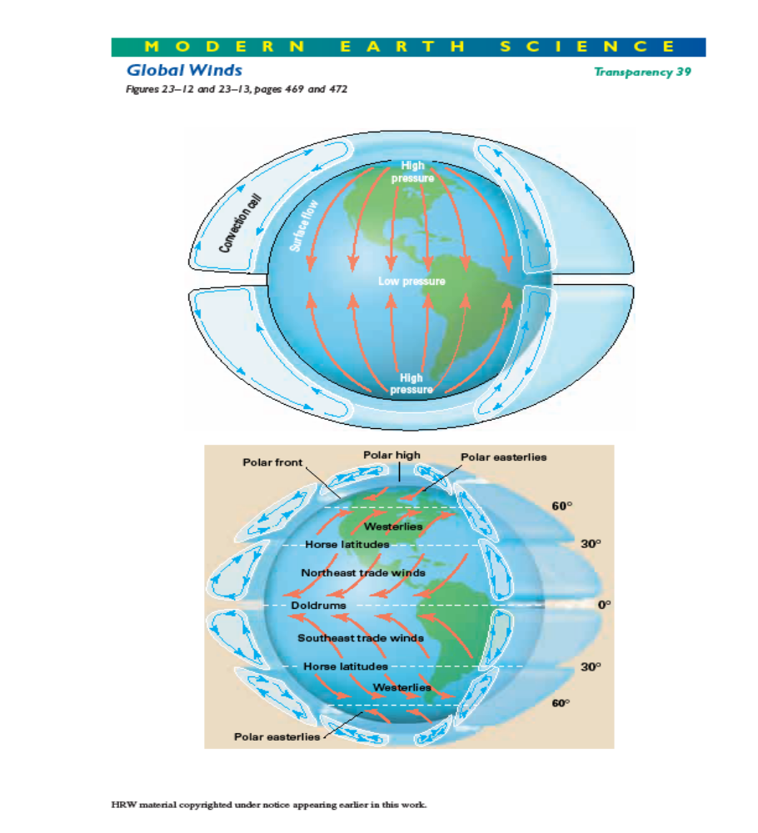

Corealis Effect
- The _______________ of the earth on its axis causes surface winds in the Northern Hemisphere to be deflected to the ____________ and those in the Southern Hemisphere to be deflected to the ______________
- Northern and Southern Hemispheres each have three convection cells at _____degrees, _____ degrees and at the ___________
Global Winds
- Trade Winds – the winds in both hemispheres flowing toward the equator between 30 degrees and 0 degrees latitude
Northern Hemisphere the flow ________ the ____________
(northeast trades) they flow to the _____________
Southern Hemisphere they flow __________ the ________________
(southeast trades) they flow to the _____________
Doldrums –where the trade winds systems meet at the equator (_________)
Horse Latitudes – belt of high pressure in the vicinity of 30 degrees
latitude created by descending air (_________)
- Westerlies – located in a belt between 40 degrees and 60 degrees latitude
Northern Hemisphere – ______________ winds
Southern Hemisphere – _______________winds

- Polar Easterlies – wind belt that exists near each of the earth’s poles
flows to the east due to the corealis effect
- Wind and Pressure Shifts
when the sun’s vertical rays shift _______________and _______________
during the year the position of the pressure belts and wind belts also shift (about
10 degrees of latitude)
- Jet Streams
- exist in the ____________ troposphere and ___________ stratosphere
-10 - 15 km in altitude, 100 feet wide and 2-3 km thick

Heat, Wind and Pressure video
Questions
1. Air is strong enough to hold up a person.
A) true B) false
2. What kind of weather should you expect when the air pressure is HIGH?
A) rainy B) icy C) sunny D) humid
3. What do we call a light wind?
A) A light wind is called a gale. B) A light wind is called a gust.
C) A light wind is called vortex. D) A light wind is called breeze.
4. What happens to air when it is heated by the sun?
A) It glows. B) It rises. C) It shrinks. D) It burns.
5. What happens when a body of cold air meets a body of warm air?
A) The warm air rises and the cold air sinks. B) The cold air rises and the warm air sinks.
C) Both the cold air and the warm air rise. D) Both the cold air and the warm air sink.
6. How high in the atmosphere is the jetstream?
A) 6 miles B) 16 miles C) 26 miles D) 60 miles
7. In which direction does wind blow?
A) Wind blows from areas without trees to areas with trees.
B) Wind blows from areas with trees to areas without trees.
C) Wind blows from areas with low pressure to areas with high pressure.
D) Wind blows from areas with high pressure to areas with low pressure.
Local Winds
Breezes – gentle winds extending over distances of less than 100 km
Land and Sea Breezes – land heats up faster than water
_____________ – cool wind blowing from water to land
_____________ – flows from cooler land to warmer water
Mountain and Valley Breezes (mountains cool quicker)
daylight (____________breeze) – warm air from valleys moving up slope
night (______________ breeze) – cool air descends from mountain peaks

Questions
- What are the results of the Coriolis effect on wind flow?

- What surface wind belt flows in the middle latitudes?

- On a camping trip on the Oregon coast, you decide to hike to the ocean, but you are not sure of the direction. The time is 4:00 P.M.
How might the breeze help you find the ocean?

Why?

