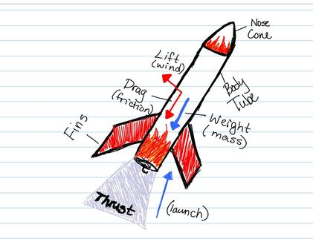

SOUTHWESTERN CHRISTIAN SCHOOL

EARTH SCIENCE

Rockets - Model Rockets 2013

LEARNING OBJECTIVES

- STUDENTS WILL BE ABLE TO IDENTIFY AND DEFINE THE PARTS OF A MODEL ROCKET

- STUDENTS WILL BE ABLE TO IDENTIFY SIGNIFICANT CONTRIBUTORS , AND THEIR CONTRIBUTIONS , TO UNDERSTAND THE ADVANCEMENTS IN ROCKETRY.

- STUDENTS WILL BE ABLE TO BUILD AND LAUNCH A SERIES ONE MODEL ROCKET WITH ADULT SUPERVISOR.
******************************************************************************
SHORT SUBJECT VIDEO > MODEL ROCKETS 101!

- ROCKETS WERE FIRST DEVELOPED BY THE _____________________ OVER

___________ YEARS AGO.

- IT HAS ONLY BEEN SINCE THE __________ THAT ROCKETS HAVE BEEN PUT TO REGULAR USE, WHEN AMERICAN _____________________________ LAUNCHED THE FIRST _____________ ____________________ ROCKET.

PARTS OF A MODEL ROCKET -

PARTS:

- BODY TUBE

- ENGINE HOLDER ASSEMBLY

- FINS

- LAUNCH LUG

- NOSE CONE

- SHOCK CORD

- RECOVERY SYSTEM

- SHROUD LINES

********************************************************************************
SHORT SUBJECT VIDEO > OUTER SPACE IS OUT THERE!

- AT THE MIRROR YOU CAN ____________________ AND TAKE A

___________________.

- STATION SPACE WALKING SUITES ARE ALSO CALLED _________________.

- THE JAPANESE SECTION OF THE SHUTTLE IS CALLED THE _____________

- THE ___________ SEAT AND THE _______________ SEAT ARE ON THE FLIGHT DECK.

********************************************************************************
SHORT SUBJECT VIDEO > IGNITE THE IMAGINATION!

- THE WAR OF THE WORLDS; WRITTEN BY ____________________ .

- ROBERT GODDARD’S FIRST ROCKET WENT _________________ FEET IN THE

AIR AND __________ __________ FLIGHT.

- AMERICA HAS ALWAYS BEEN _____________ WHEN WE DARED TO BE

_____________.

********************************************************************************

FLIGHT PROFILE :

- THRUST

- LIFT-OFF

- PROPELLANT

- IGNITER

********************************************************************************
SHORT SUBJECT VIDEO > THE WRIGHT WAY!

- IF AT FIRST YOU DO NOT SUCEED _______, __________ AGAIN.

- ON _________________ THEY GOT IT RIGHT AND USHERED IN THE MODERN ERA OF FLIGHT.

- THEY STUDIED BIRDS TO UNDERSTAND THE BASIC CONCEPTS OF FLIGHT

_____________ , ______________ , ____________ , ______________
********************************************************************************

REACHING APOGEE :

- APOGEE

- TIME DELAY

1.

2.

- SMOKE-TRACKING

WHAT GOES UP:
THE EJECTION CHARGE IS ABOVE THE DELAY ELEMENT. IT PRODUCES HOT GASES THAT EXPAND AND BLOW AWAY THE CAP AT THE TOP OF THE ENGINE.

- EJECTION CHARGE

- RECOVERY SYSTEM

- TOUCHDOWN

SHORT SUBJECT VIDEO > WHAT GOES UP

- ASK AN ASTRONAUT WHICH PART IS MOST IMPORTANT AND THEY WILL

PROBABLY SAY THE _________________________

- THERE ARE ALL KINDS OF WAYS TO GET ROCKETS AND ROCKET PARTS

BACK TO EARTH BY _____________________, WITH ________________, EVEN

BY __________________ LIKE AN AIRPLANE.

- THE SHUTTLE ITSELF _____________________ TO A ___________________ LIKE

AN AIRPLANE.

PARTS OF A MODEL ROCKET -

FINS :

FOUR COMMON FIN SHAPES:

FOUR PARTS OF A FIN:

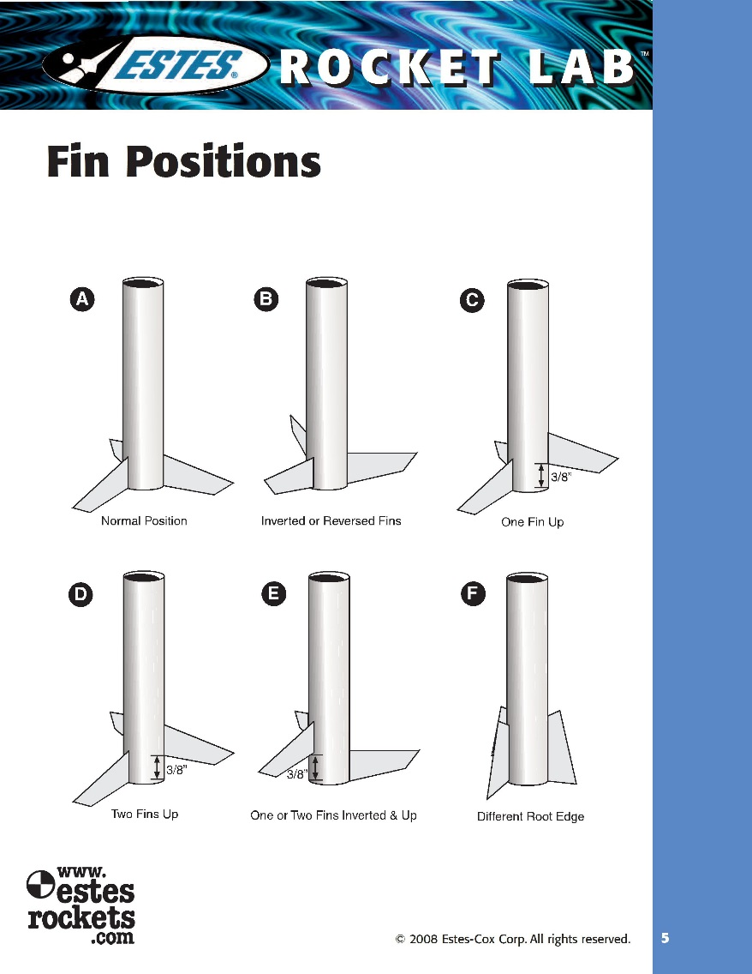

PARTS OF A MODEL ROCKET -

DRAG :

SHAPE OF THE FIN:

-

FIN CHARACTERISTICS SUCH AS:
- TOTAL SURFACE AREA
- TOTAL SPAN
- SWEEP ANGLE

*

HOW ARE YOU GOING TO PLACE YOUR FINS?

SHORT SUBJECT VIDEO > ISAAC NEWTON

- ________________ _______________ APPLIED NEWTONS 3RD LAW, FOR EVER

ACTION THERE IS AN OPPOSITE AND EQUAL ___________________ASK AN

- IN OUTERSPACE THERE IS NO _______________________

NEWTON’S FIRST LAW OF MOTION

OBJECTS AT REST WILL STAY AT REST, AND OBJECTS IN MOTION WILL STAY IN MOTION IN A STRAIGHT LINE UNLESS ACTED UPON BY AN UNBALANCED FORCE.

NEWTON’S SECOND LAW OF MOTION

FORCE IS EQUAL TO MASS TIMES ACCELERATION.

NEWTON’S LAWS OF MOTION PUTTING THEM TOGETHER WITH MODEL ROCKETRY

LAW 1:
AN __________________________FORCE MUST BE EXERTED FOR A ROCKET TO LIFT OFF FROM A LAUNCH PAD.

LAW 2:
THE AMOUNT OF THRUST (FORCE PRODUCED BY A ROCKET ENGINE) WILL BE

DETERMINED BY THE ______________OF ROCKET FUEL THAT IS BURNED AND HOW FAST THE GAS ESCAPES THE ROCKET.

LAW 3:
THE REACTION, OR MOTION, OF THE ROCKET IS EQUAL TO AND IN AN

OPPOSITE DIRECTION FROM THE ______________, OR ______________, FROM THE ENGINE.

