A Level 9231 Further pure mathematics 1
Topic 1.1: Roots of polynomial equations
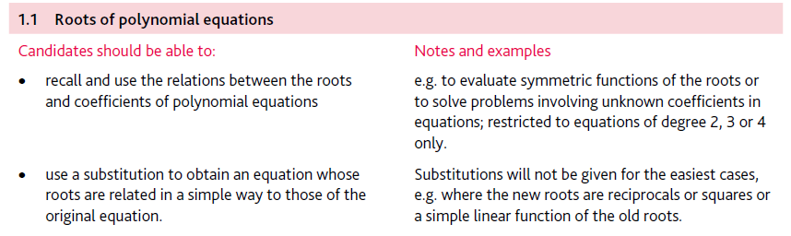
Application | Terminology
Formulae | Algorithms

