A Level 9231 Further pure mathematics 1
Topic 1.2: Rational functions and graphs
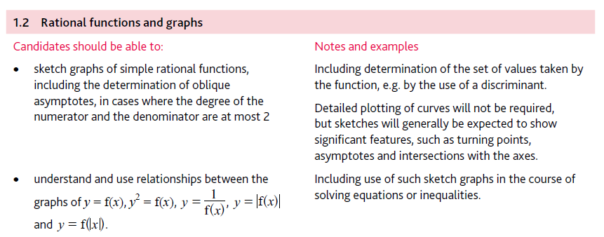
Application | Terminology
Formulae | Algorithms

