A Level 9231 Further pure mathematics 1
Topic 1.3: Summation of series
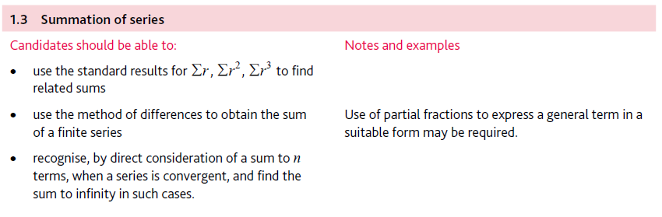
Application | Terminology
Formulae | Algorithms

