A Level 9231 Further pure mathematics 1
Topic 1.5: Polar coordinates
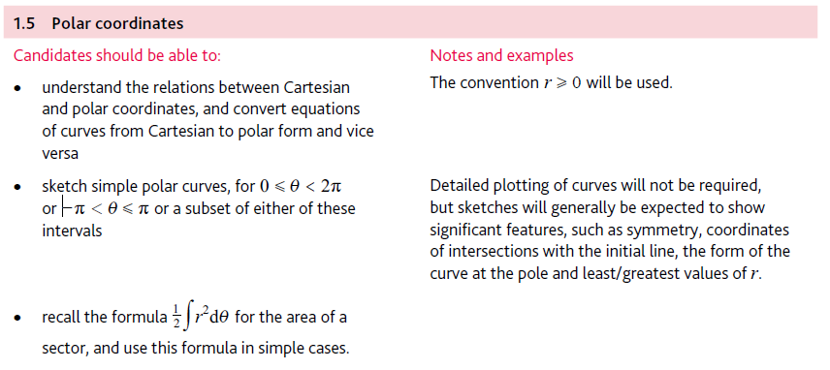
Application | Terminology
Formulae | Algorithms

