9231 2020-2021 WEEKLY PLAN
Teacher:  Thomas |  |  |  | Year/Subject:  12/9231 Further Mathematics |  | Week of:  21/9/2020 |  | Week:  4 | Term:  1
Notes:

Day, P | Unit, Topic, Subtopic | Learning Objectives  Students will be able to: | Activities & Differentiation  Indep’t, Pair, Group, Whole class |  | Evidence/Assessment & Hwk  QA, Disc’n, Obs, Pair/Self, Mark’d |  | Materials &  Resources
1 | Ch. 2 Rational functions  2.3 Inequalities p. 30 | Topic 1.2 Rational functions and graphs: Understand and use relationships between the  graphs of  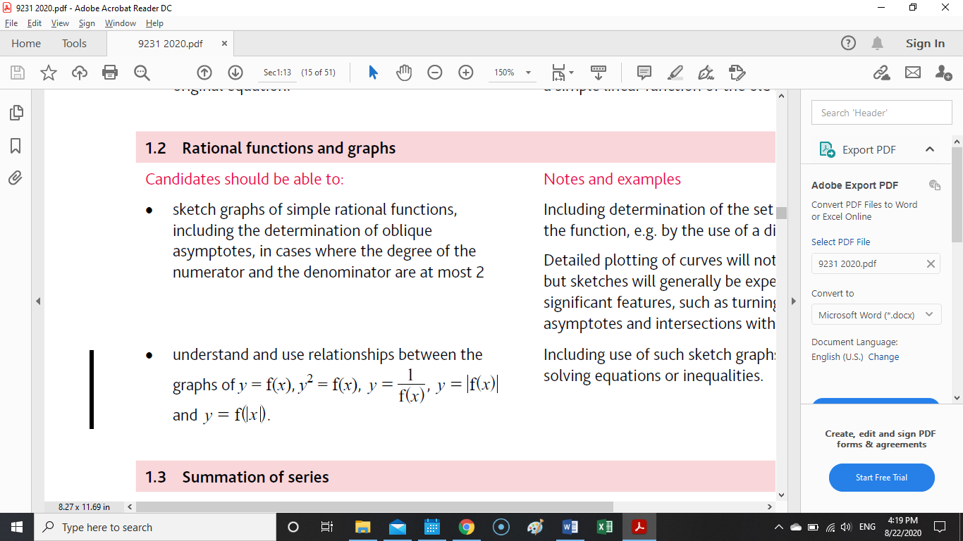  and | Inequalities ALG:  - Sketch curve  - Set ineq to 0, solve for critical values  - Use sketch to ID intervals  Range ALG:  - [p/fractions] differentiate  - y’ = 0, find ys  - small y max large y min  or  - set quad eq w/ys in constants  - discxriminant < 0, excluded ys  - find included ys  - small y max, large y min  y = 1/quad  y = quad/quad; num = 0, no x-int; den = 0, v/asym.s  graph sketch patterns  Ex 2.8, 2.9  2C 1, 2, 5, 8 |  | QA  QA  O,P |  | Textbook
2 | Ch. 2 Rational functions  2.3 Inequalities p. 30 | Topic 1.2 Rational functions and graphs: Understand and use relationships between the  graphs of  and | Ex 2.10  2C 5, 8 |  | QA  O,P |  | Textbook

3 | Ch. 2 Rational functions  2.4 Relationships between curves p. 35 | Topic 1.2 Rational functions and graphs: Understand and use relationships between the  graphs of  and | 1/f(x)  f(x) roots: asymptotes  f(x) y-int: 1/y-int  f(x) w/no roots: no discontinuity  y=|f(x)|: reflect through x-axis  y= f|x|: reflect through y-axis  also reflect asymtotes  reflect x>0 values and keep x>0  disregard x<0 values  y² = f(x) ALG:  - y = f(x)^{1/2}, x: f(x)>=0  - sketch +y, -y  - ID intersections  Ex 2.11  2D 1a | QA  QA  O,P | Textbook
4 | Ch. 2 Rational functions  2.4 Relationships between curves p. 35 | Topic 1.2 Rational functions and graphs: Understand and use relationships between the  graphs of  and | Ex 2.12, 2.13  2D 4, 6a | QA  O,P | Textbook
Reflection and notes:

