A Level 9709 Mechanics
Topic 1: Forces and equilibrium
Outcomes
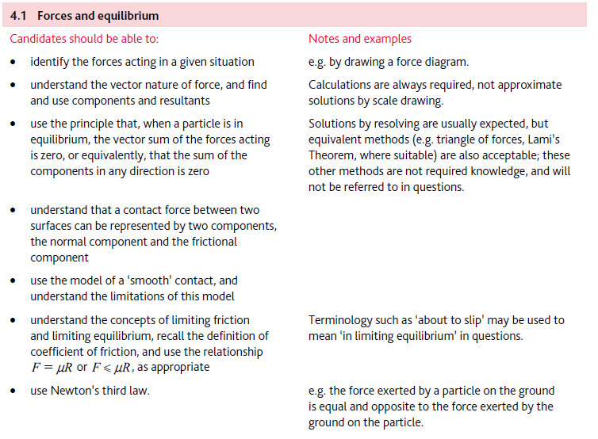
Application | Terminology
Formulae | Algorithms

