A Level 9709 Mechanics
Topic 2: Kinematics of motion in a straight line
Outcomes
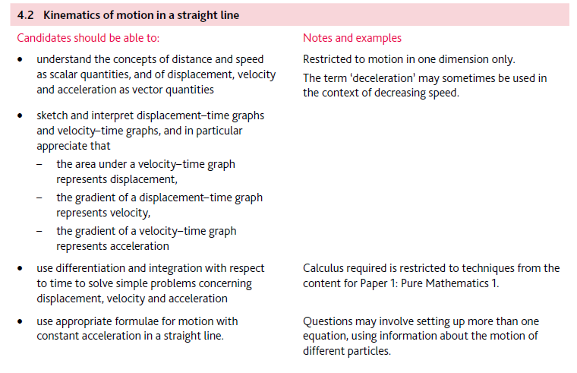
Application | Terminology
Formulae | Algorithms

