A Level 9709 Mechanics
Topic 3: Momentum
Outcomes
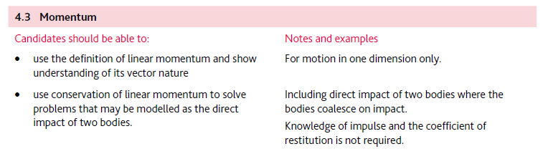
Application | Terminology
Formulae | Algorithms

