A Level 9709 Mechanics
Topic 4: Newton’s laws of motion
Outcomes
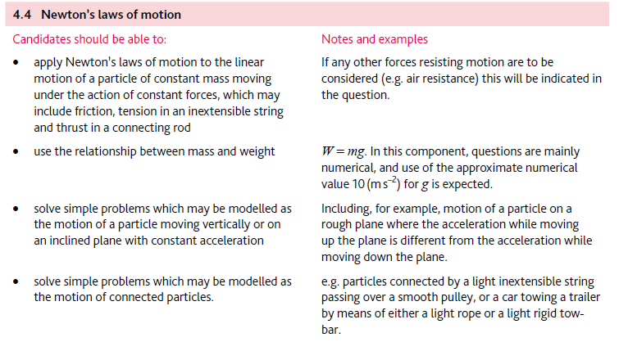
Application | Terminology
Formulae | Algorithms

