A Level 9709 Mechanics
Topic 5: Energy, work and power
Outcomes
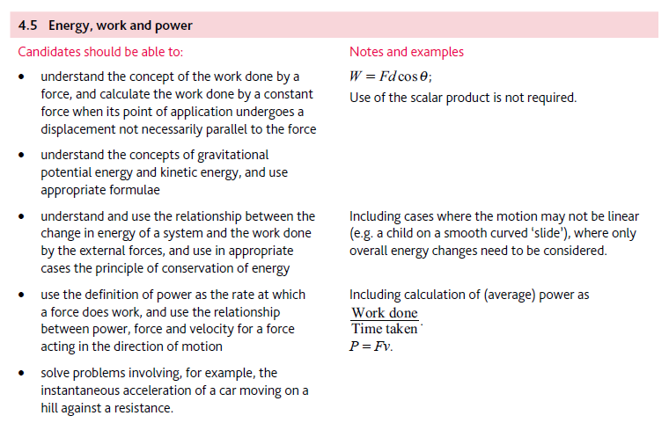
Application | Terminology
Formulae | Algorithms

