A Level 9709 PM 1
Topic 1.2: Functions
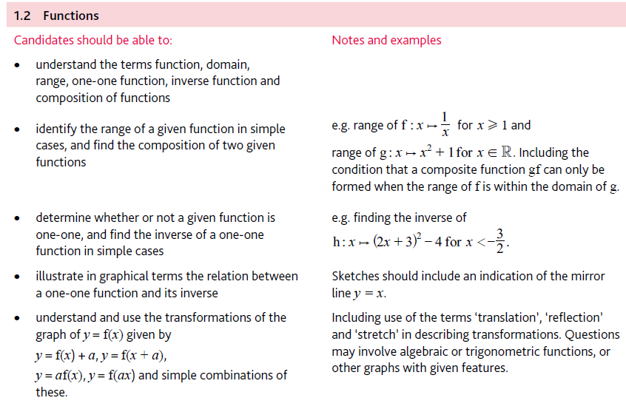
Application | Terminology
Formulae | Algorithms

