A Level 9709 PM 1
Topic 1.3: Coordinate geometry
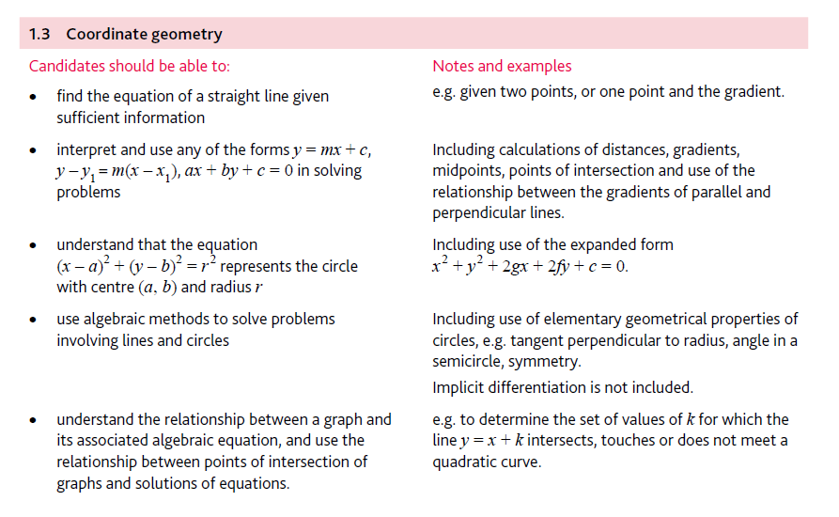
Application | Terminology
Formulae | Algorithms

