A Level 9709 PM 1
Topic 1.4: Circular measure
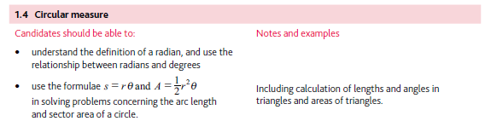
Application | Terminology
Formulae | Algorithms

