A Level 9709 PM 1
Topic 1.7: Differentiation
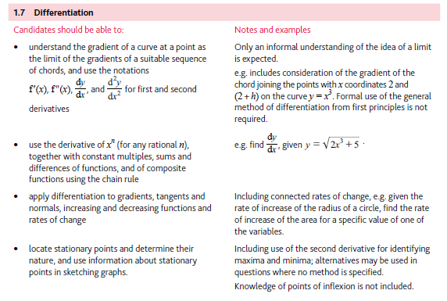
Application | Terminology
Formulae | Algorithms

