A Level 9709 PM 1
Topic 1.8: Integration
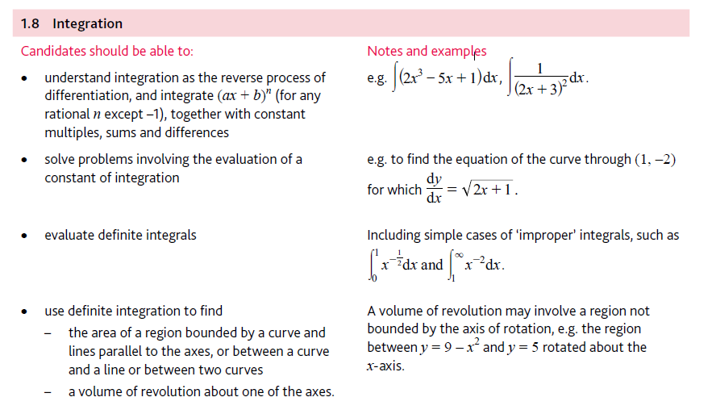
Application | Terminology
Formulae | Algorithms

