A Level 9709 PM 3
Topic 3.1: Algebra
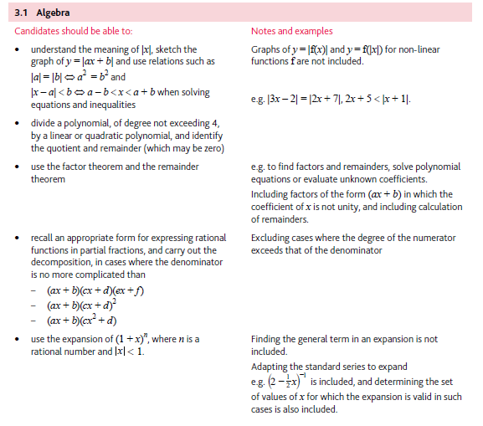
Application | Terminology
Formulae | Algorithms

