A Level 9709 PM 3
Topic 3.2: Logarithmic and exponential functions
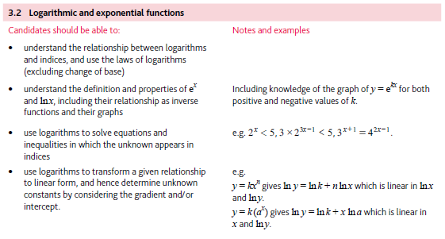
Application | Terminology
Formulae | Algorithms

