A Level 9709 PM 3
Topic 3.4: Differentiation
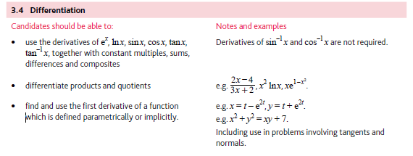
Application | Terminology
Formulae | Algorithms

