A Level 9709 PM 3
Topic 3.5: Integration
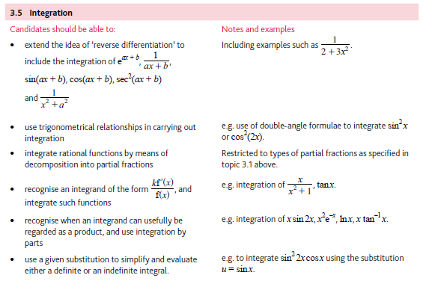
Application | Terminology
Formulae | Algorithms

