A Level 9709 PM 3
Topic 3.6: Numerical solution of equations
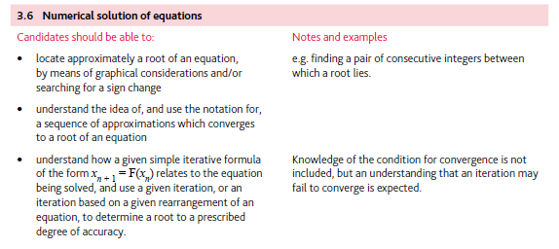
Application | Terminology
Formulae | Algorithms

