A Level 9709 PM 3
Topic 3.7: Vectors
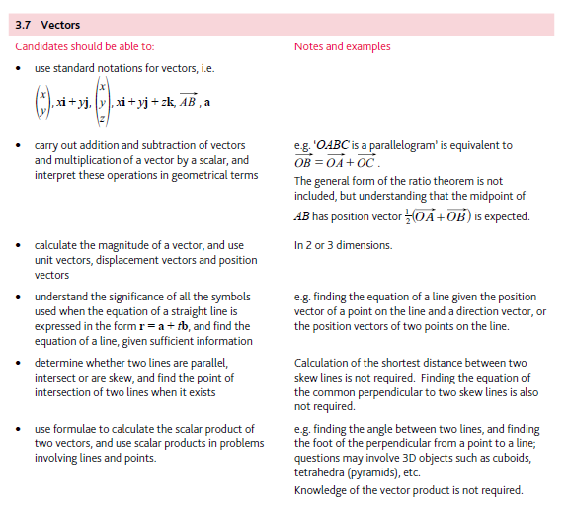
Application | Terminology
Formulae | Algorithms

