A Level 9709 PM 3
Topic 3.8: Differential equations
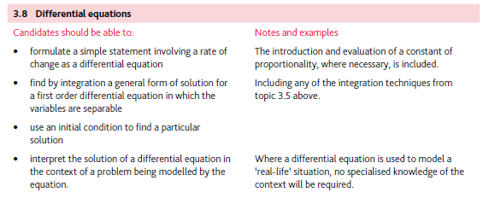
Application | Terminology
Formulae | Algorithms

