A Level 9709 PM 3
Topic 3.9: Complex numbers
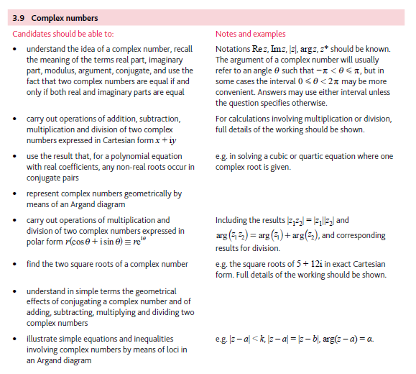
Application | Terminology
Formulae | Algorithms

