A Level 9709 PS 1
Topic 1: Representation of data
Outcomes
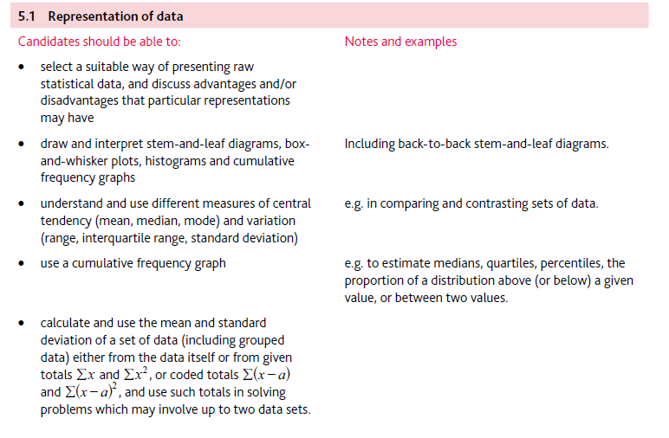
Application | Terminology
Formulae | Algorithms

