A Level 9709 PS 1
Topic 2: Permutations and combinations
Outcomes
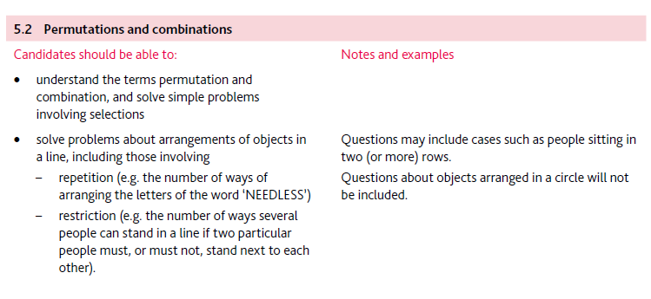
Application | Terminology
Formulae | Algorithms

