A Level 9709 PS 1
Topic 3: Probability
Outcomes
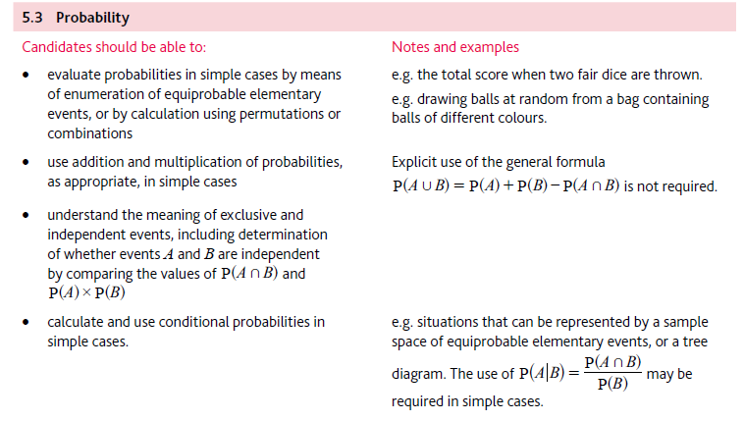
Application | Terminology
Formulae | Algorithms

