A Level 9709 PS 1
Topic 4: Discrete random variables
Outcomes
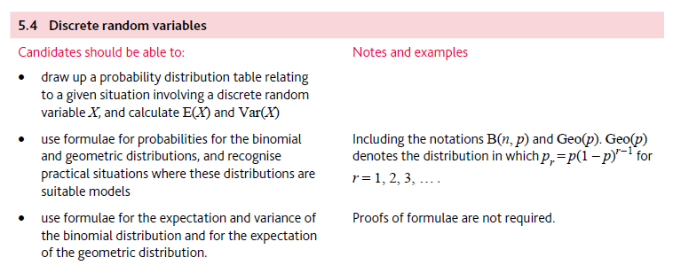
Application | Terminology
Formulae | Algorithms

