A Level 9709 PS 1
Topic 5: The normal distribution
Outcomes
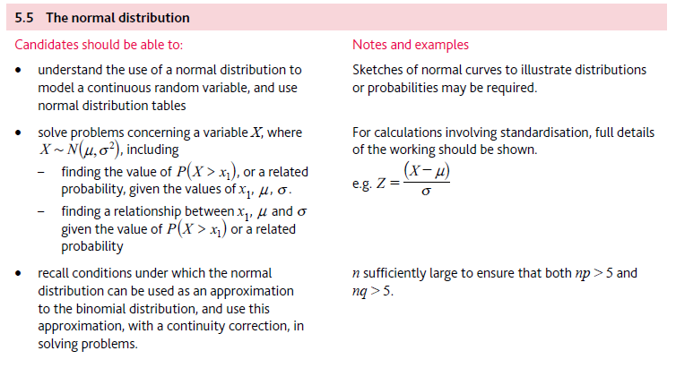
Application | Terminology
Formulae | Algorithms

