Financial Institutions and Markets
Week One Exercises SOLUTIONS

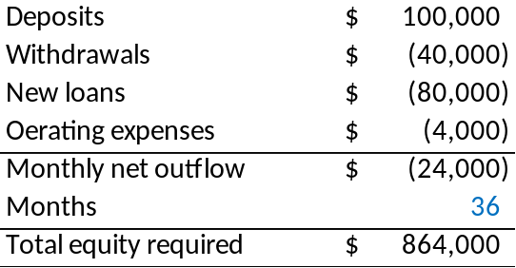

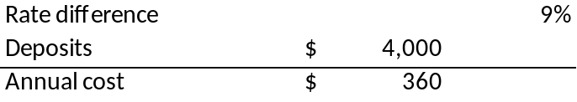

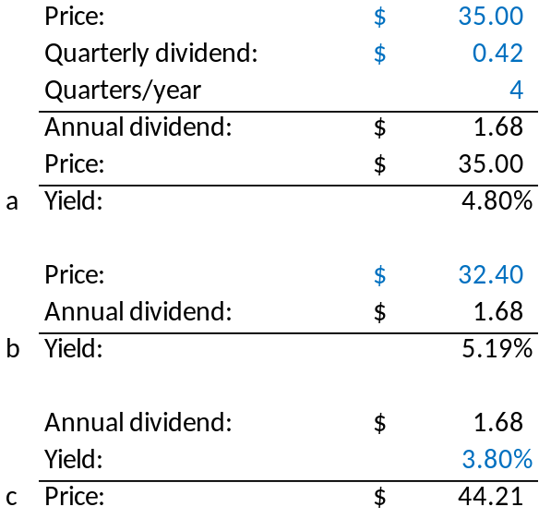

  - Change in yield from 9% to 10%

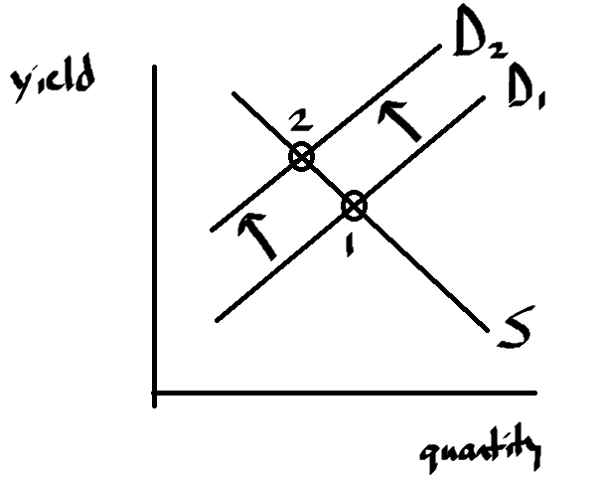
Investors SELL, price DECREASE, yield INCREASE

  - Change in yield from 9% to 8%
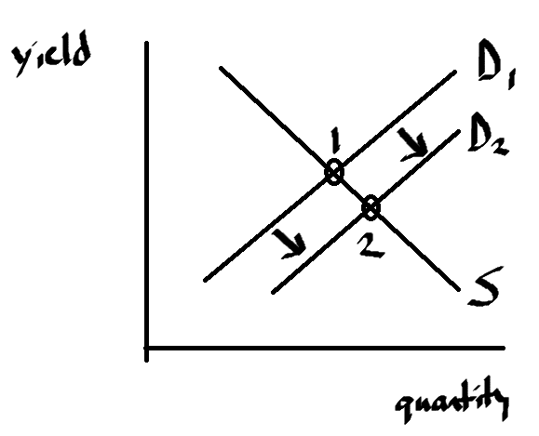
Investors BUY, price INCREASE, yield DECREASE

Financial Institutions and Markets
Week Two Exercises SOLUTIONS

- An economy has the following sector activity:

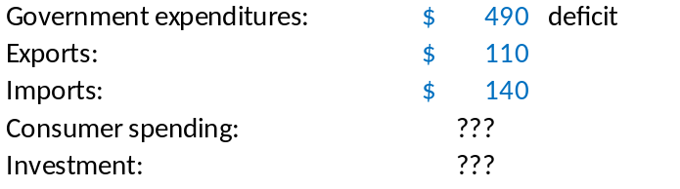

- Provide a possible scenario with a consumer spending deficit
- Provide a possible scenario with a consumer spending surplus

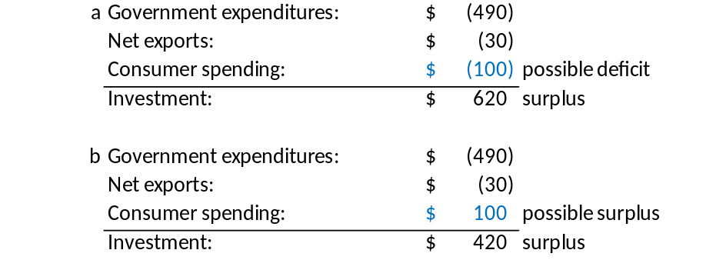

- An economy has the following factors:
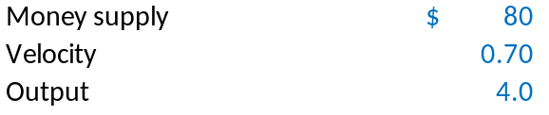
  - What is the price level?
  - If the country’s target price level is $12, what does the money supply need to be (velocity and output are the same as given)?
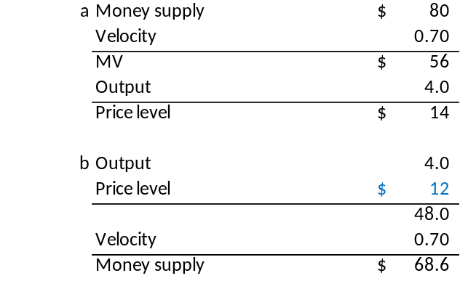
- Create a supply/demand graph showing the change in equilibrium interest rate if new technology results in attractive new investment opportunities for businesses in an economy.

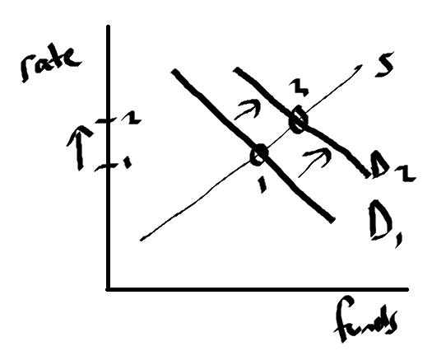
New opportunities create new demand for funds; interest rate increases to create equilibrium.

- Create a supply/demand graph showing an equilibrium interest rate of 6% and a government interest rate ceiling of 8%, and explain the effects of this ceiling.

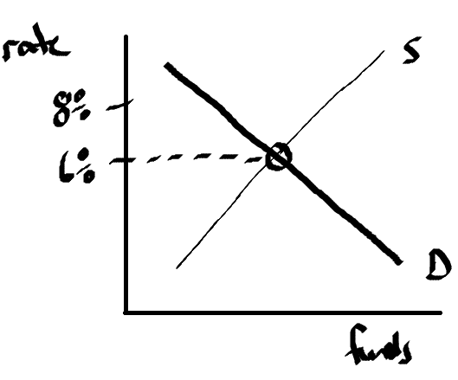
Because the ceiling is higher than the market rate, all loans are already below the ceiling; thus, no effect on supply and demand.

