Financial Management
Week 1 Exercises

- Based on the following company information:

Calculate:

  - Net income
  - Cash flow from operations
  - Retained earnings, 2016

- A company has the following income statements:

  - Complete the vertical analysis of the company and identify any unusual results.
  - Complete the horizontal analysis for sales and evaluate this result by comparison to industry performance.

- Using the income statements from question 2) and the following balance sheet:

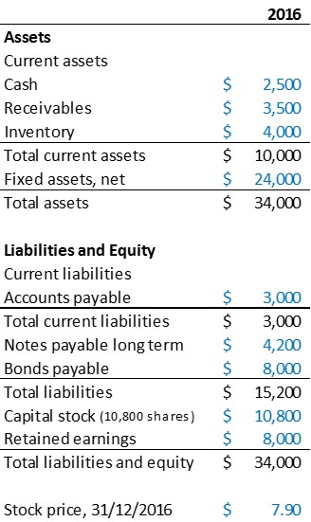

Calculate the following ratios:

  - Current ratio
  - Debt to equity ratio
  - Asset turnover ratio
  - Operating margin, 2015 and 2016
  - Price to earnings ratio

