Financial Management
Review Exercises 2 SOLUTIONS

- A company makes the following three year investment:

  - Calculate the present value of the following cash flows.

  - Does the investment achieve the required return?
Yes; NPV is not negative; any NPV of $0 or greater meets return requirements.

- A company has the following income statements:

  - Assess the company’s management of working capital.

Receivables
Formula: AR / (sales x credit % / 365)

Inventory

Formula: Inventory / (COGS / 365)

Payables

Formula: AP / (COGS / 365)

Calculations:
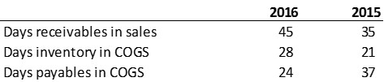

  - Is the company’s cash position improving or worsening based on your analysis?

Worsening; receivables collection time is increasing (less cash in), inventory level is increasing (more cash out), and payables payment tie is decreasing (more cash out).

  - Advise management regarding working capital management strategies.
Collect receivables more quickly
Reduce inventory levels
Pay payables more slowly

- A company has the following short term financing terms:

  - Calculate the annual cost of trade credit with the vendor.

  - The company wants to pay the balance on the last day of the net period. How much will the company save in financing costs by borrowing from the bank to pay the balance due on the last day of the discount period, then paying the loan off on the
last day of the net period?

- A company enters into a receivables factoring agreement under the following terms:

  - How much cash will the company receive upon factoring?

  - Assuming no customer returns, how much cash will the company receive at the end of the receivables period?

  - What expense will the company record on the income statement for this transaction?

