PMD Pro Level 1 Practice Exam Answer Key
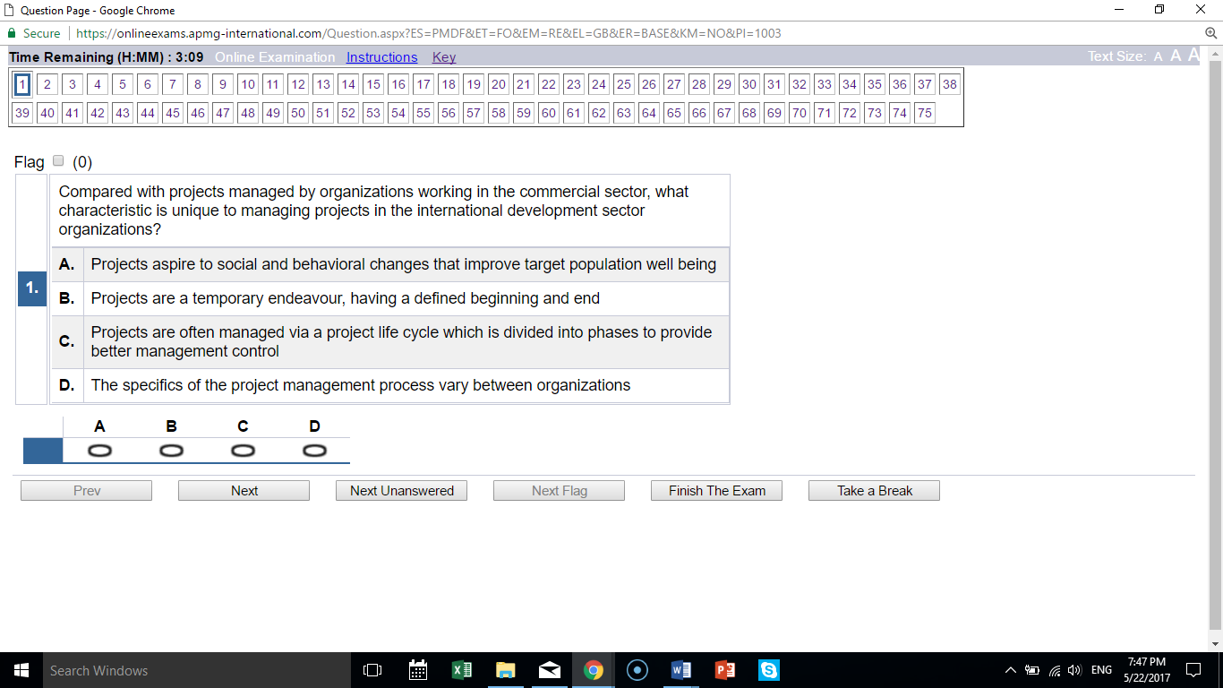
A the social nature is the key concept; others are not particular to development.
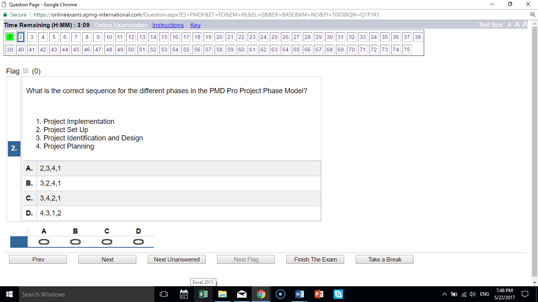
B 3, 2, 4, 1

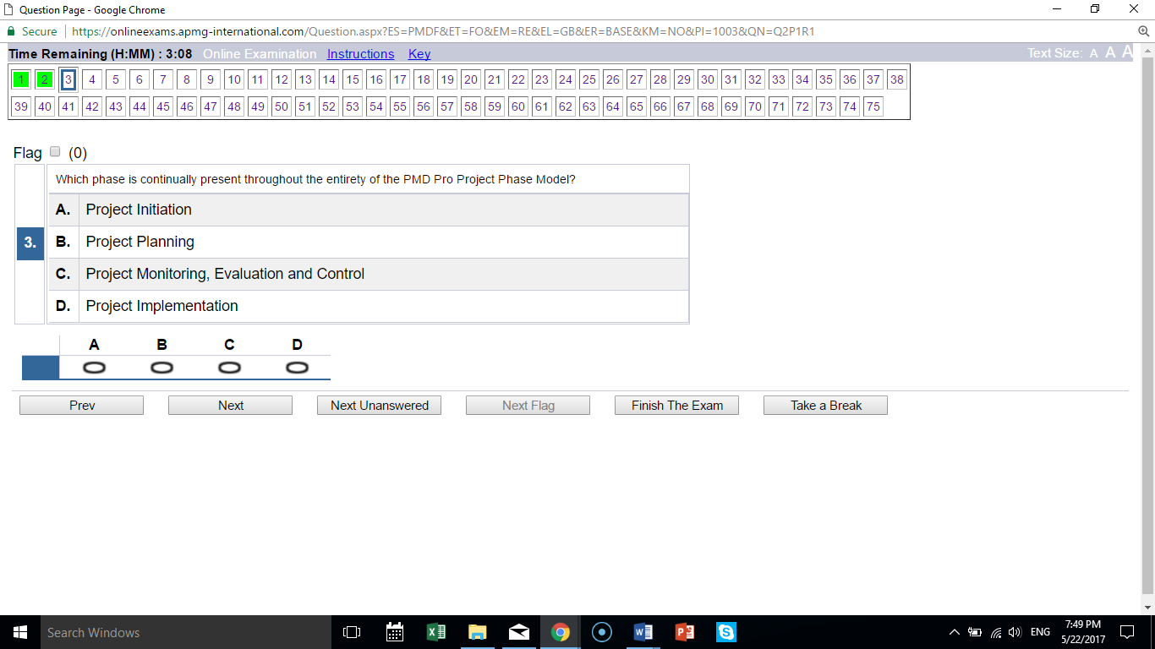
C

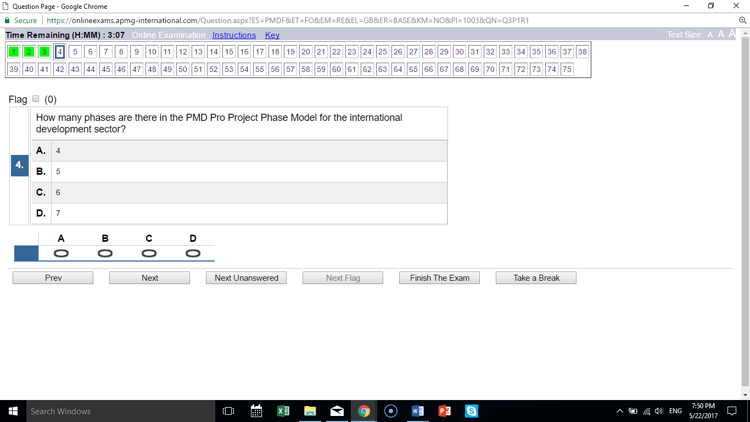
C

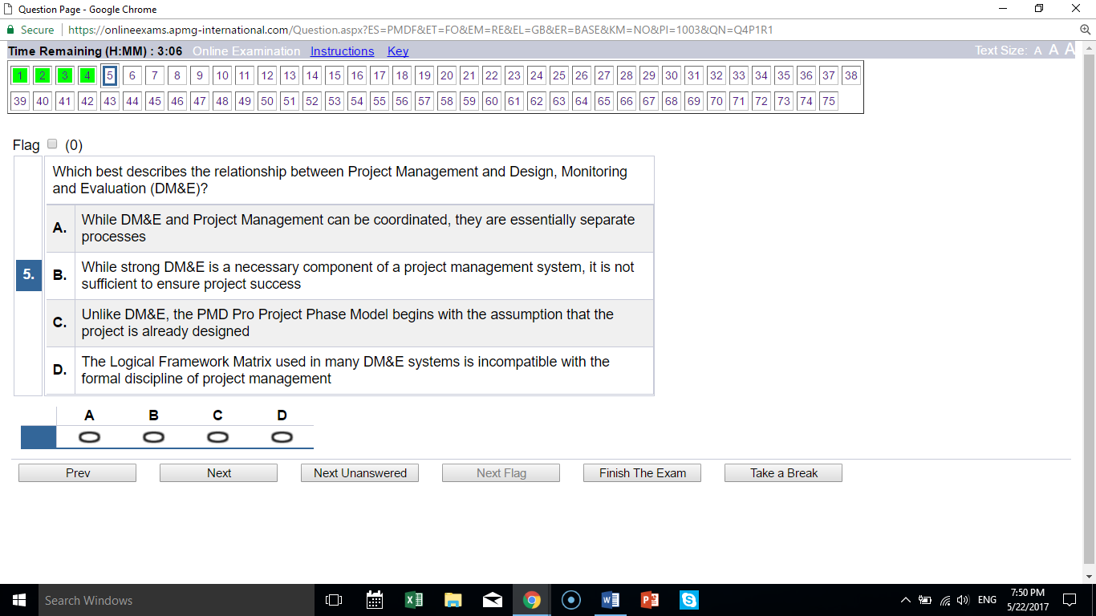
B is the only correct statement

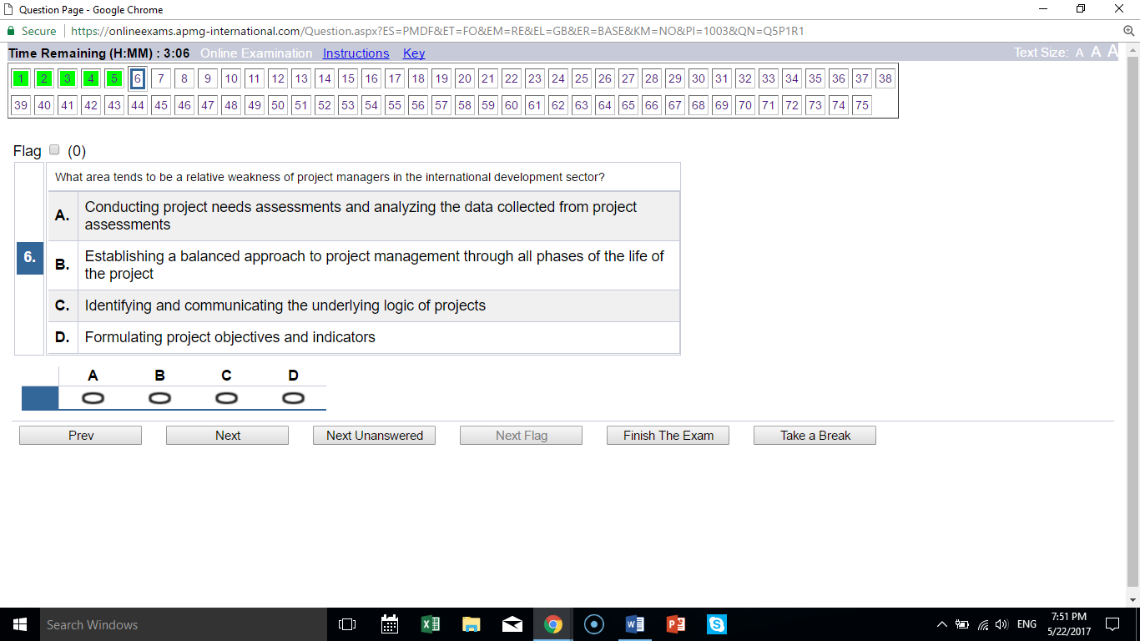
B balance is the weakness

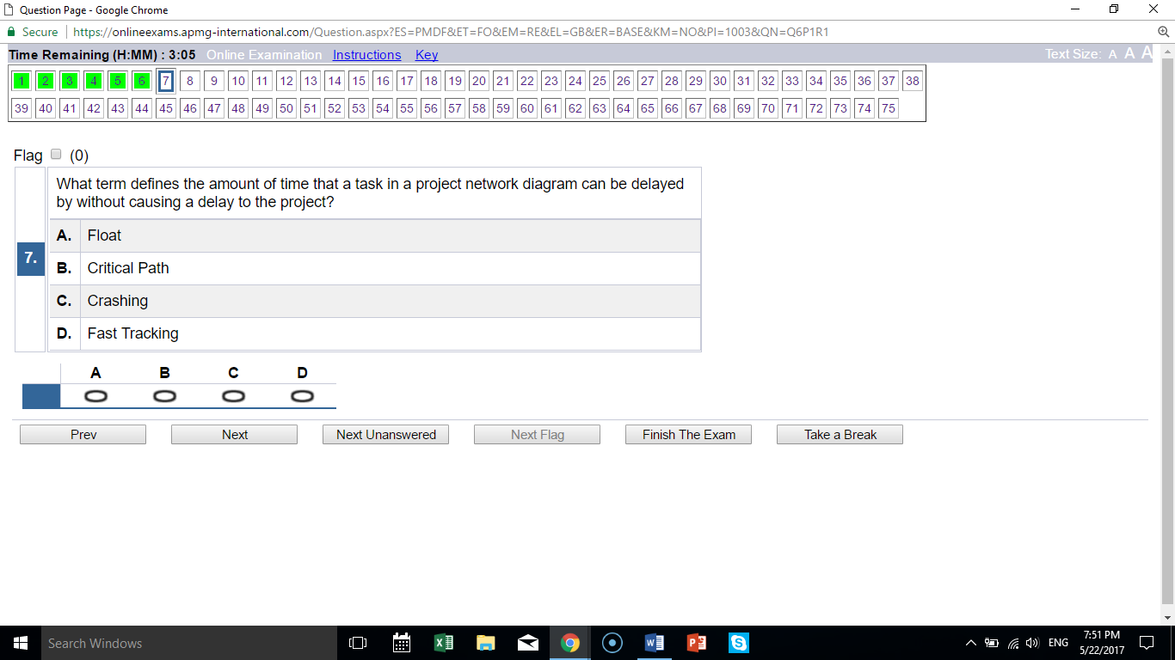
A “float” is defined here.

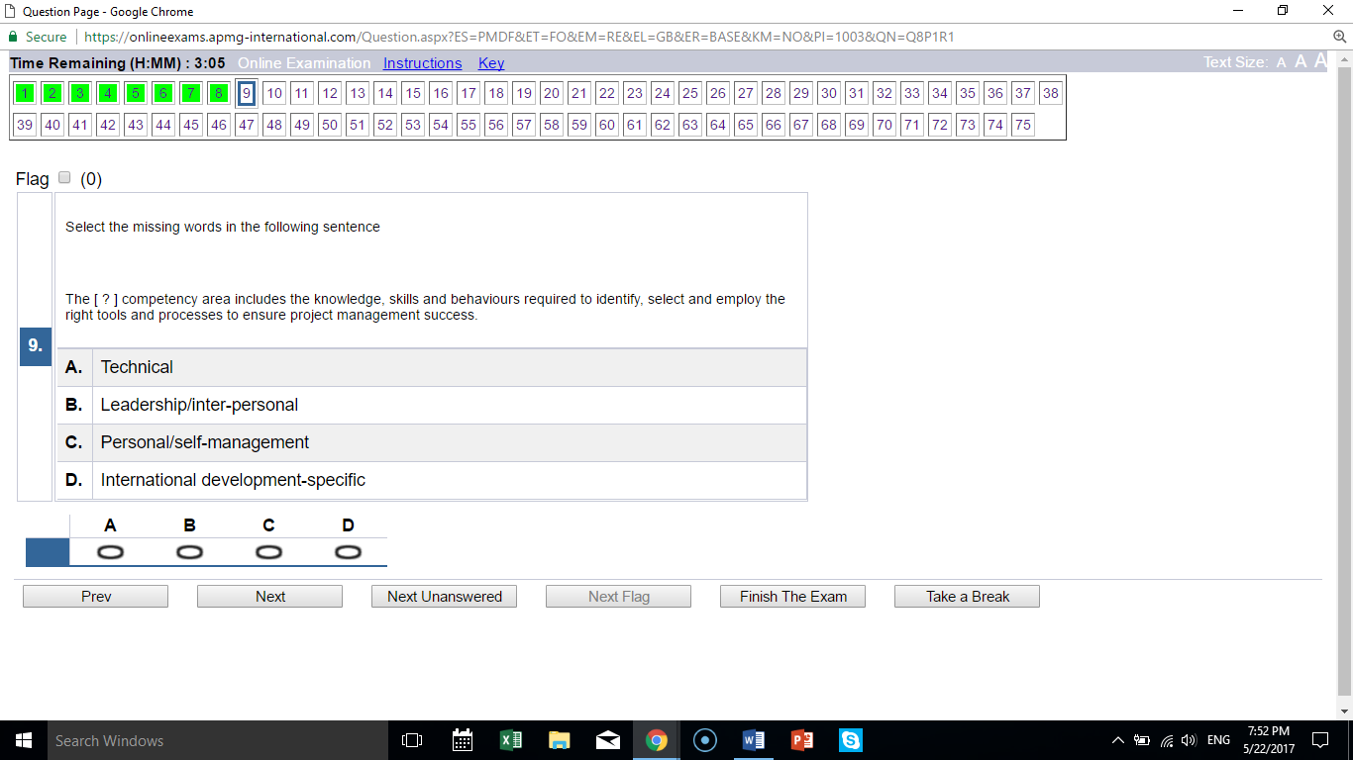
A these are technical concepts

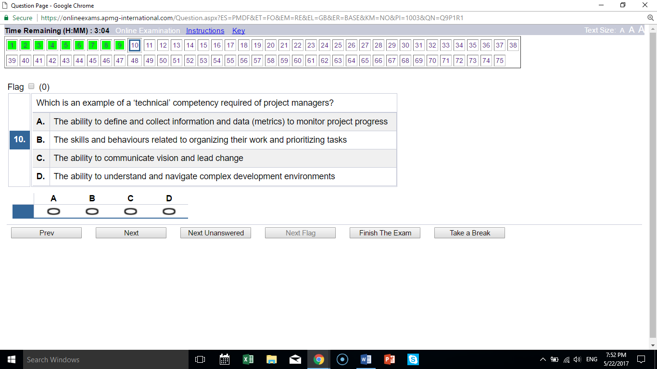
A is the only technical skill

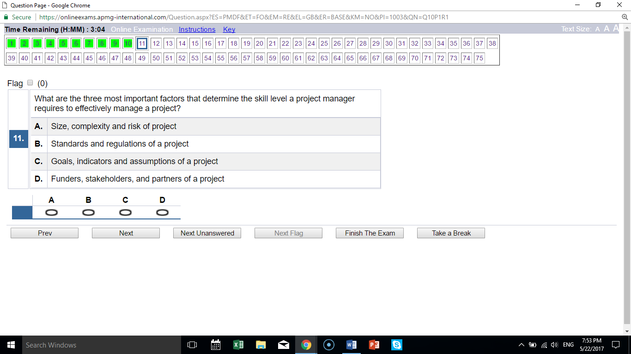
A lists the PMD’s skill-related factors

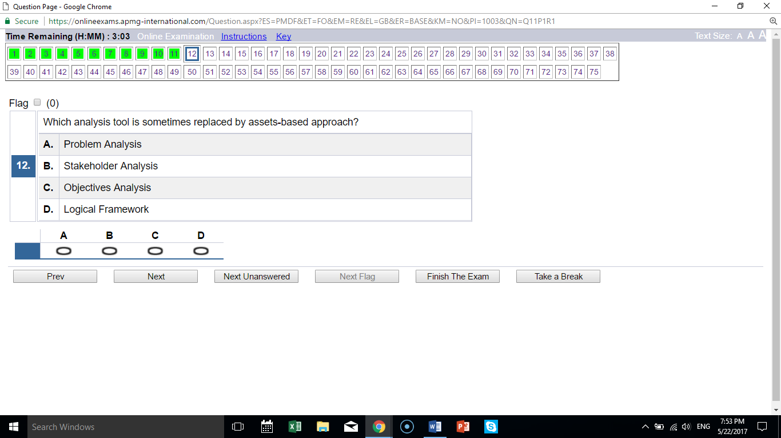
A problem analysis is similar to assets-based approach

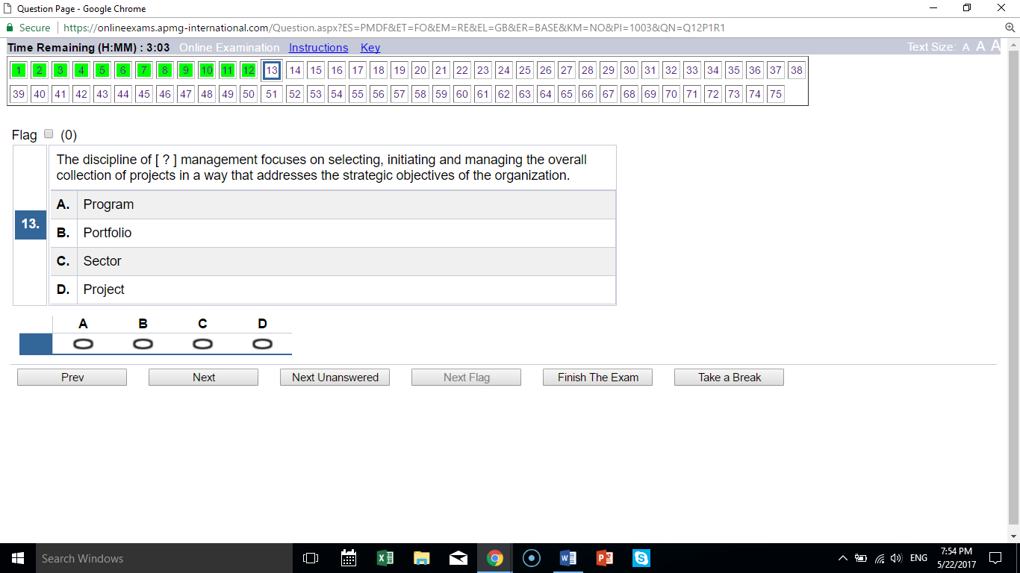
B “strategic” indicates this is portfolio

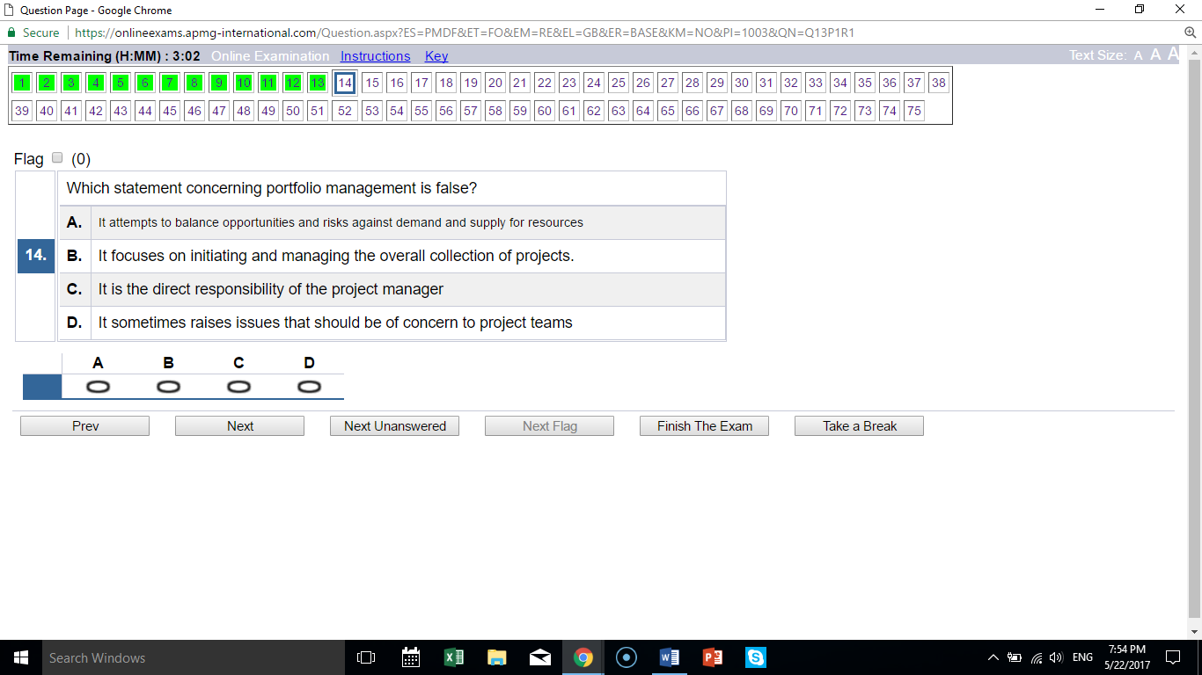
C the project manager does not manage the portfolio; all other answers are true

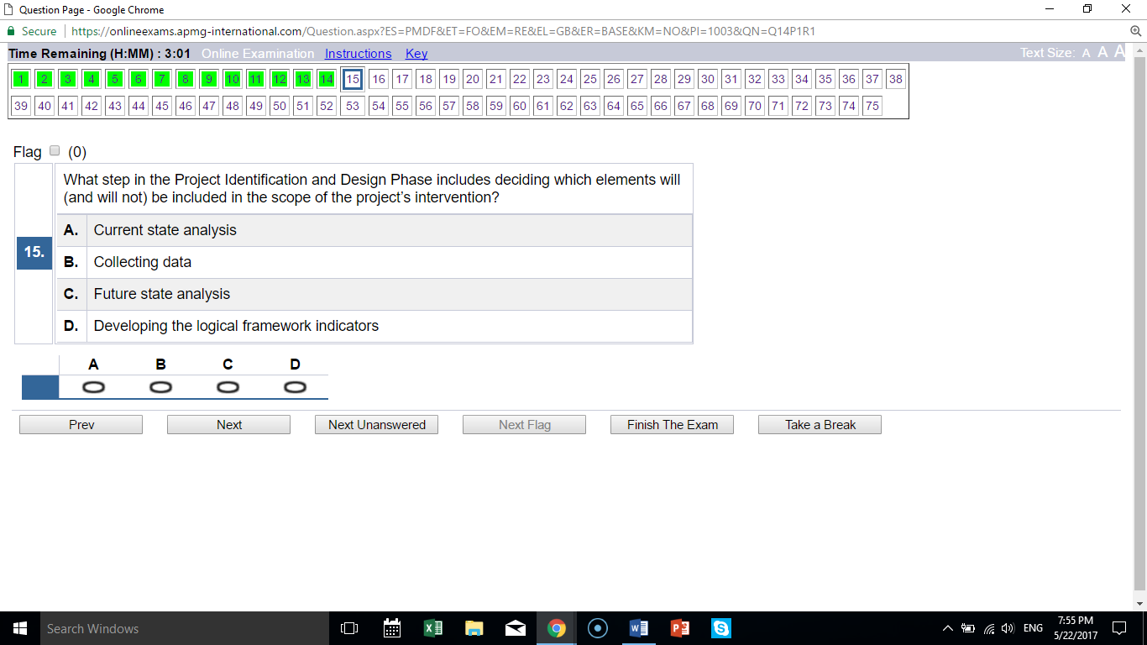
C this activity happens during future state analysis

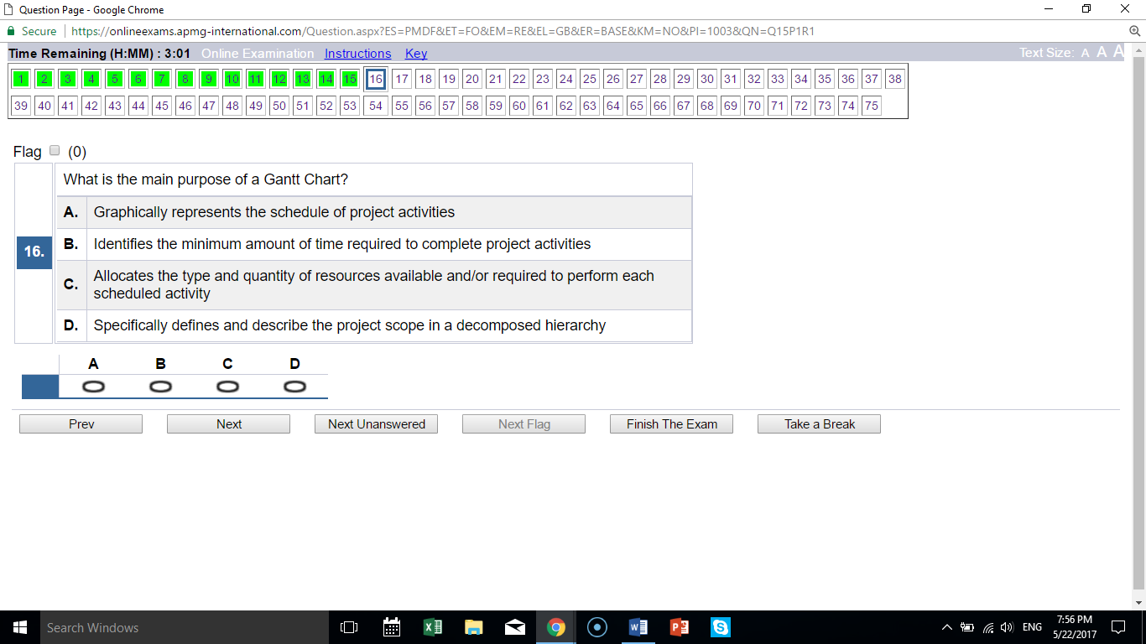
A “graphically represents schedule” defines Gantt Chart; all other answers are other tools

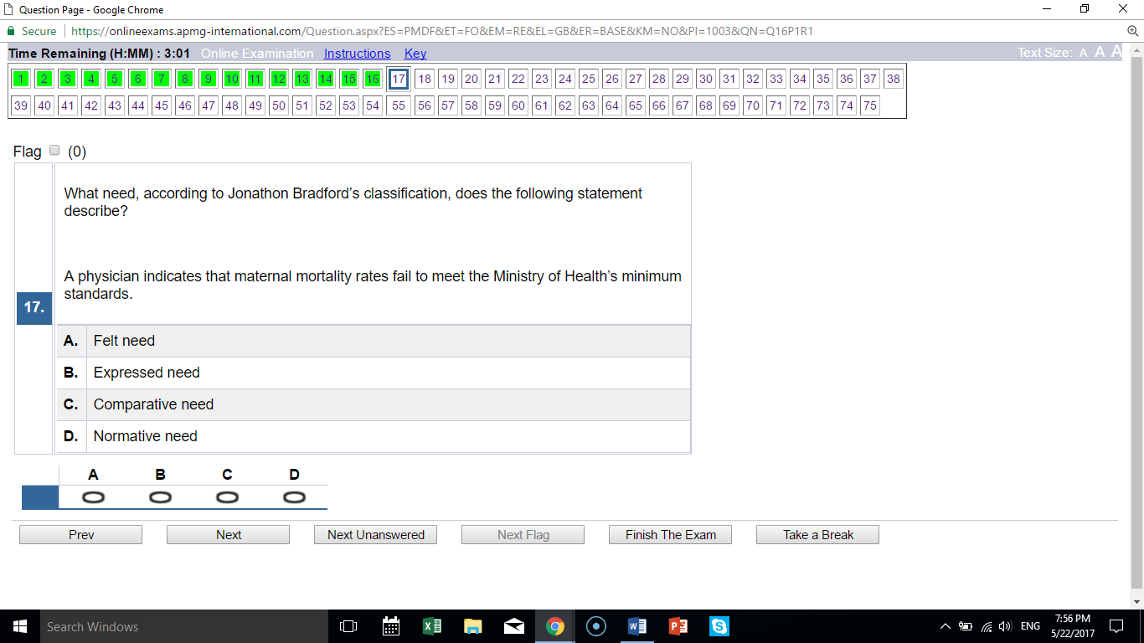
D expert opinion relates to normative need

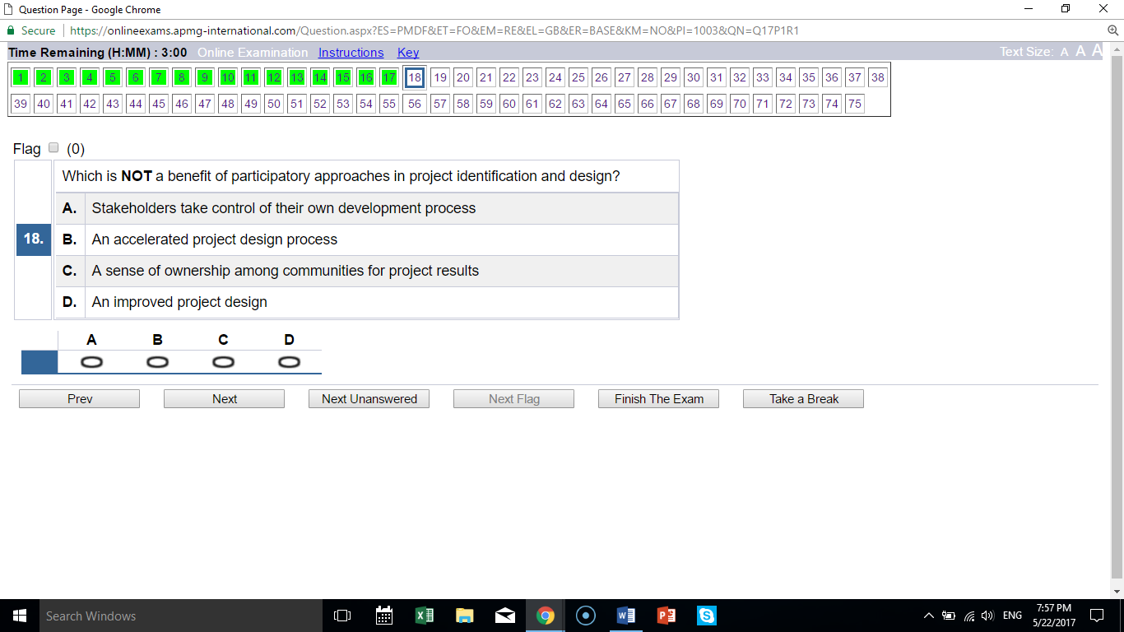
B the process is NOT accelerated; all other answers are actual benefits

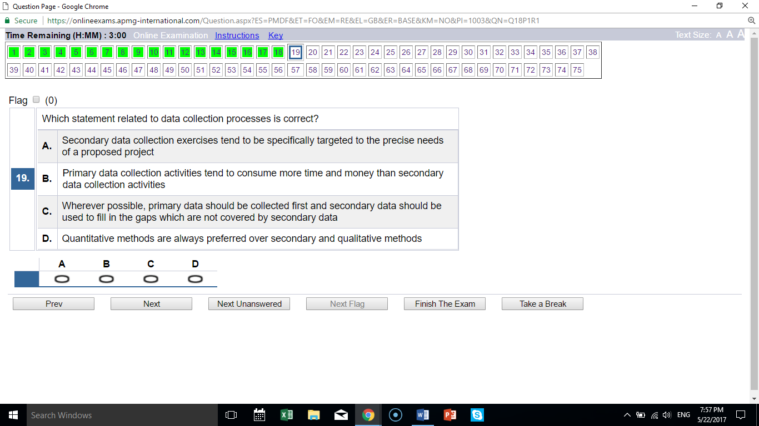
B; all other answers are incorrect

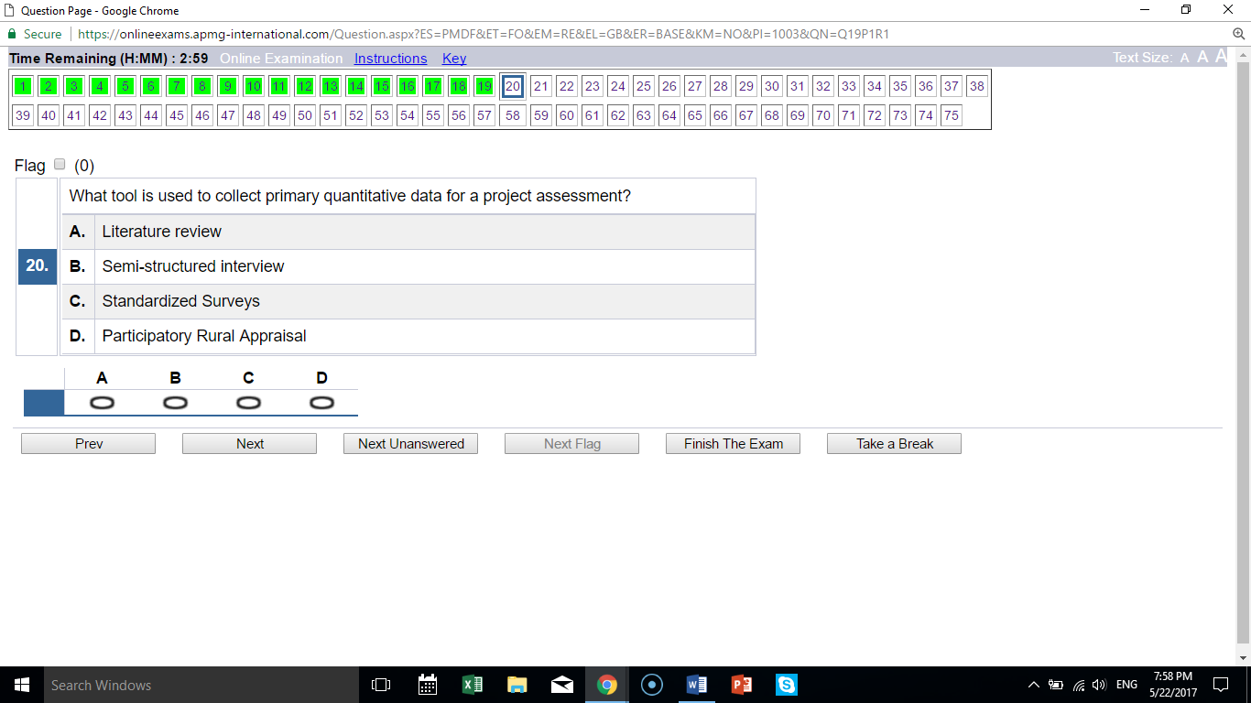
C surveys are quantitative; the others are qualitative

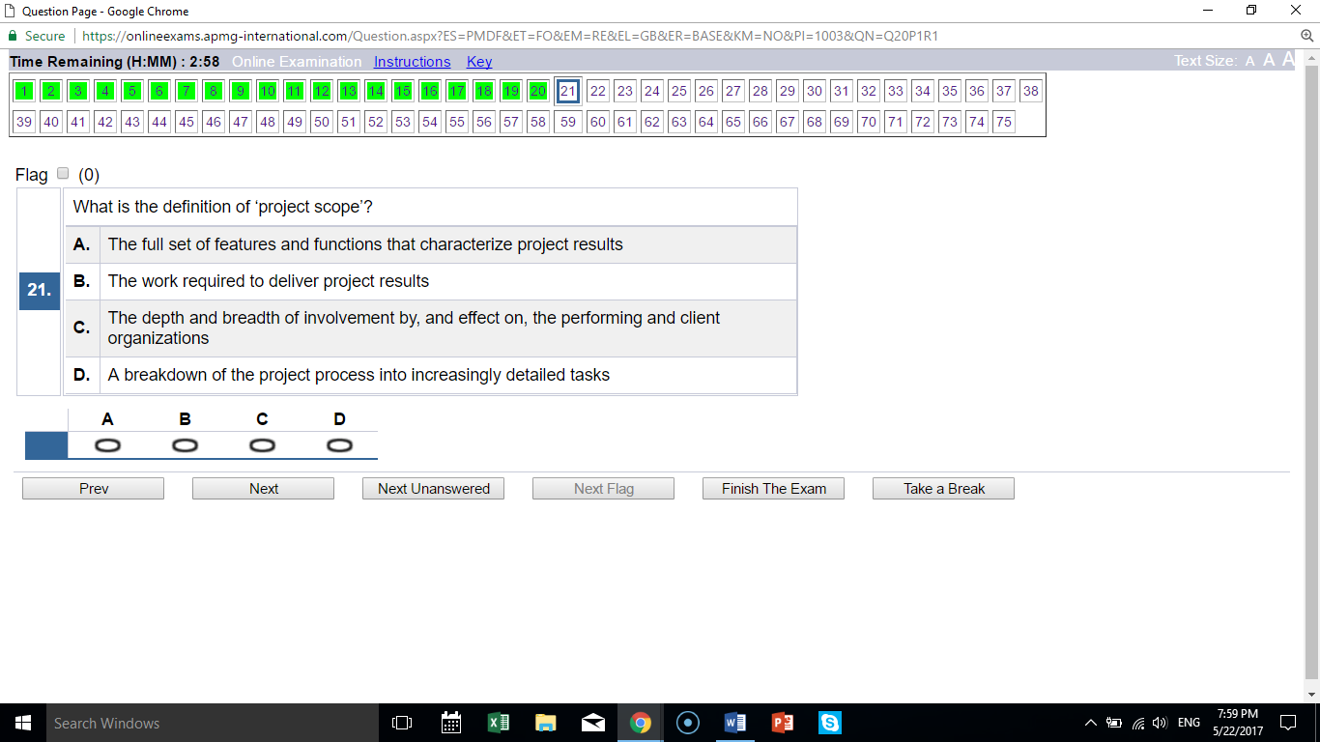
B defines project scope; A defines product scope, others are not relevant

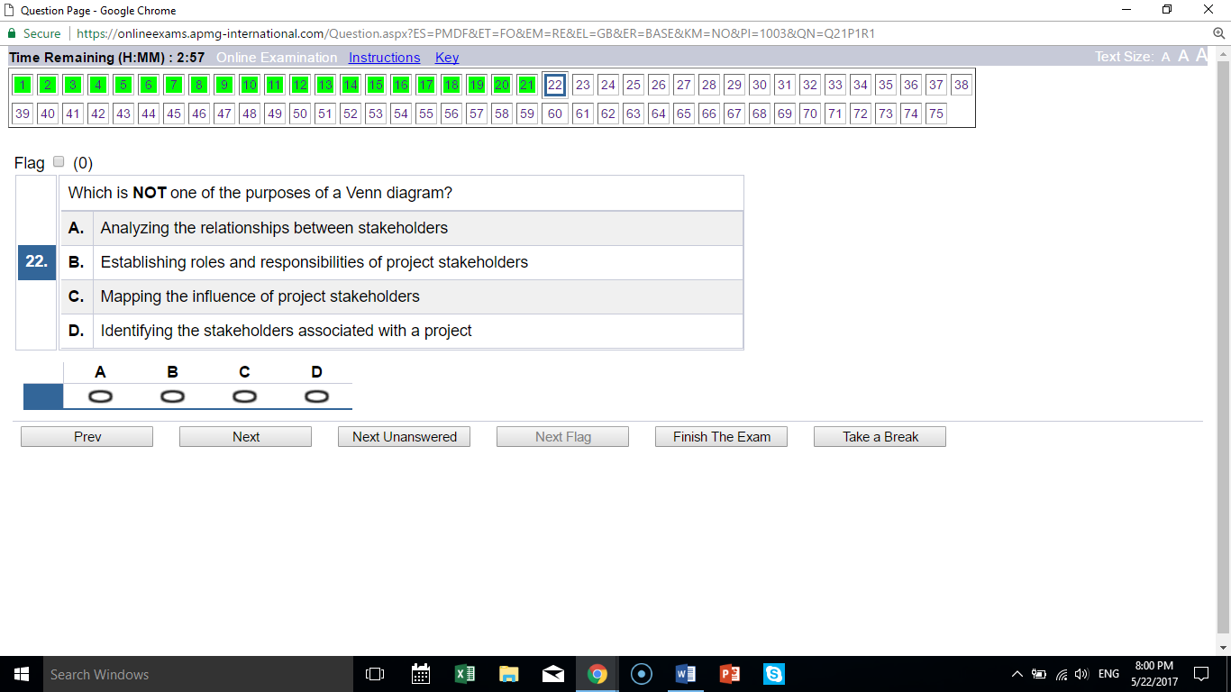
B roles and responsibilities are not part of a Venn diagram; the other choices are

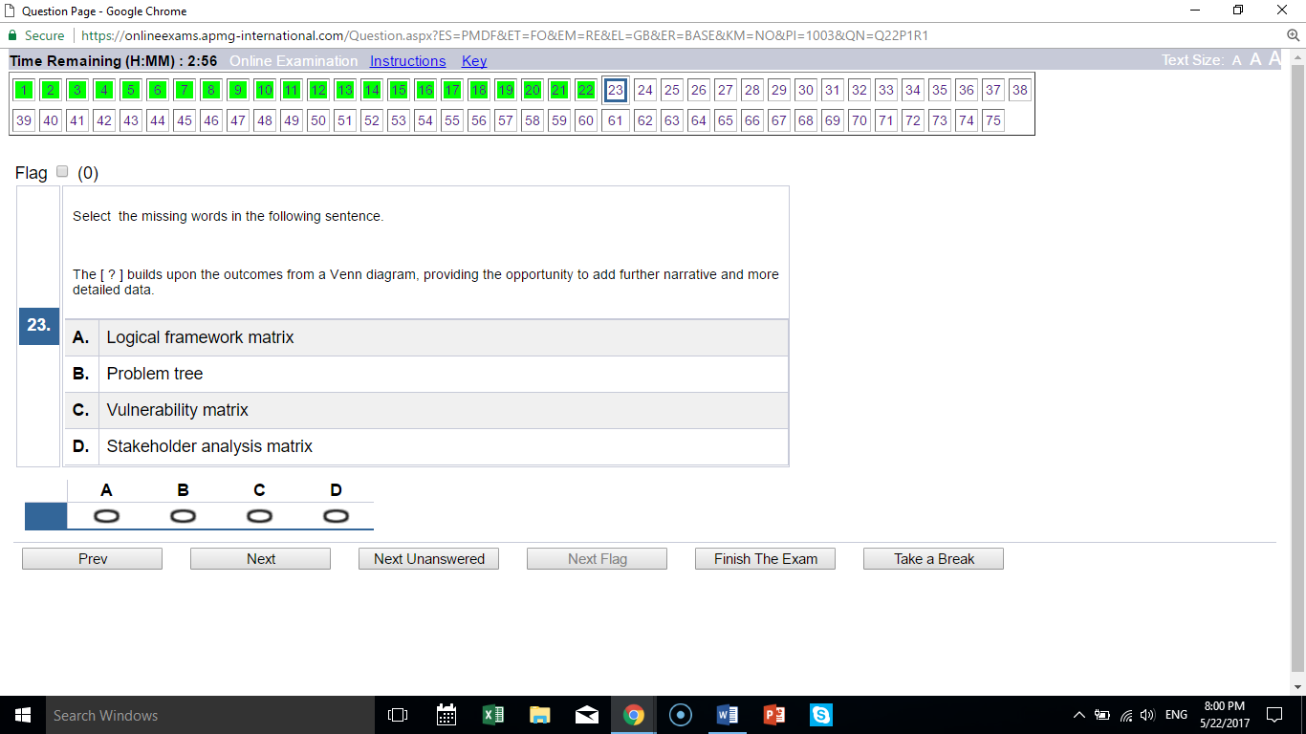
D is a more detailed stakeholder analysis tool; others do not relate to stakeholders

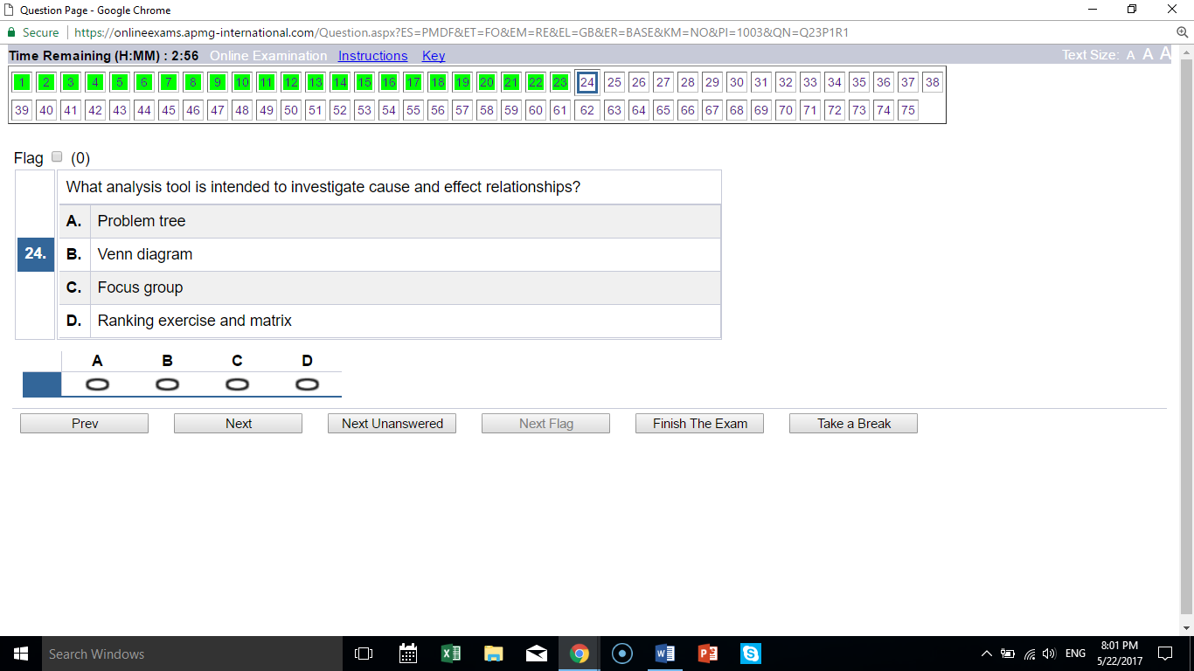
A is the only cause-effect related tool

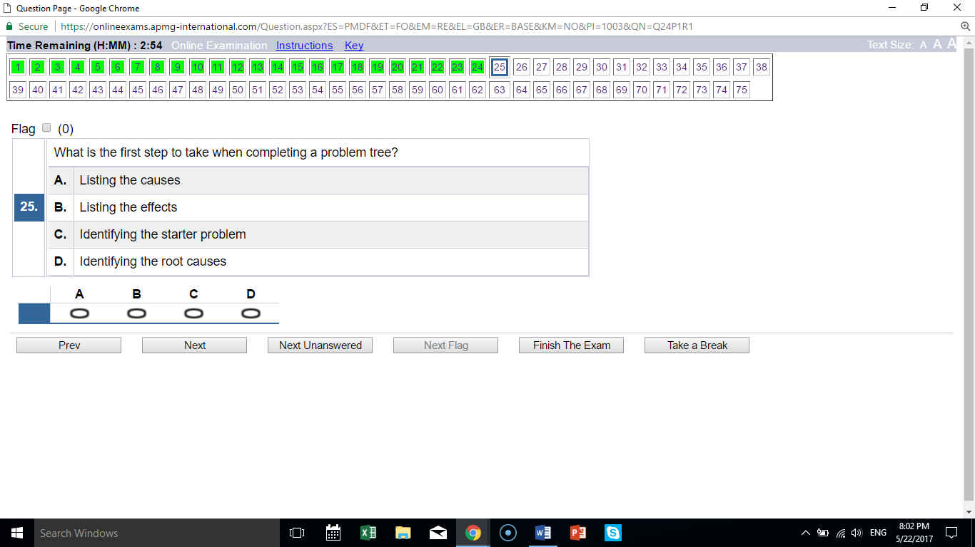
C is the first step; the other answers are later steps

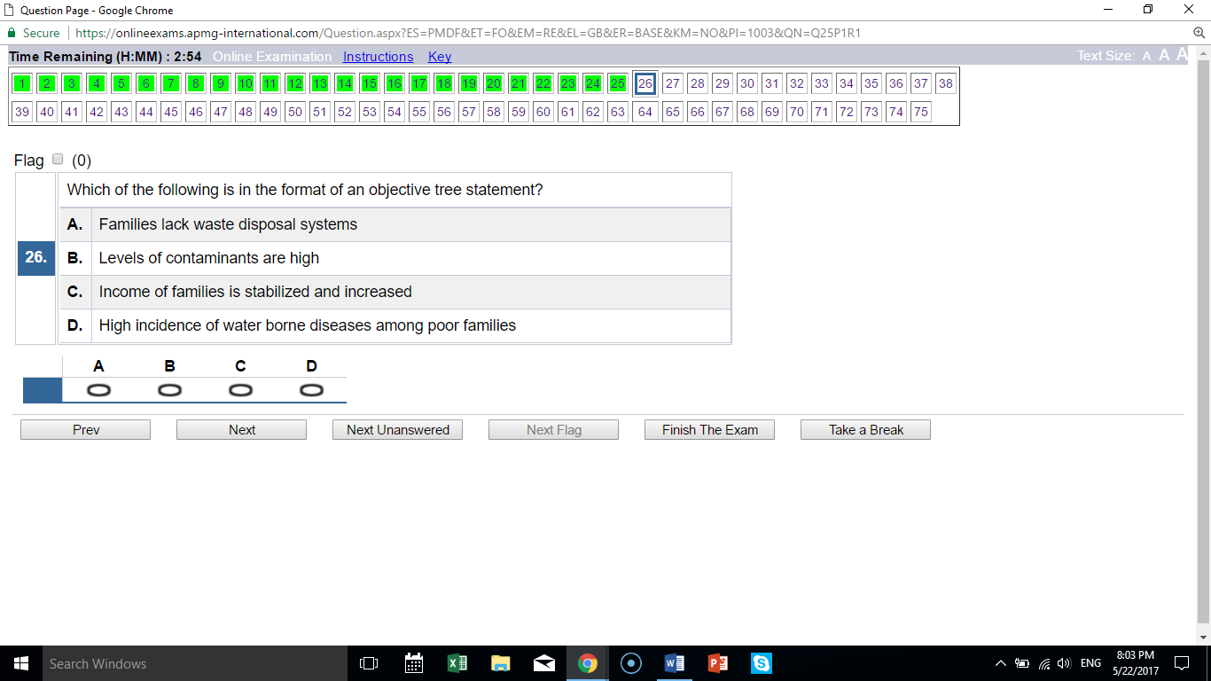
C is in the form you want in the future; the others are “problem tree” statements

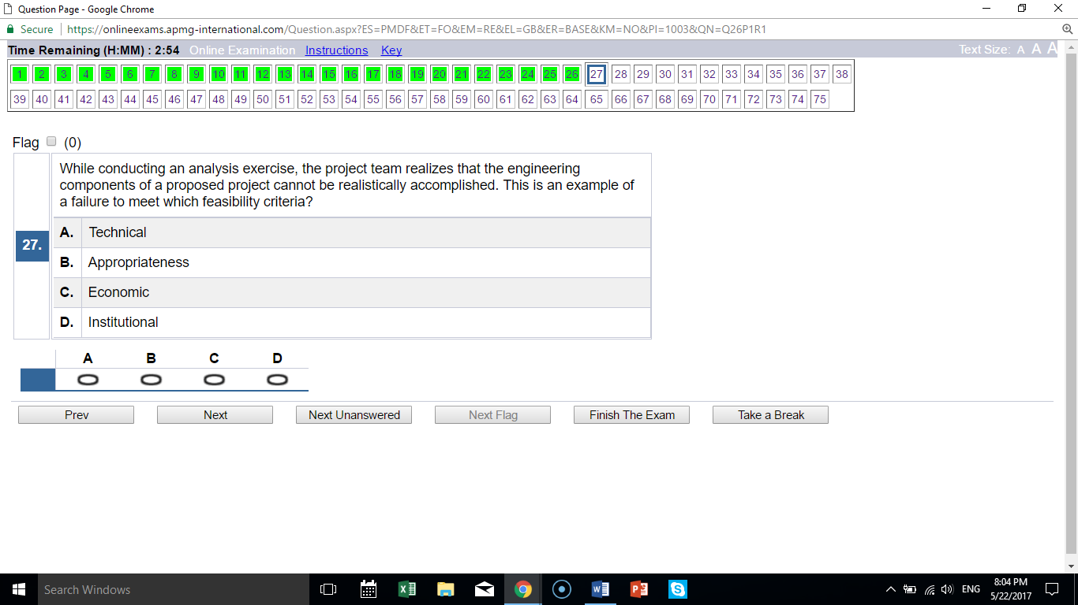
A engineering is a technical issue

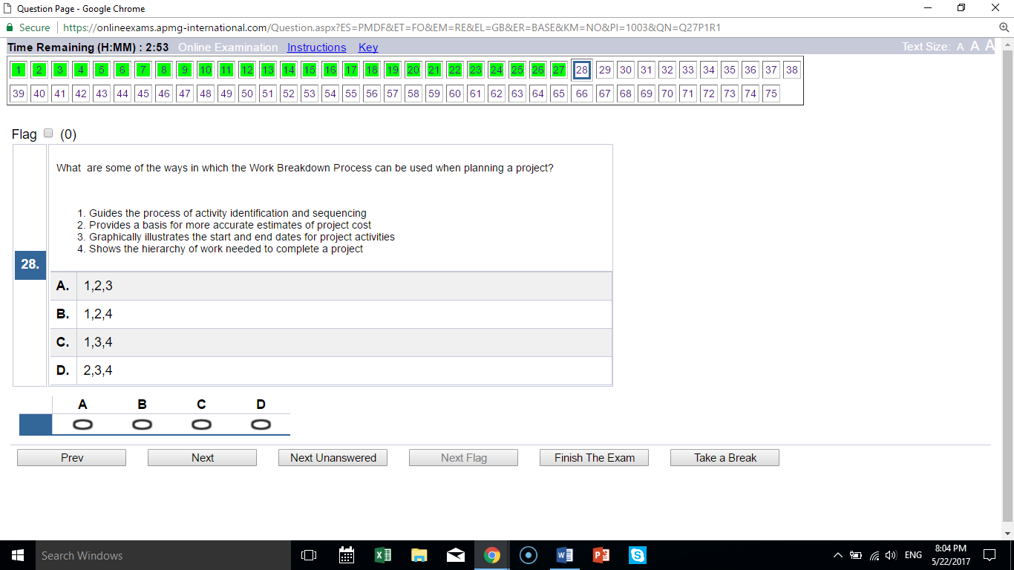
B exclude 3; the WBS does not include an indication of time; 1, 2, 4 are correct

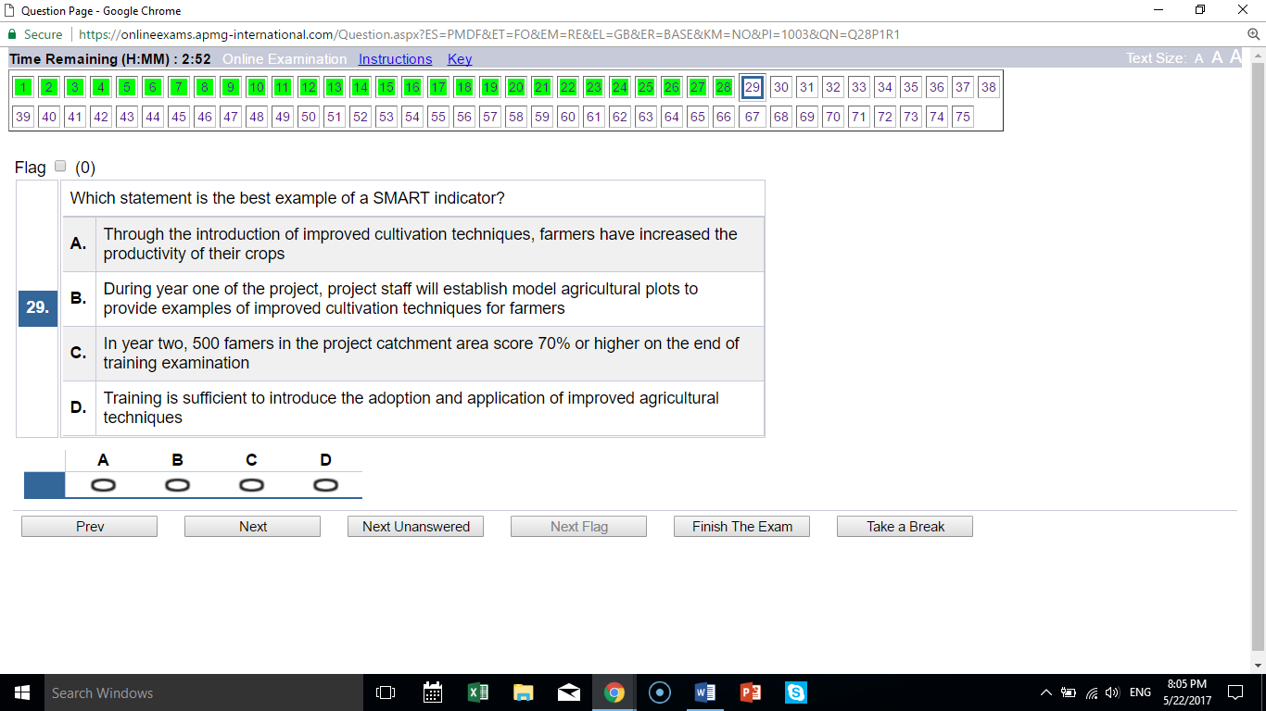
C follows the SMART rules, the clue is NUMBERS

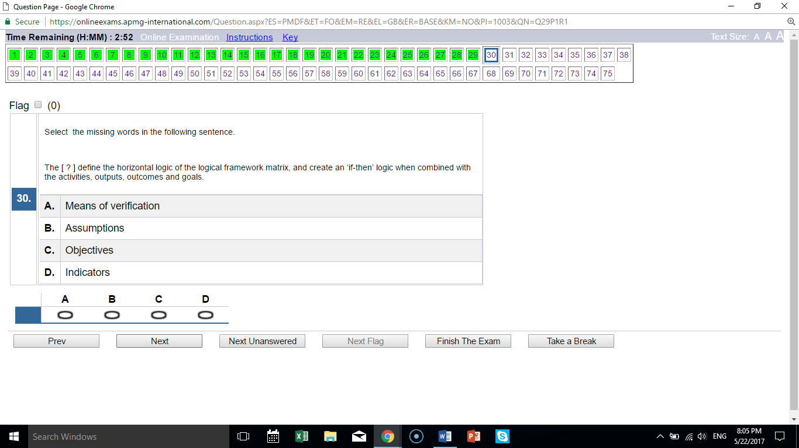
B if-then relates to assumptions

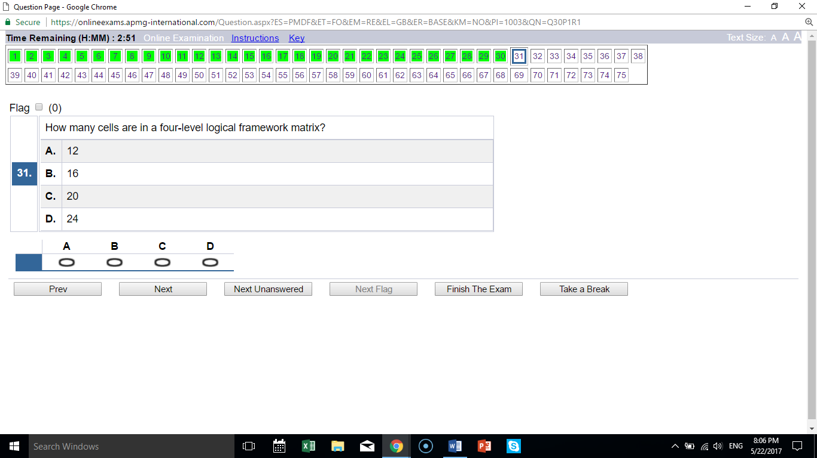
B 16

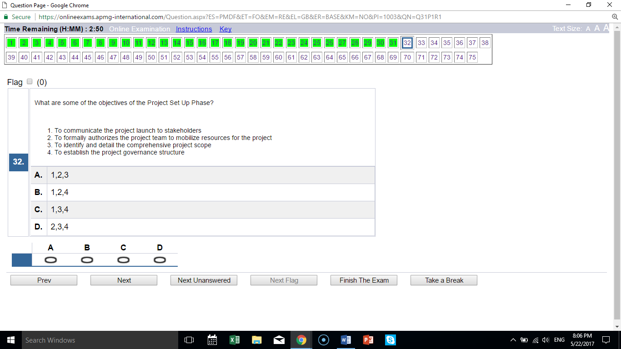
B exclude 3; 1, 2, 4 are all part of setup

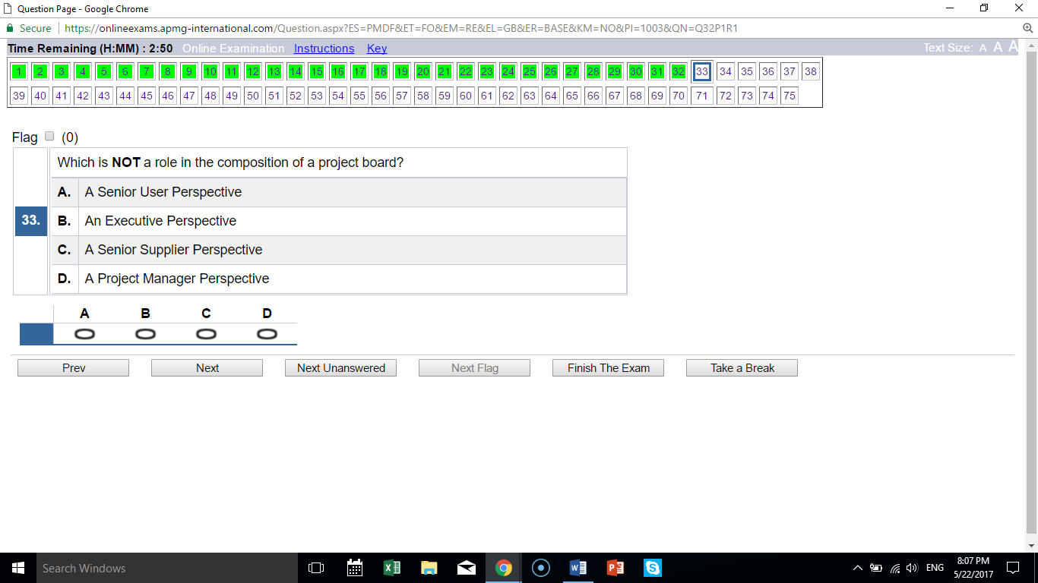
D the project manager is not a board perspective; the others are

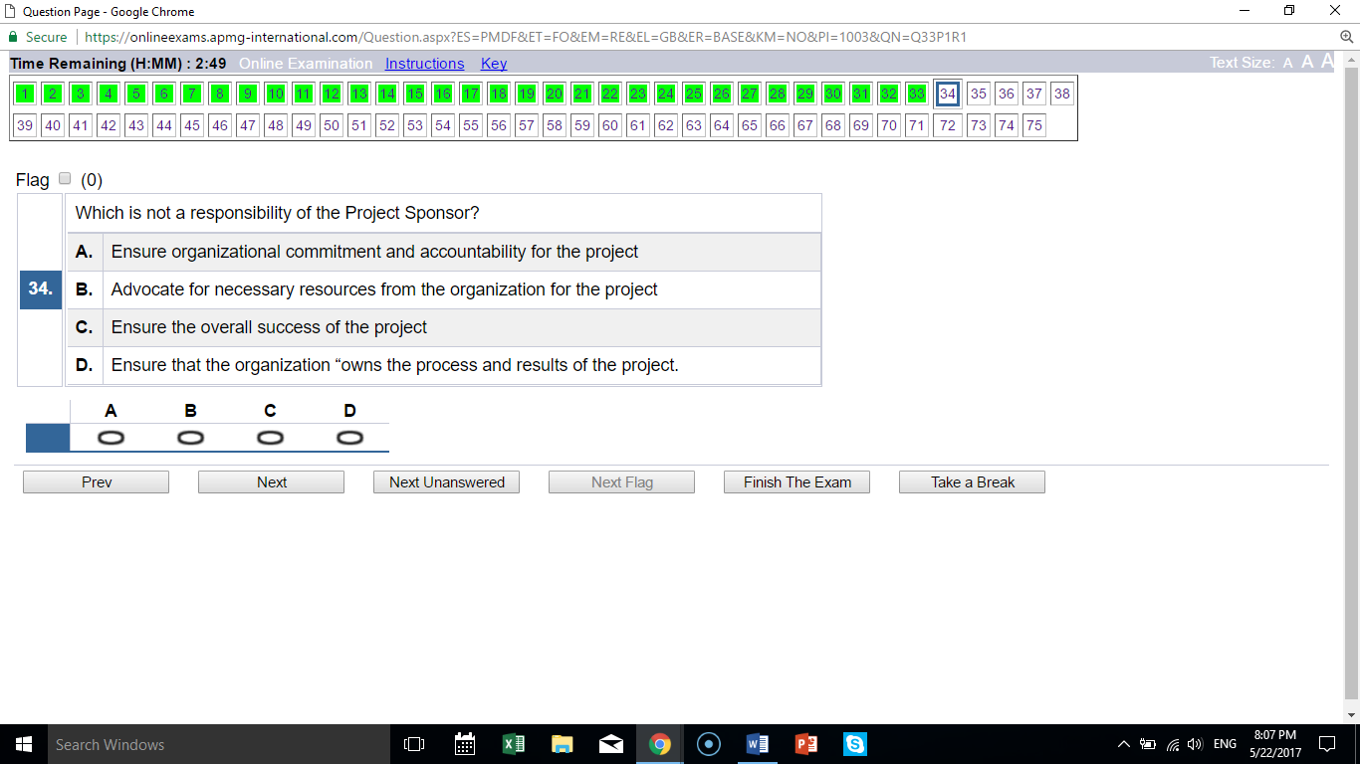
C no one can “ensure success” of the project; the others are true

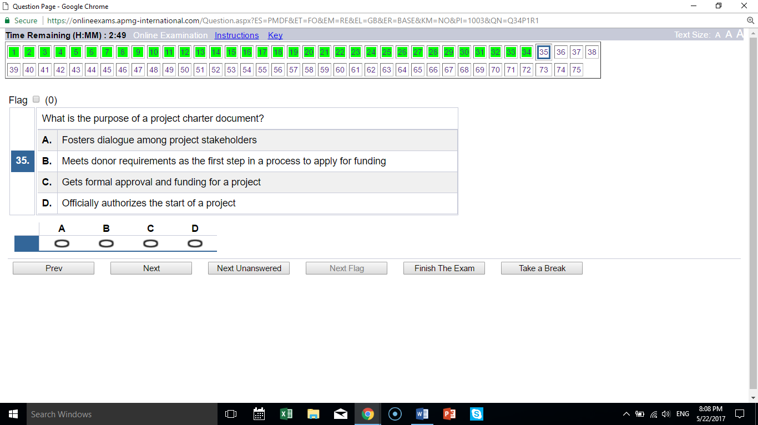
D authorizes project start; other answers describe other documents

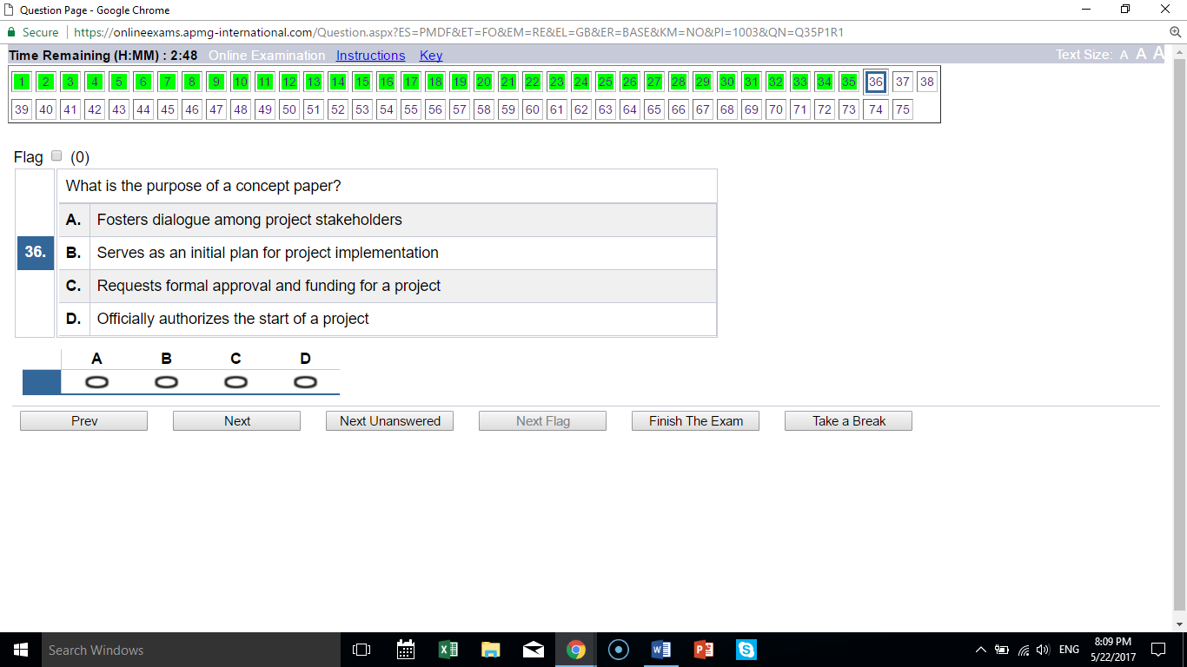
A first document in the project process; fosters dialogue

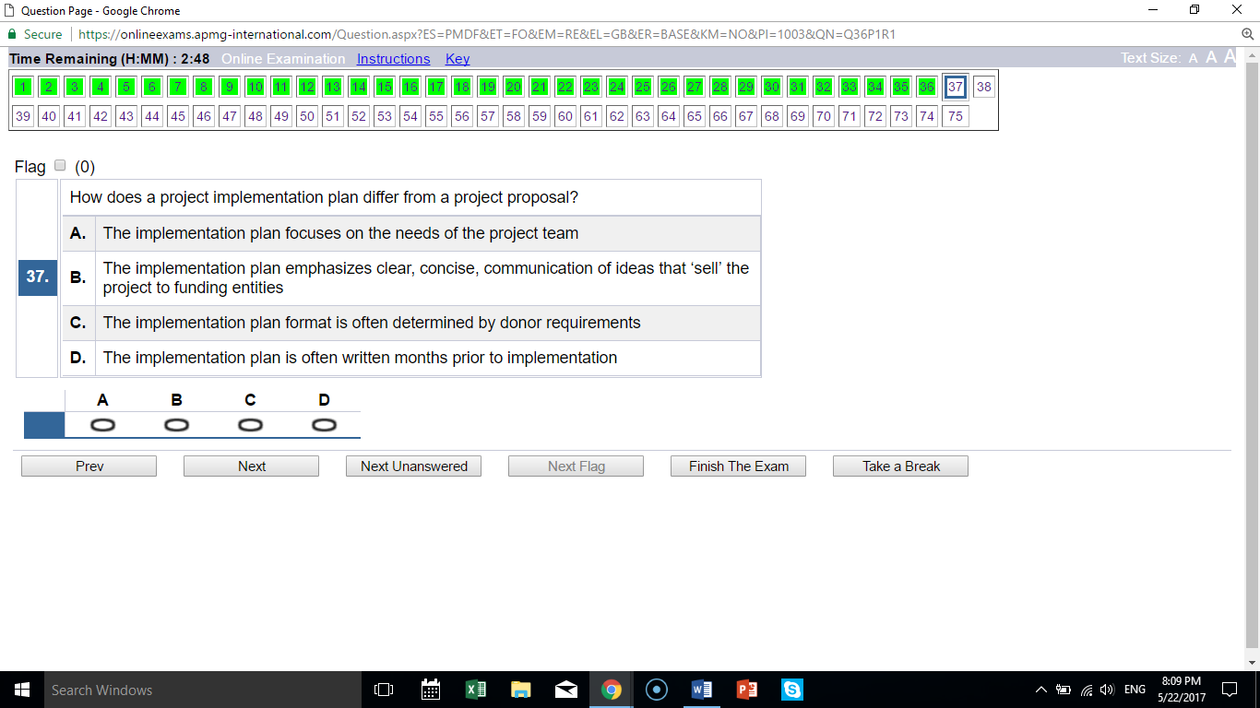
A is true; the other answers describe the project proposal

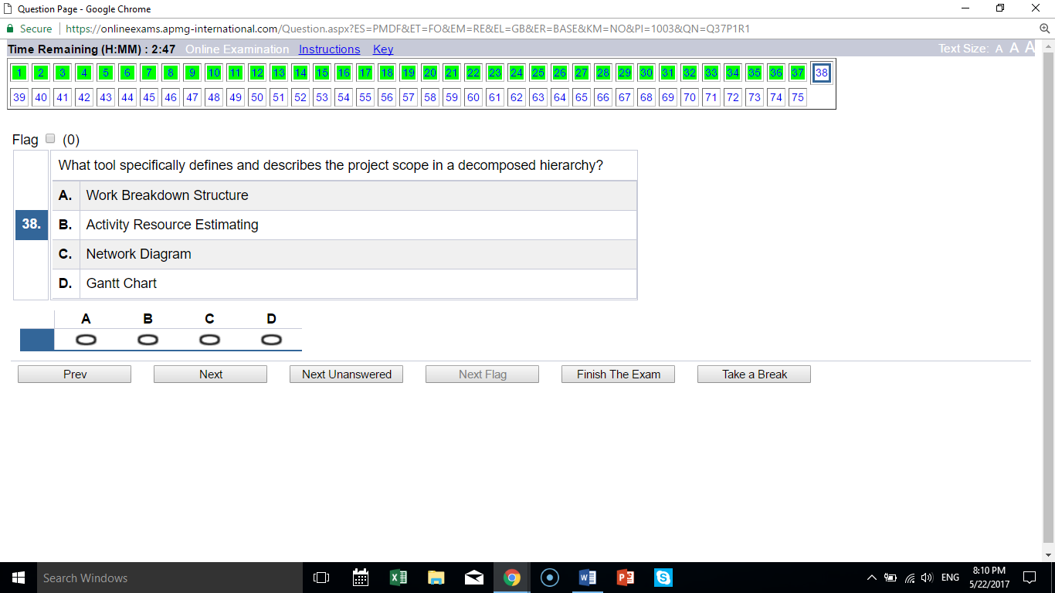
A “decomposed hierarchy” are key words for the WBS

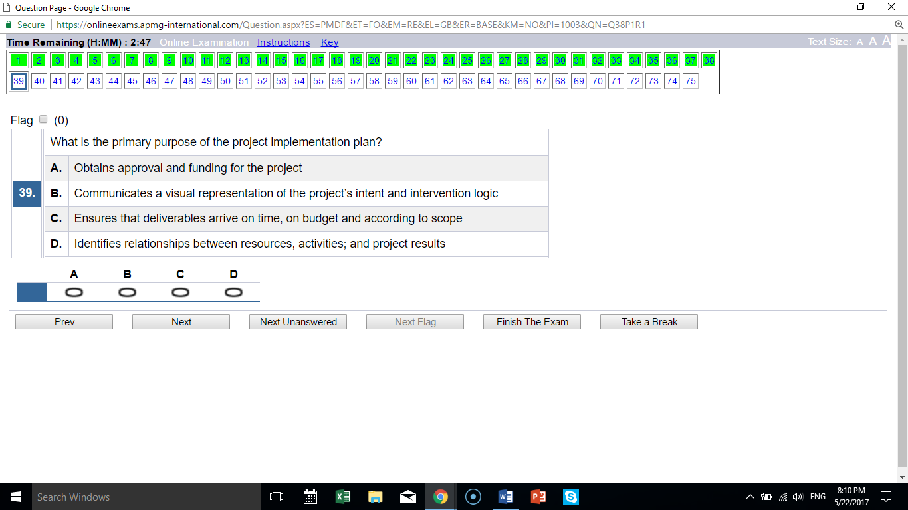
C correctly identifies the plan purpose

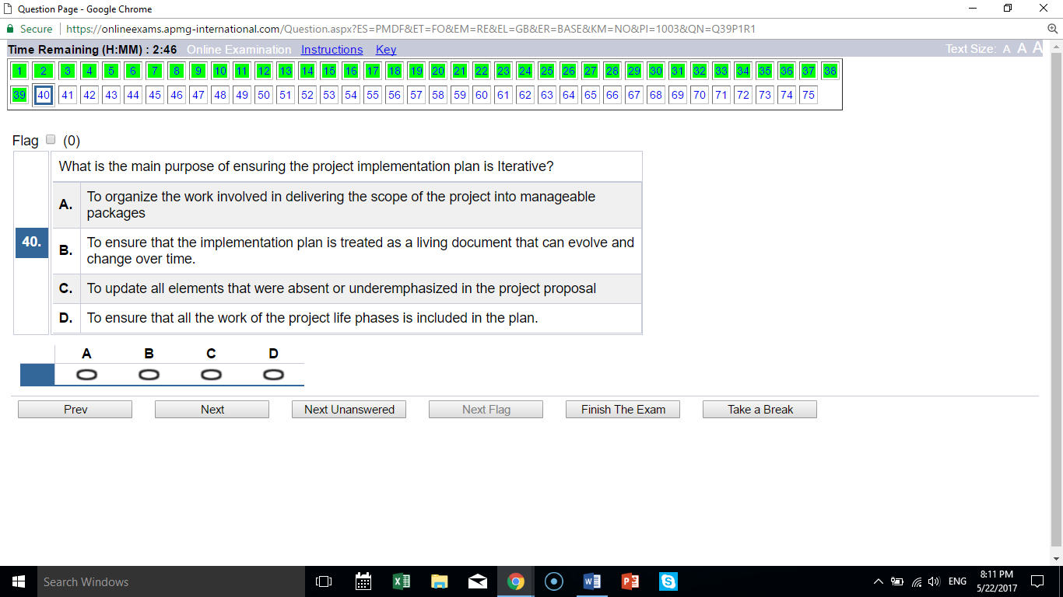
B “living document” are key words for iterative

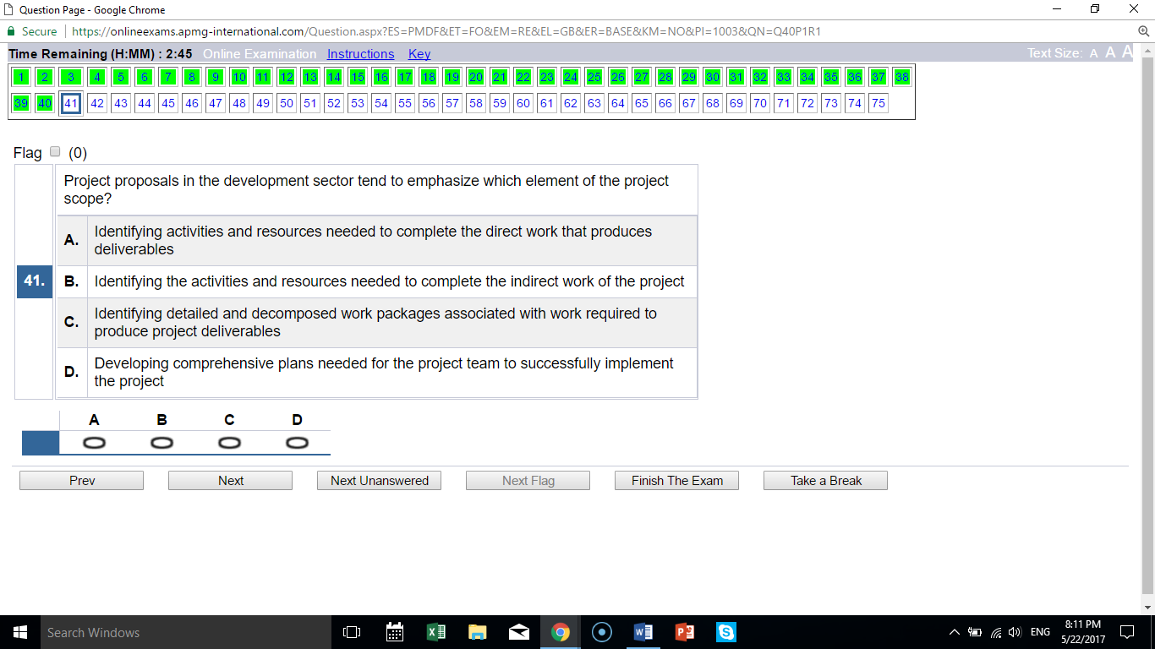
A emphasis is on direct work (but should be on direct and indirect work, which is part of PMD Pro training)

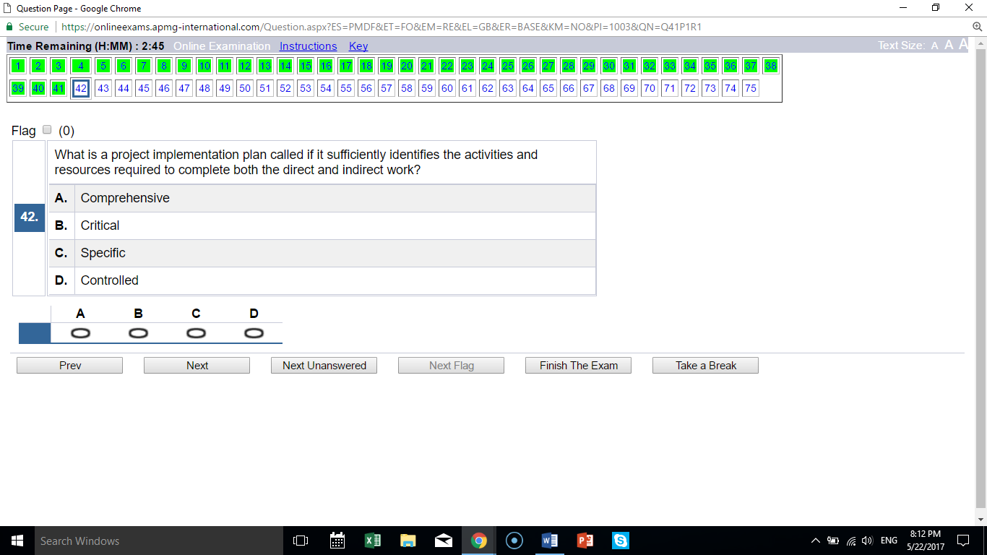
A direct and indirect = comprehensive

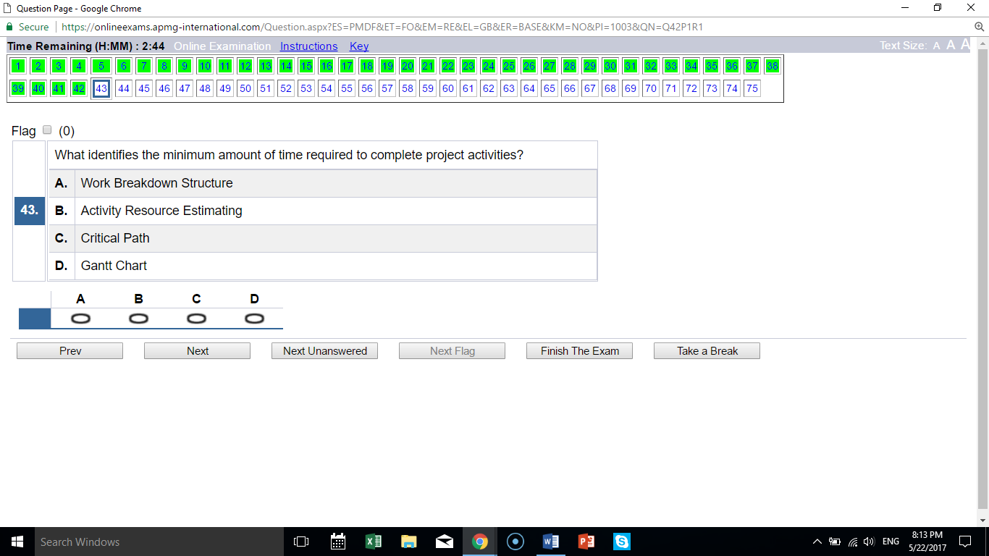
C statement is definition of critical path

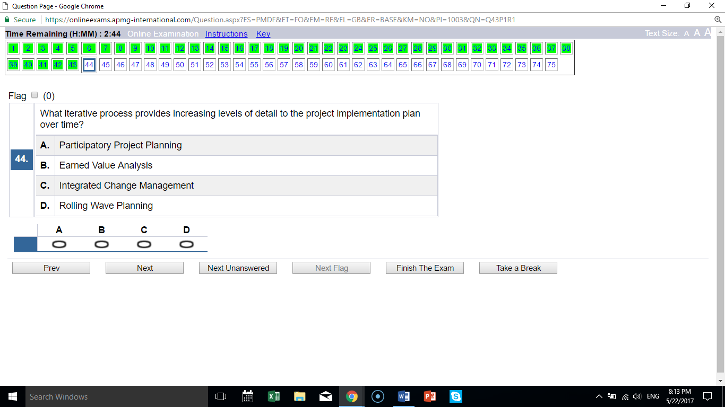
D “iterative” is key word for rolling wave planning

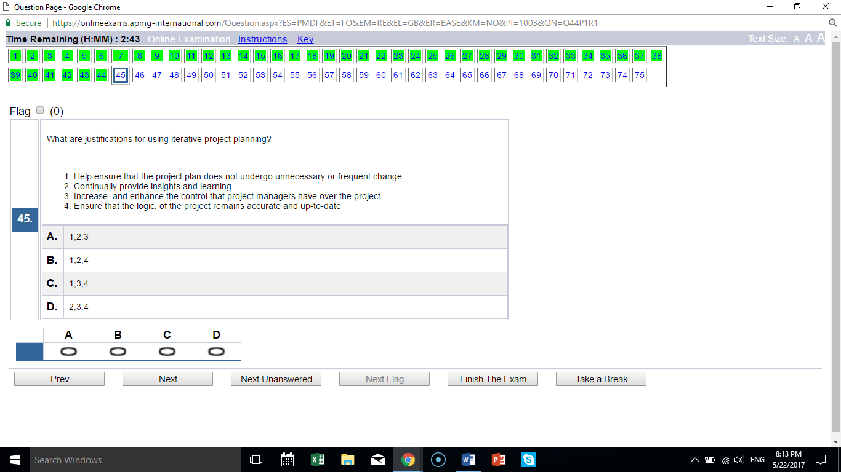
D exclude 1; all others are real benefits

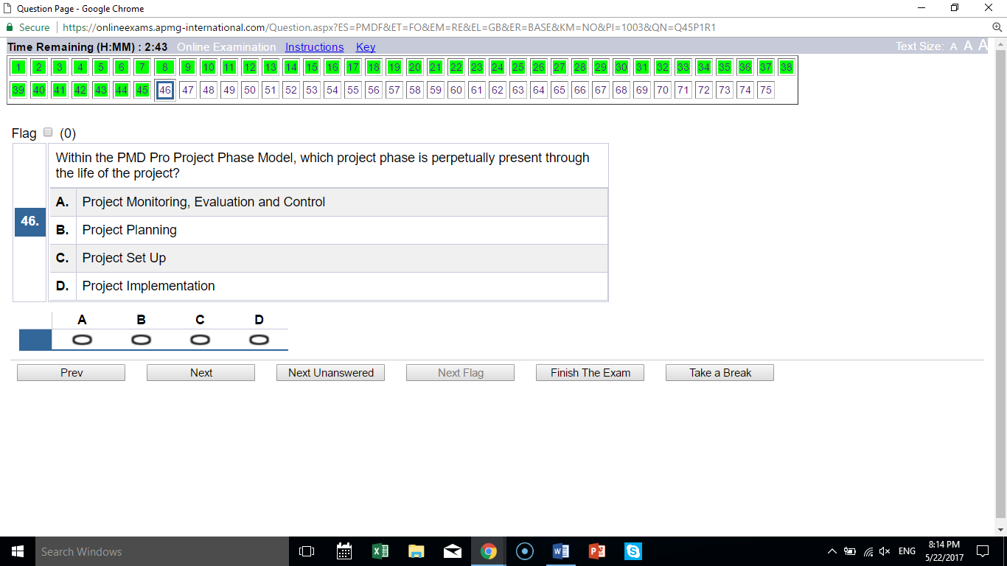
A MEC is perpetually present

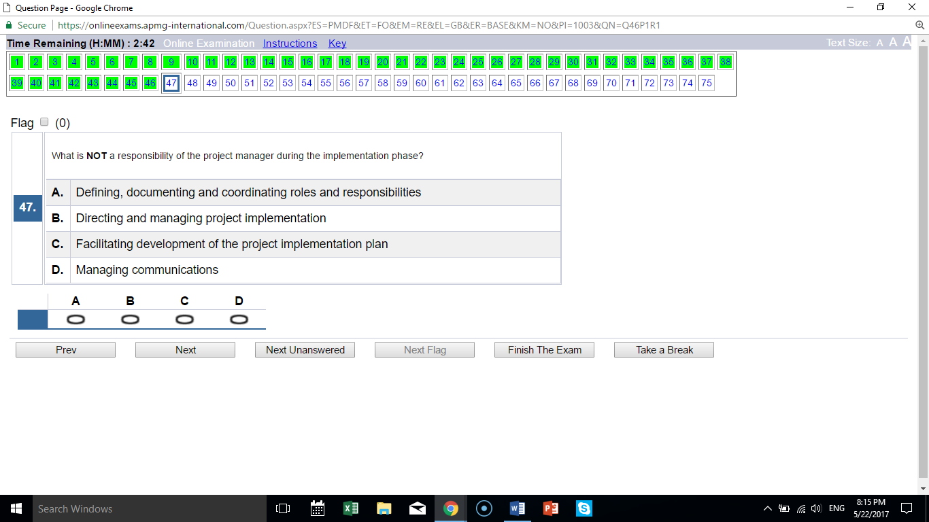
C plan development happens before, not during, implementation

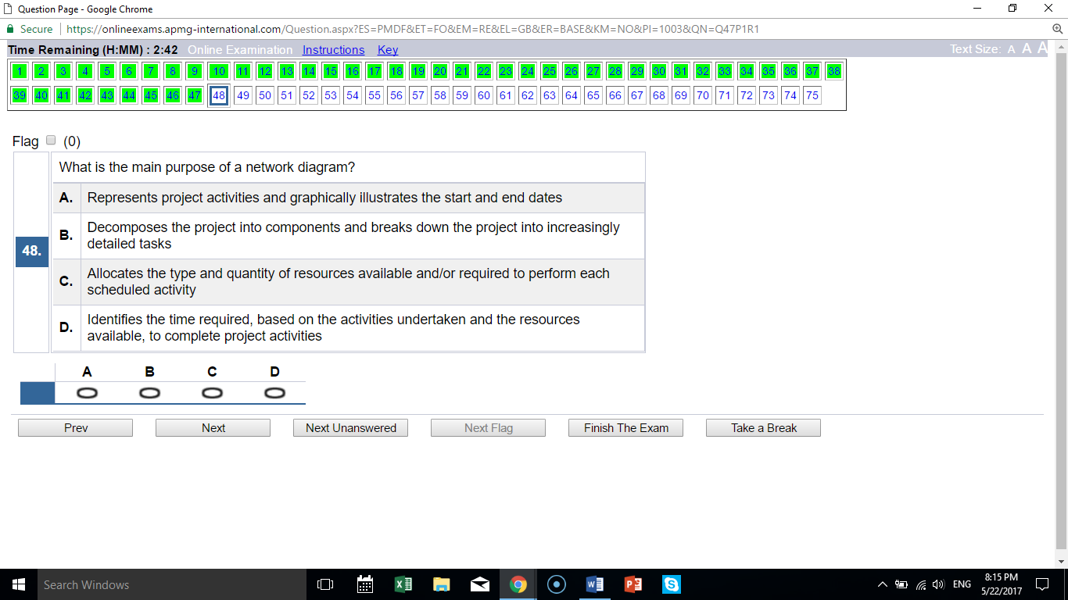
D is the description of network diagram; A is a Gantt chart, the others are other descriptions

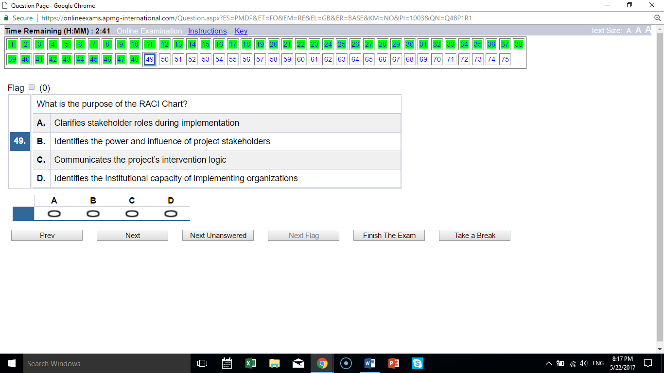
A RACI chart purpose is to clarify roles

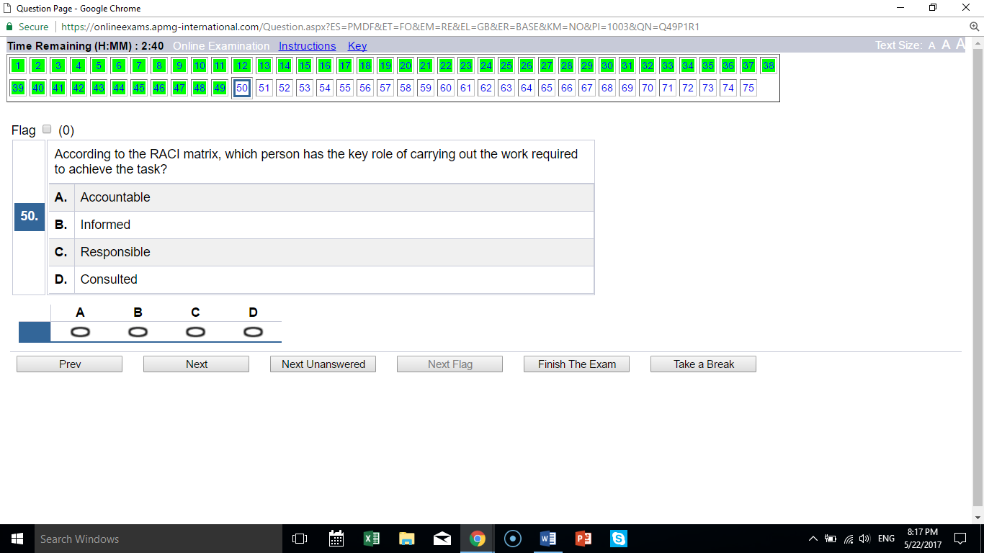
C the description is of the responsible person

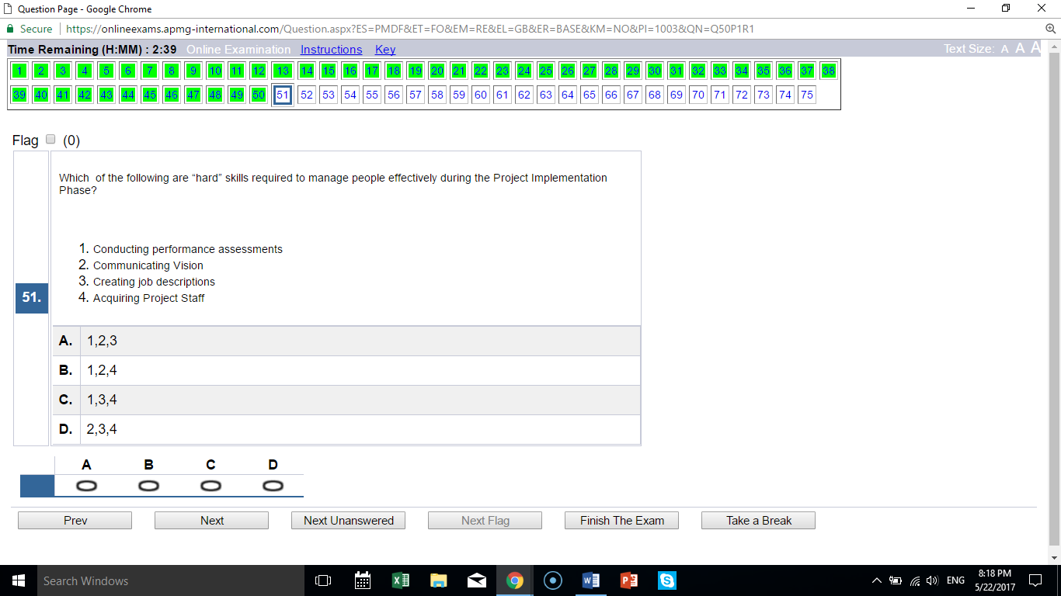
C exclude 2, which is a “soft” skill

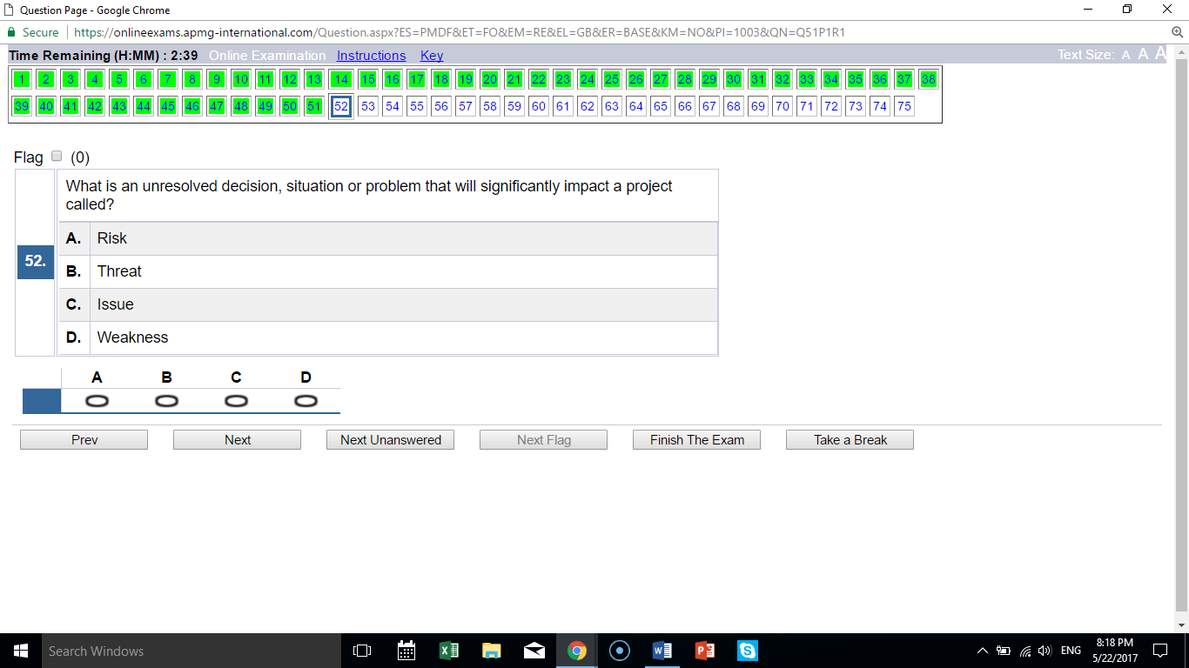
C the statement is a definition of “issue”

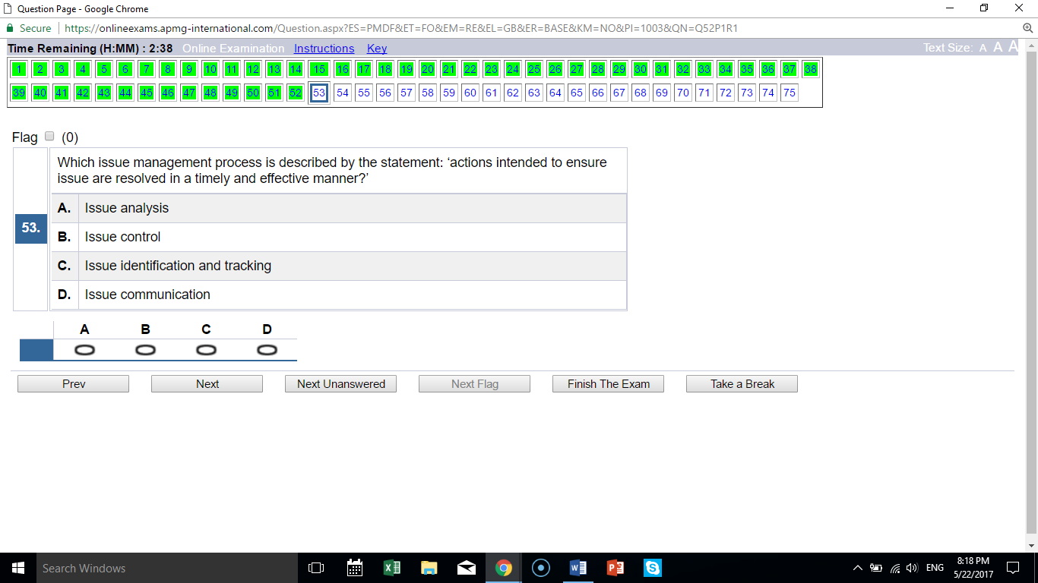
B statement is definition of “issue control”

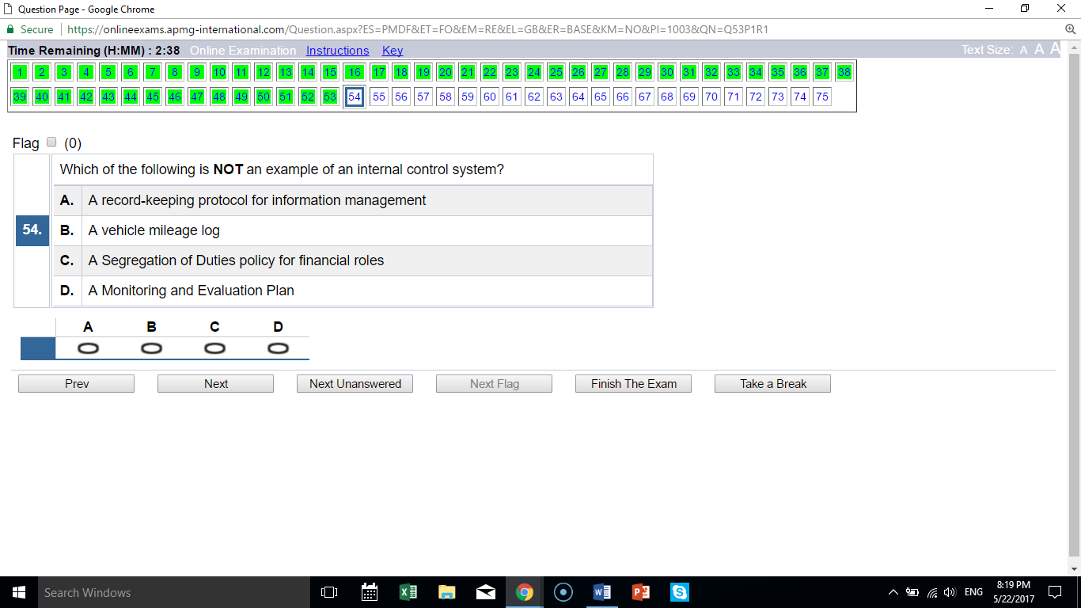
D M/E is not an internal control procedure; the others are

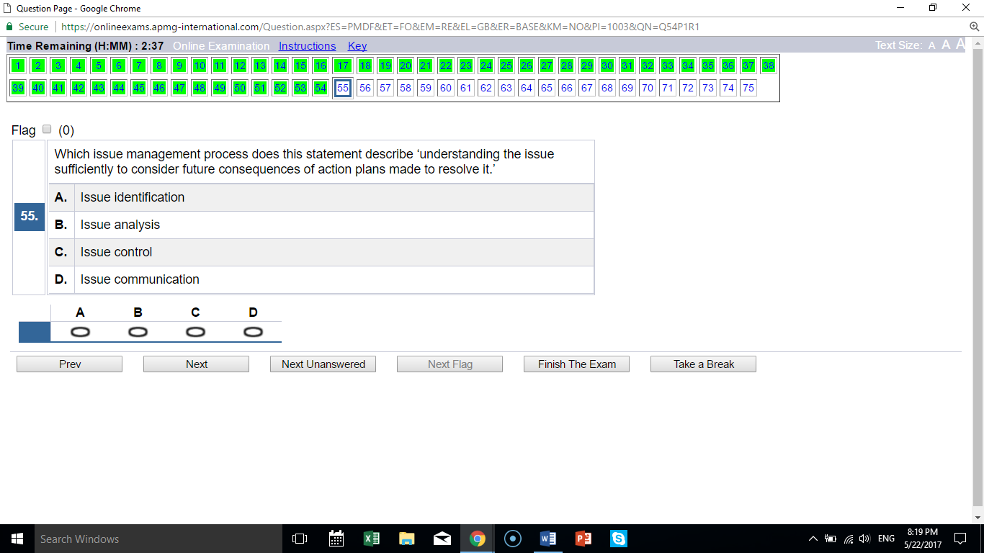
B the statement defines “issue analysis”

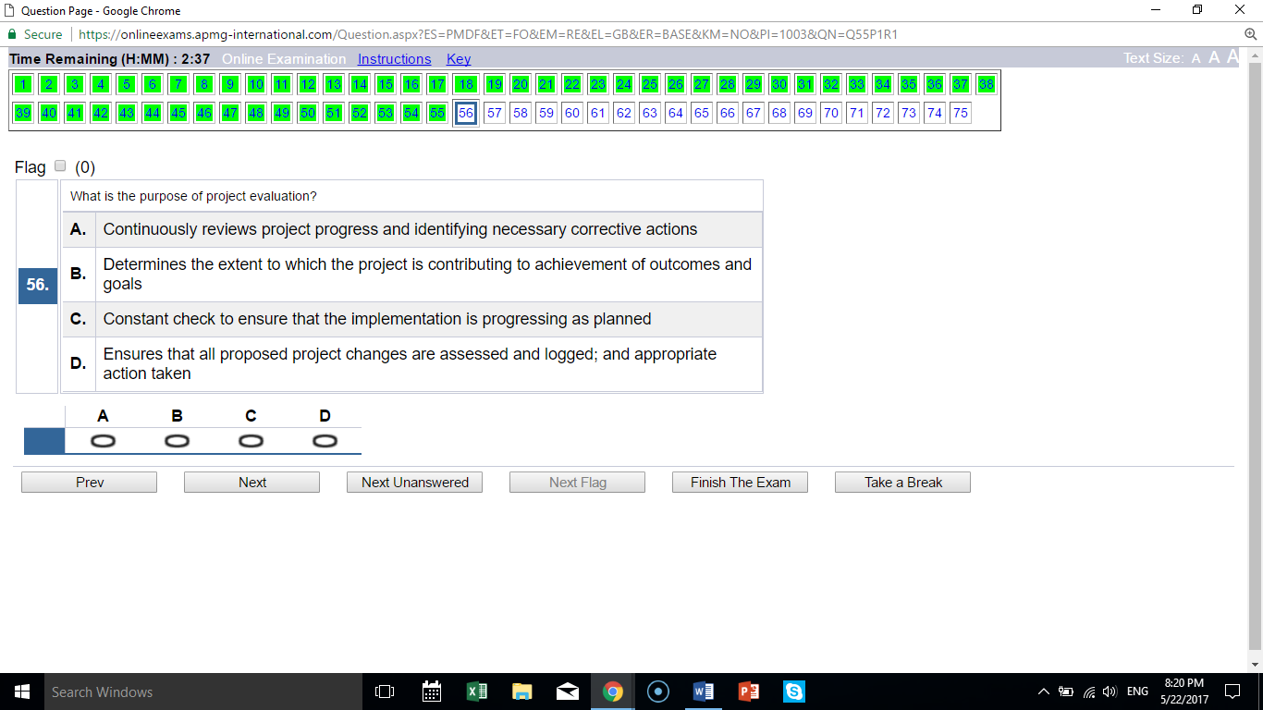
B evaluation focuses on outcomes and goals and is not continuous/constant

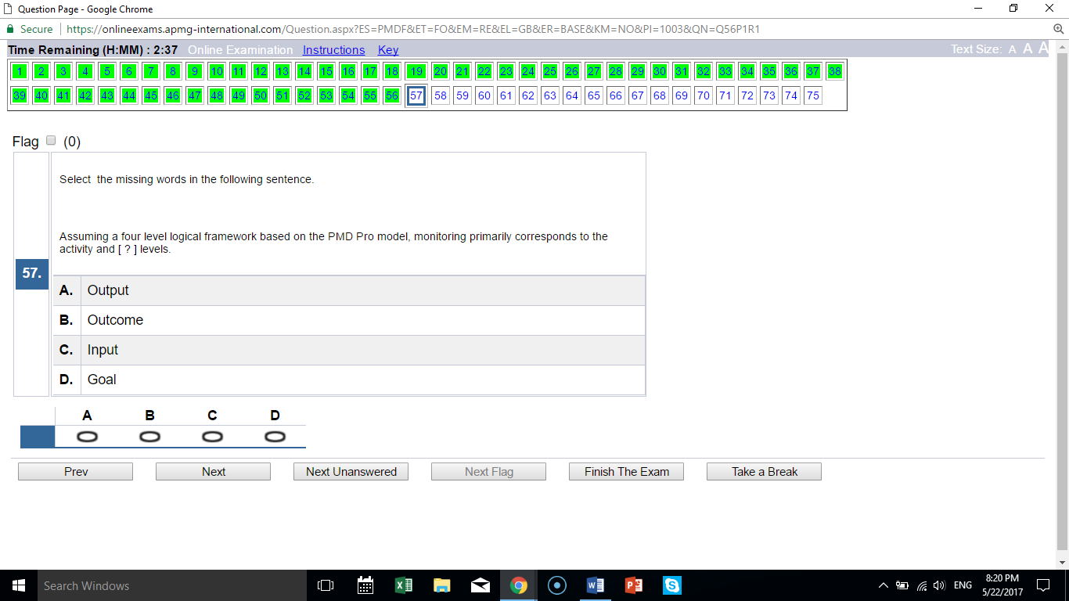
A monitoring relates to activities and outputs

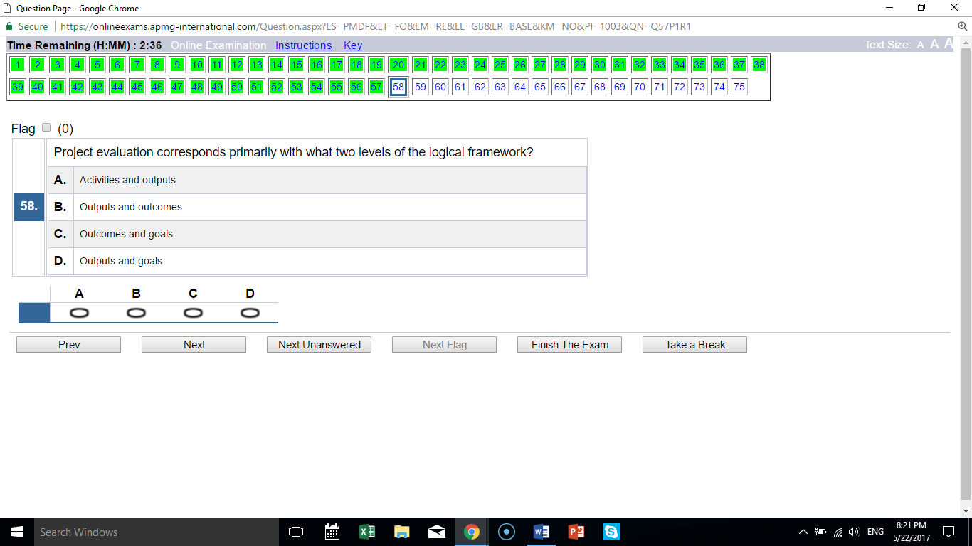
C evaluation relates to outcomes and goals

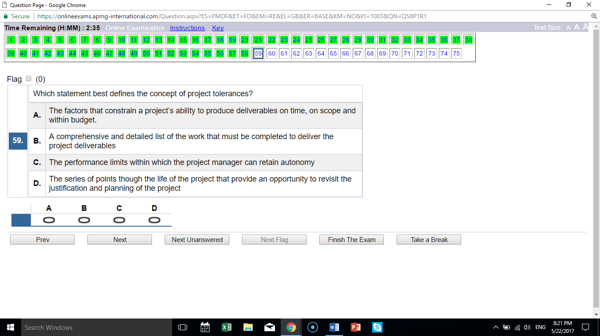
C correctly defines “tolerances”

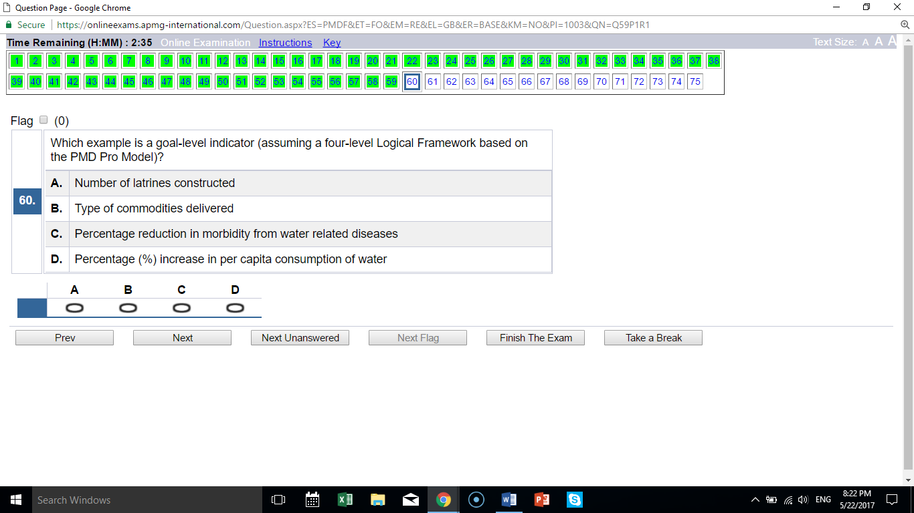
C is a goal; D is an outcome; A is an objective; B is an activity

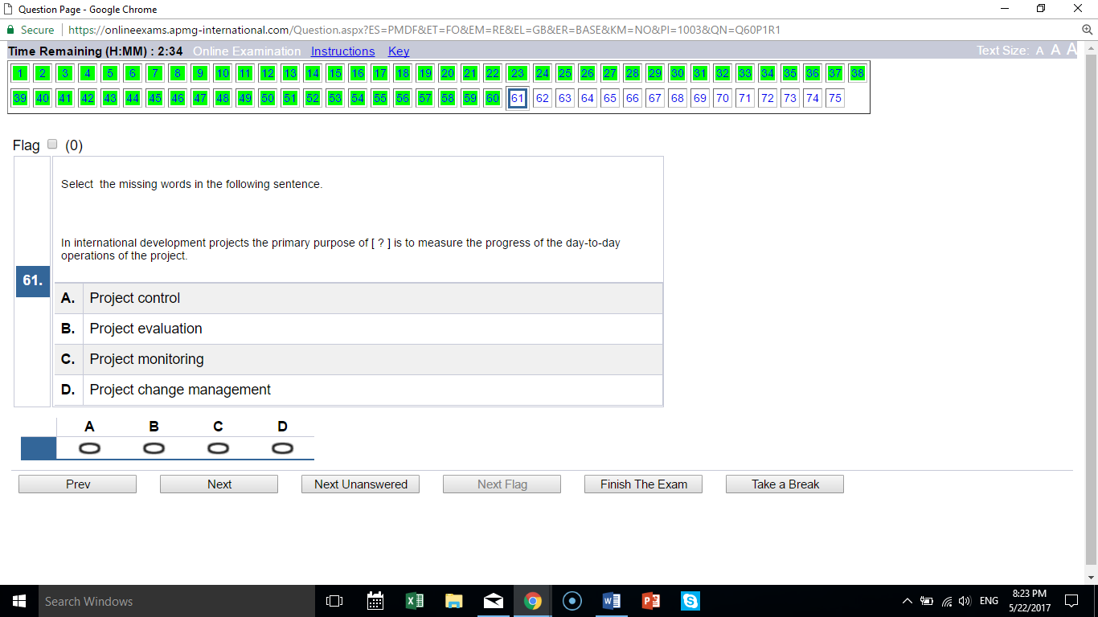
C monitoring relates to day-to-day progress

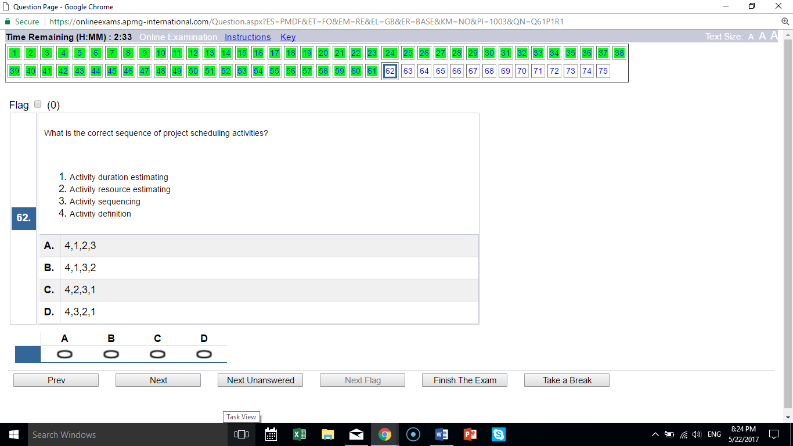
D 4, 3, 2, 1 is the correct order

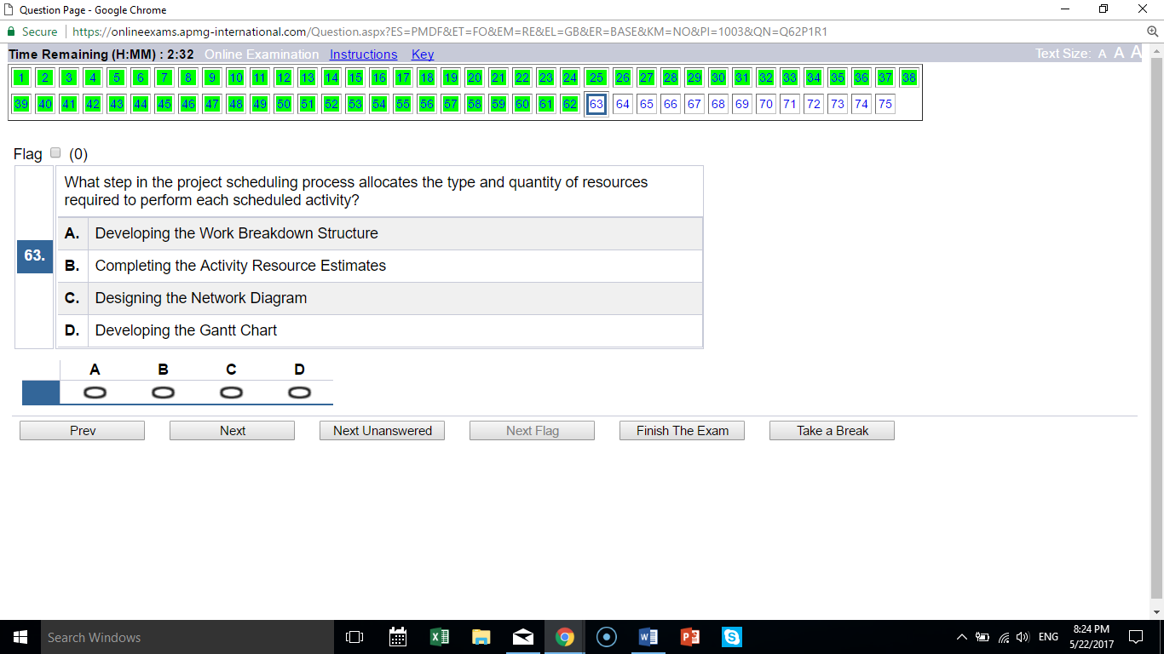
B the statement defines “activity resource estimates”

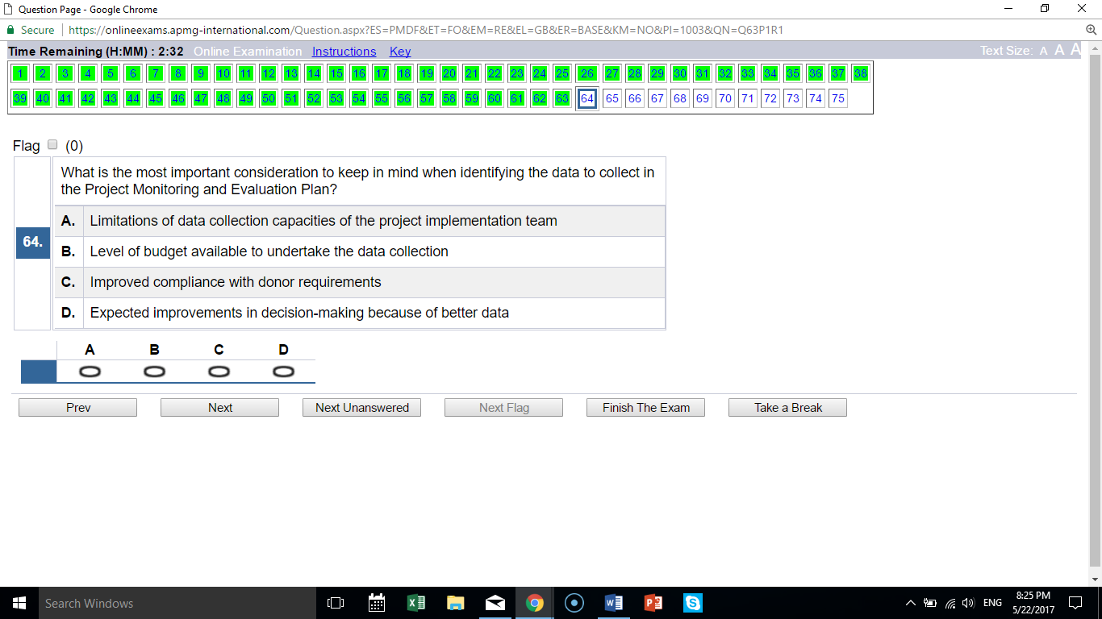
D decision making (not budget/cost) is the most important consideration

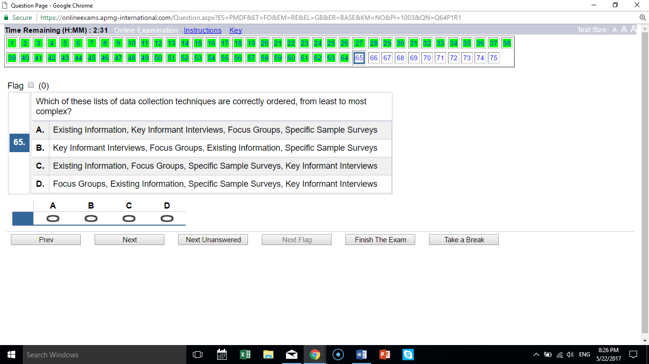
A is correctly ordered based on increasing complexity

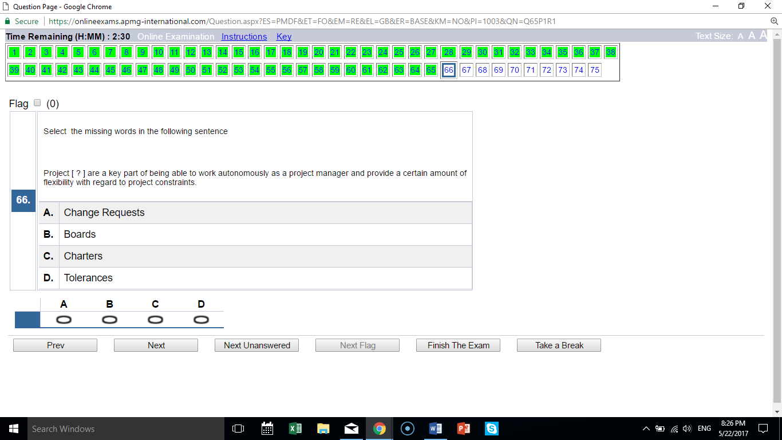
D tolerances provide flexibility regarding constraints

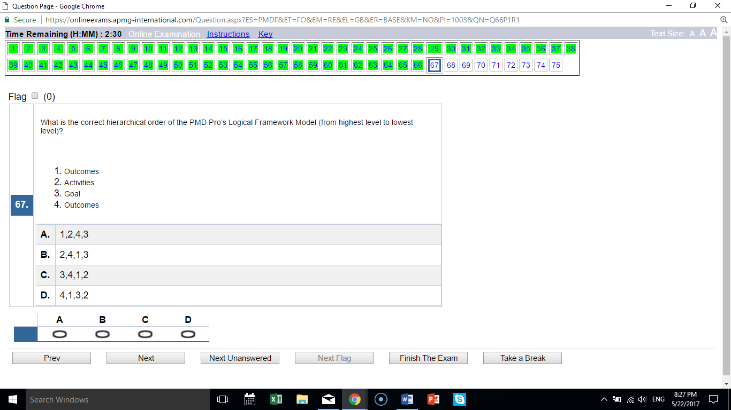
C goals is the highest level of the framework, then 4 outcomes, then 1 outputs (TYPO in the question), then 2 activities

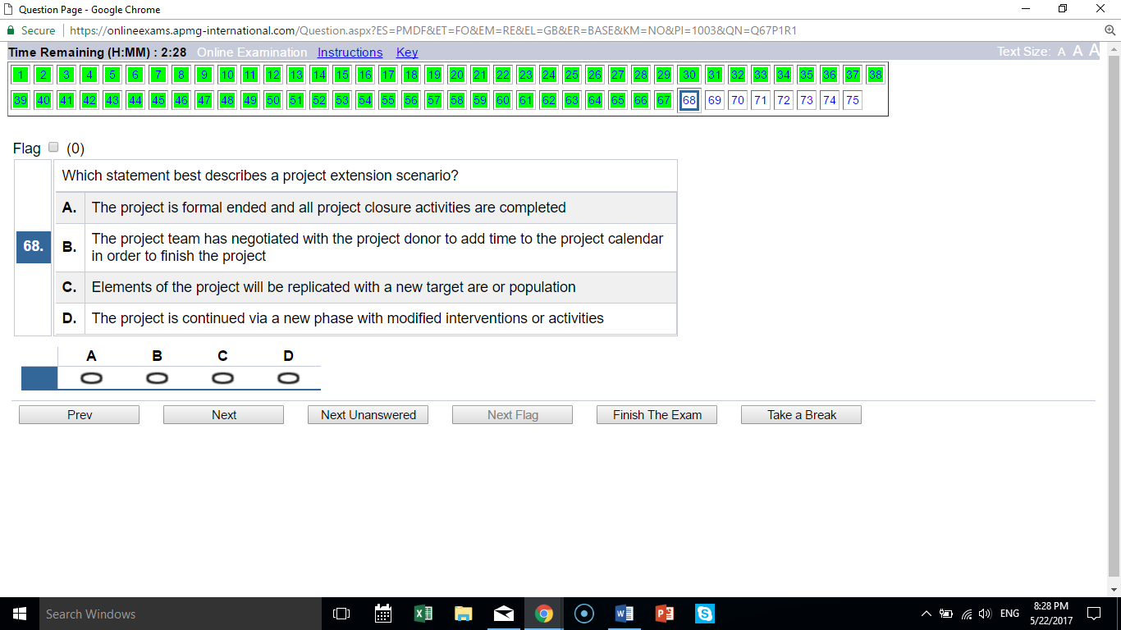
B extension = same project, more time

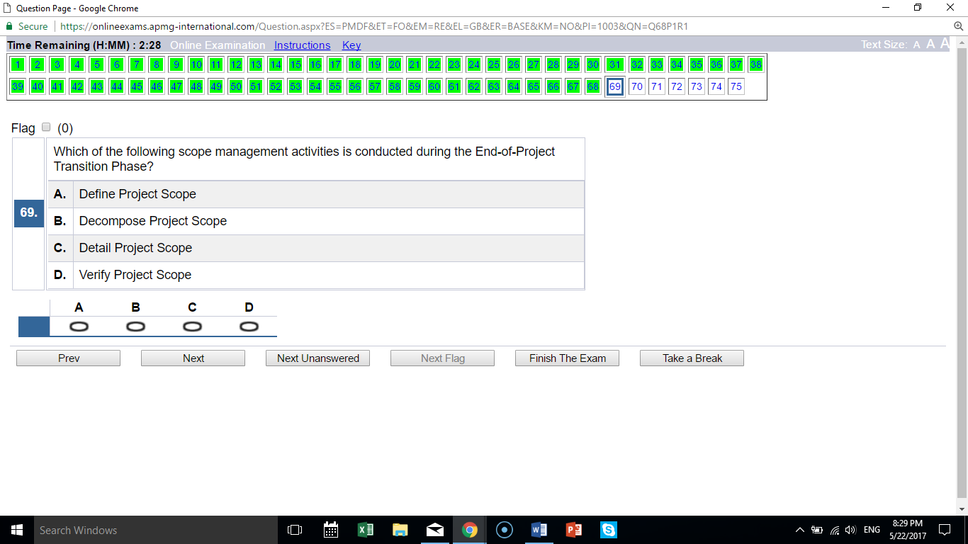
D verify scope occurs during transition

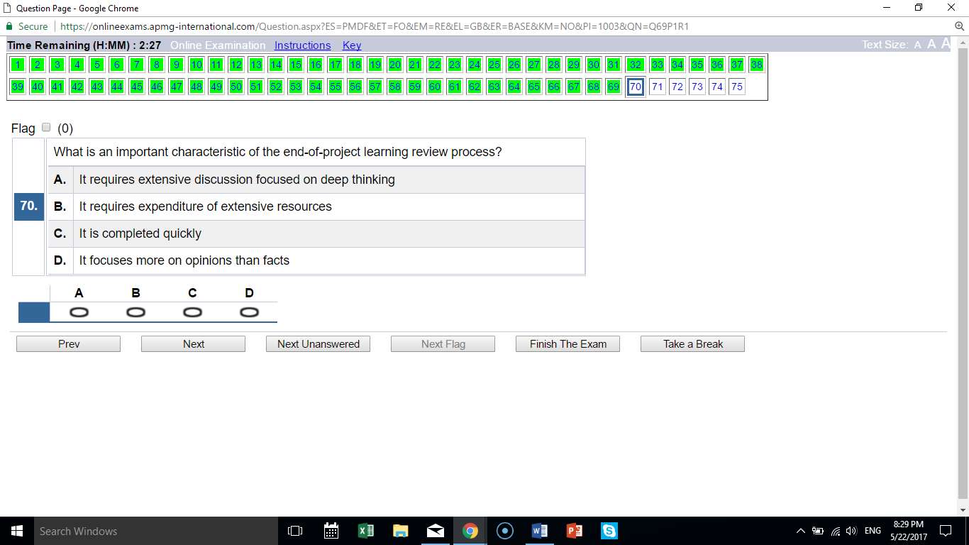
C learning review is quick and low cost

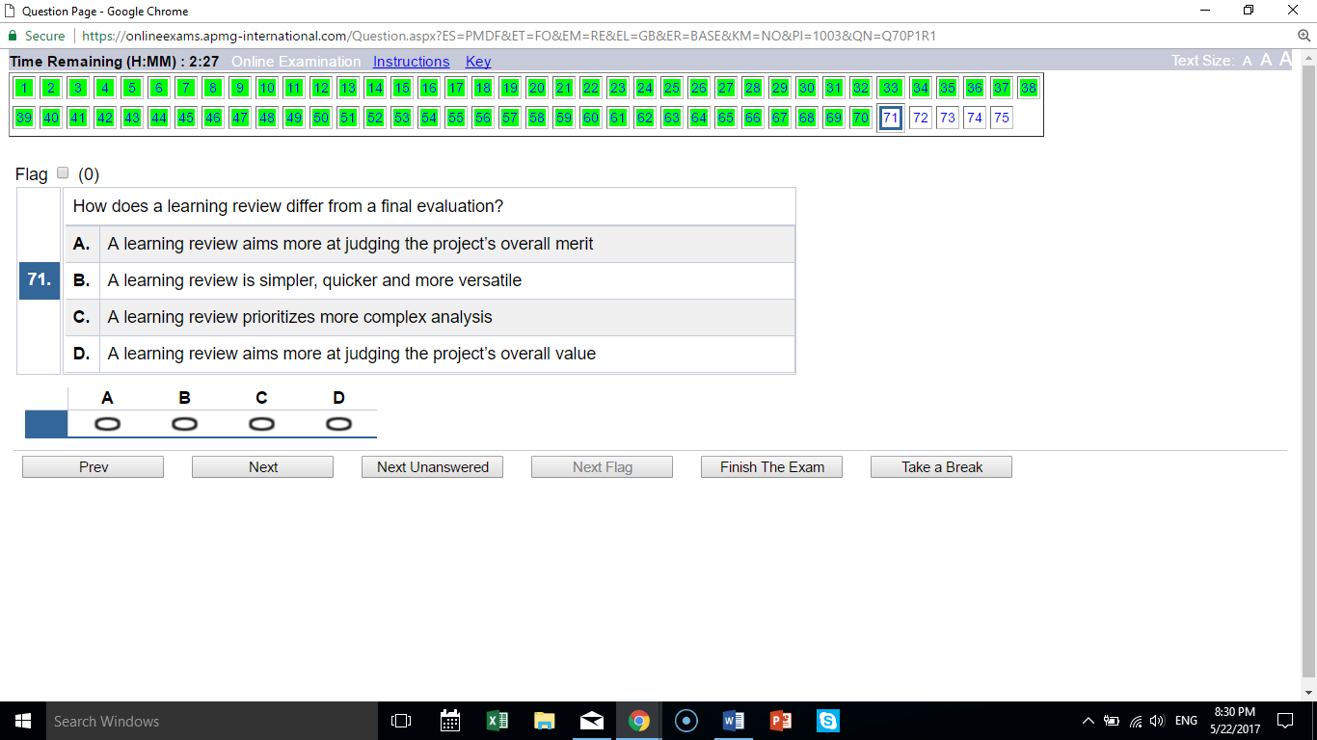
B learning review is relatively simple vs. an evaluation

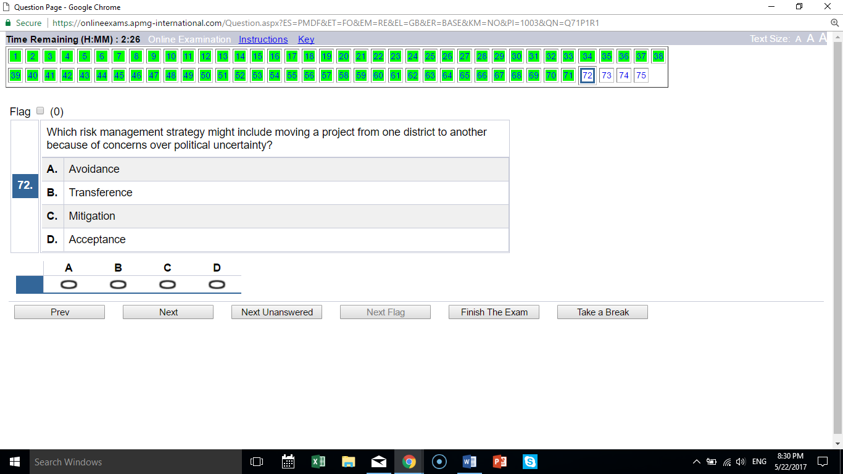
A not working in a particular area is avoidance

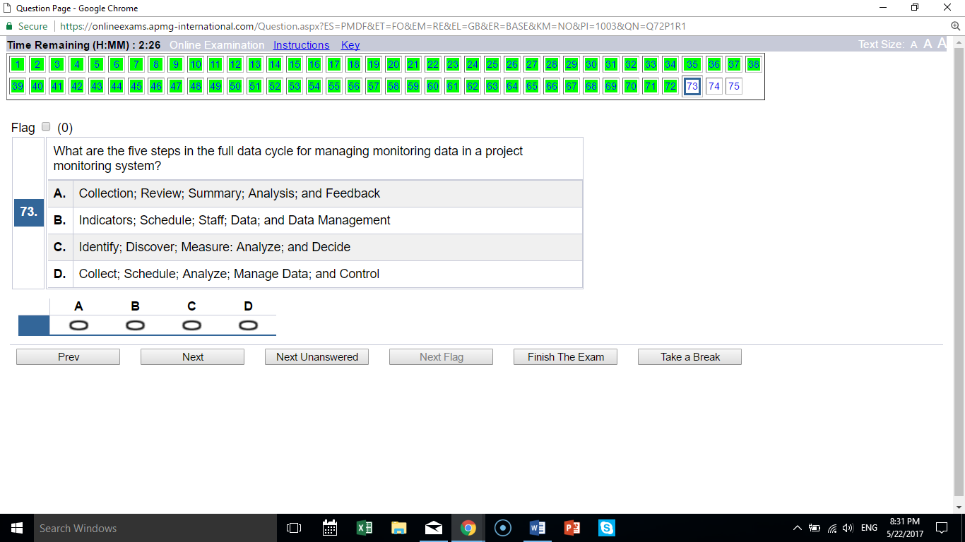
A is the correct list of a data cycle

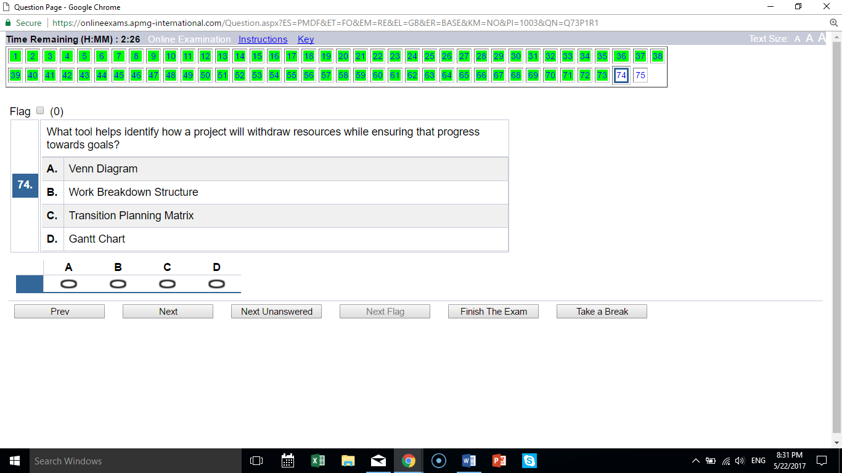
C “withdraw resources” happens during transition

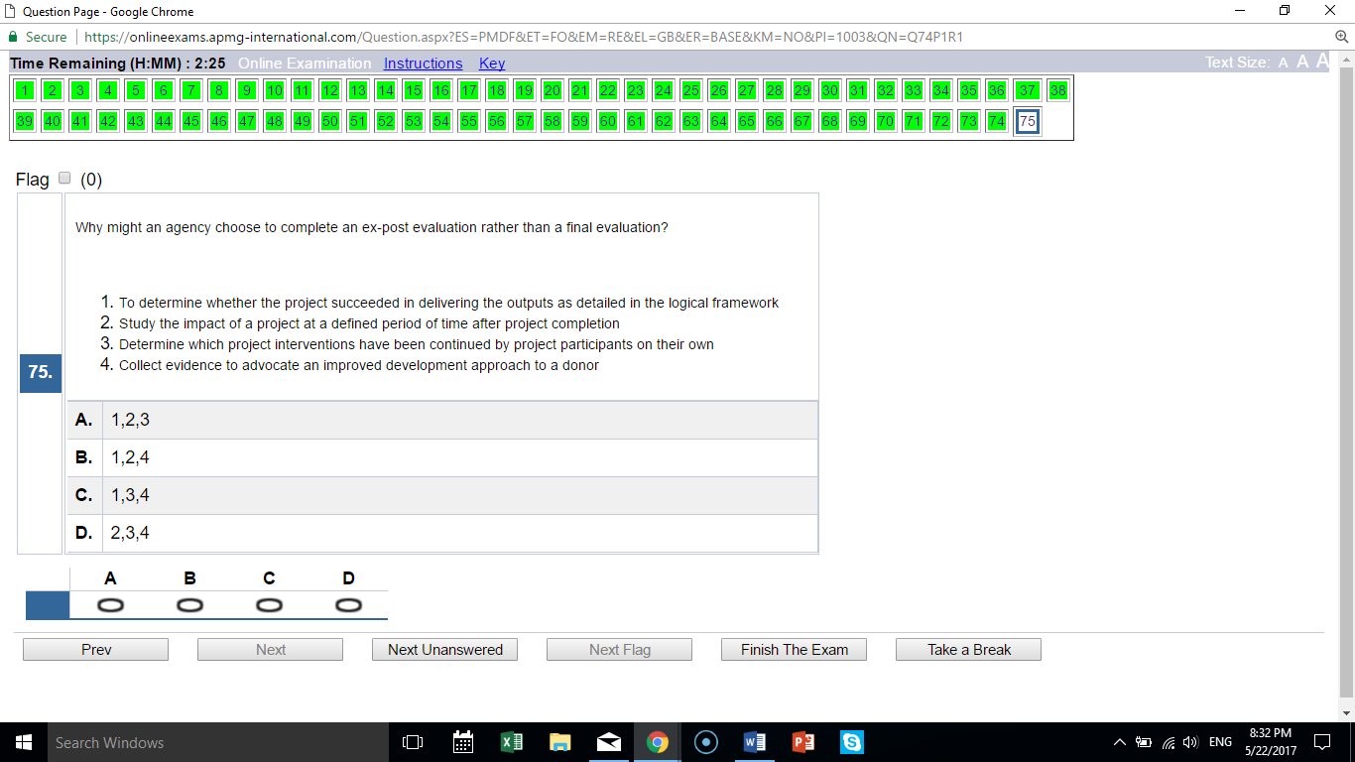
D exclude 1, which does happen during a final evaluation; all others only happen with an ex-post evaluation

FINAL RESULT:
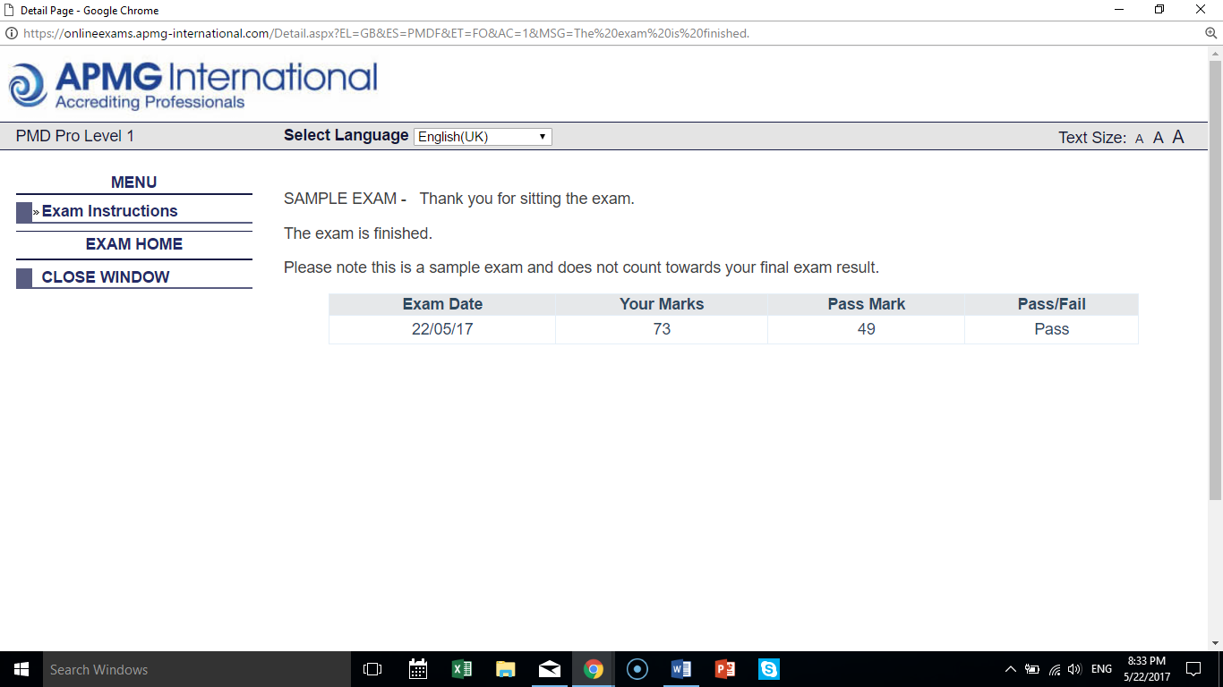
73/75; two of the answers are incorrect; APMG does not disclose the answers, so I do not know which two.

