Botany Lab

First a quick overview of the evolution of plants and then we discuss how they work.
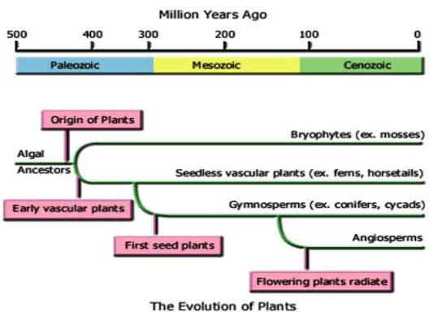
What kind of an ancestor did all land plants have? _____________________________
Give an example of a non-vascular land plant: _________________________________
Name three kinds of vascular plants: ___________ , _______________, ____________

Draw the life cycle of any plant:
Mosses
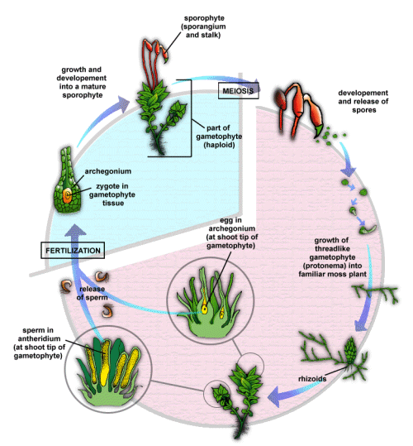
Moss is considered a primitive plant (basically a “landed” seaweed). Like all plants it undergoes alternation of generations.

Which generation is dominant in moss? ___________

Do you see the haploid generation?

Do you see a diploid generation?

Can you identify the male gametophyte?

Can you identify the female gametophyte?

Use magnifying glasses or microscopes to find any of the structures on the diagram.

They are limited in size. Why is that?

Ferns and Allies (Pteridophyta and allies)
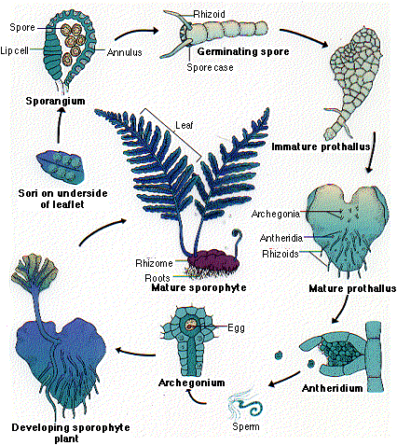
Which generation is now dominant?

What is another name for a fern gametophyte?

A sorus is a sac of many spore producing sporangia. Where are these located in a fern?
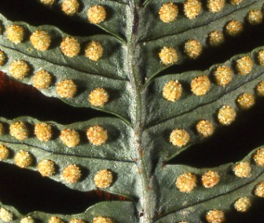

Identify and define the following:
Frond:
Rhizome:
Roots:
Monocots vs. Dicots
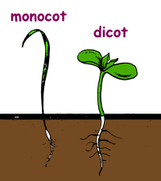
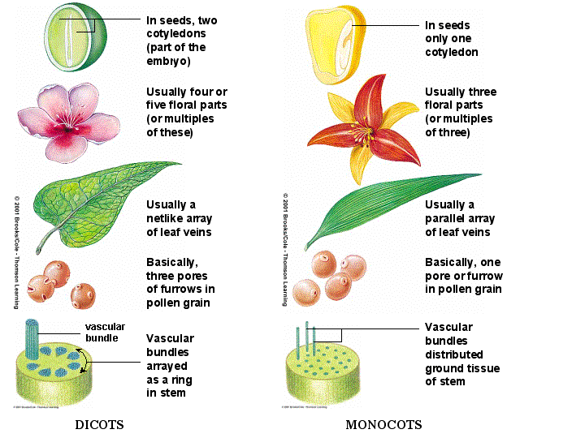
You have been handed two flowers;
Identify both as monocot or dicot and explain how you identified them.

What about kale? Explain
Go to page 612:
What is the function of flowers?

An angiosperm is a plant that produces seeds that are enclosed in a _______________.
The male structure of a flower is known as the _______________.
The female structure of a flower is known as the _______________ .

List the structures that make up the stamen.

List the structures that make up the carpel.

Describe the function of petals on a flower.
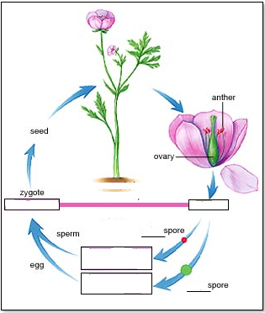
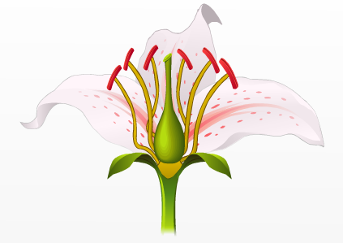

Fill in missing labels.

Indicate haploid and diploid

Label the flower diagram:
Draw the life cycle of ANY plant - Compare to angiosperm above

Look at a corn leaf – identify as monocot or dicot. Explain.

Try to dissect a corn kernel. Find the embryo. Draw a sketch.
Try to dissect a bean. Find the embryo. Draw a sketch.

Slice a small section of a stem from a monocot plant. View it under the microscope and make a diagram.
Slice a small section of a stem from a diocot plant. View it under the microscope and make a diagram.
Monocot Dicot

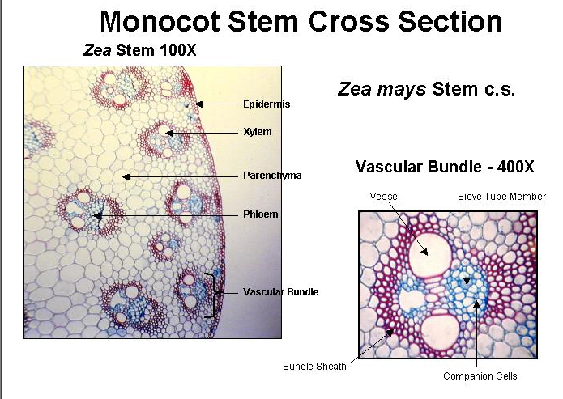
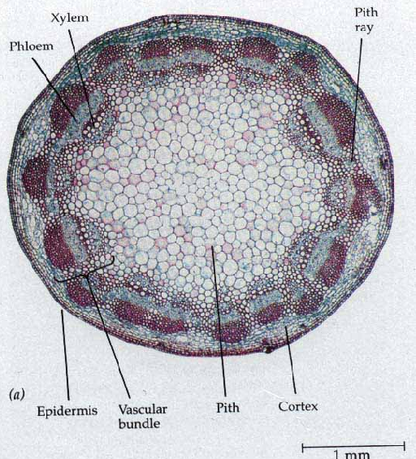

What is phloem?____________________________________________________________
What is xylem?____________________________________________________________

View a Leaf cross-section under the microscope. Find and label the following structures:

