Abiogenesis – the emergence of life for the very first time.

The question Darwin never addressed; was how life on Earth arose from inorganic matter; the so-called primordial soup. Consider, if life arose once on this planet, that would then mean that all life is related. Ultimately, humans and carrots have a common ancestor; the first proto-cell. Arrogant Worms tell it!

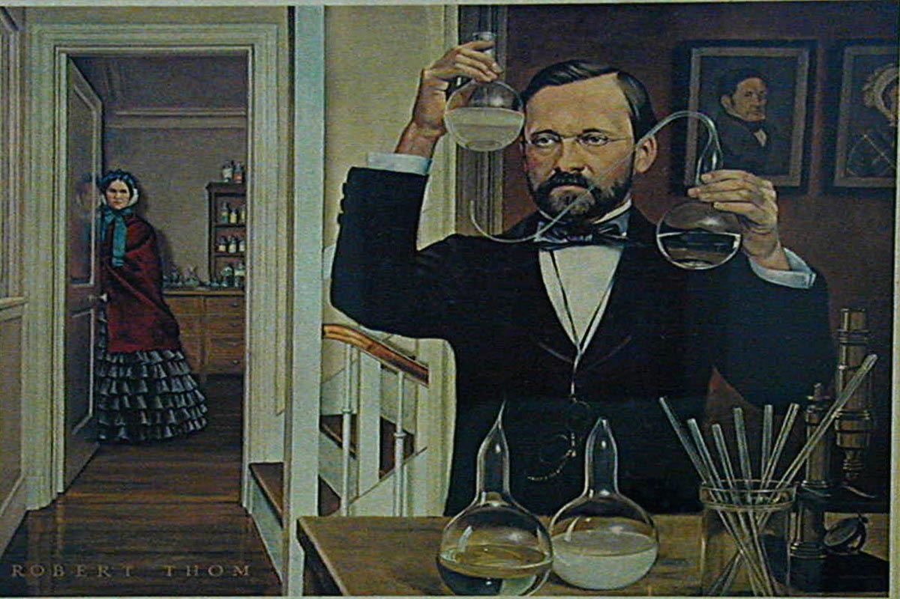
Science always proceeds in fits and starts. Pasteur disproved abiogensis with his famous swan-neck flask experiments. This success only confirmed Pasteur’s belief that something about life was different.

Pasteur believed that all metabolism including fermentation were special reactions that only occur in living organisms; i.e. there something special, maybe even supernatural to life. Pasteur believed that living things (the cells) contained a mysterious “vital force”. According to Pasteur, those marvelous macromolecules made by a cell could never be made in a test-tube. Pasteur was unaware of enzymes!
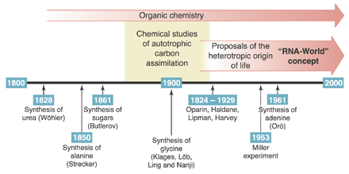
Pasteur discovered that Racemic acid can consist of two different geometrically mirror imaged crystals with opposite optical properties. Pasteur painstakingly separated out the two sets of crystals with tweezers before preparing two separate solutions. Pasteur correctly attributed differential optical activity to what he termed “molecular asymmetry”, which formed different crystals that were either right or left handed. Pasteur was the first scientist to understand the “homochirality problem” (explained below) (Link)

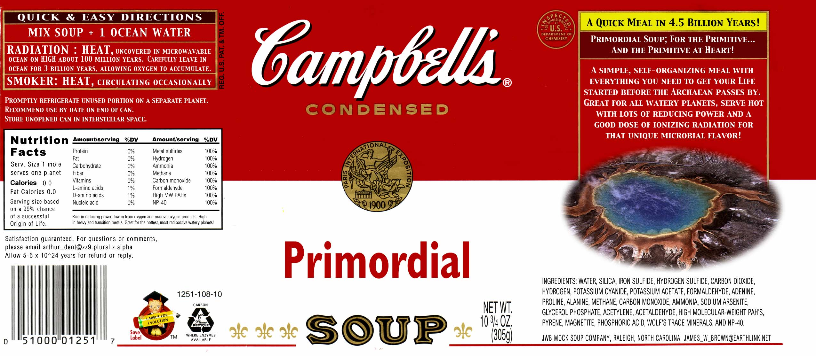
We now think a pre-biotic mix of monomers and polymers accumulated somewhere on our planet. From this mixture rose life for the first and only time, a very very unlikely event – the first proto-cell - explaining why all life shares the same genetic code. How did these molecules first arise and how they were first assembled?
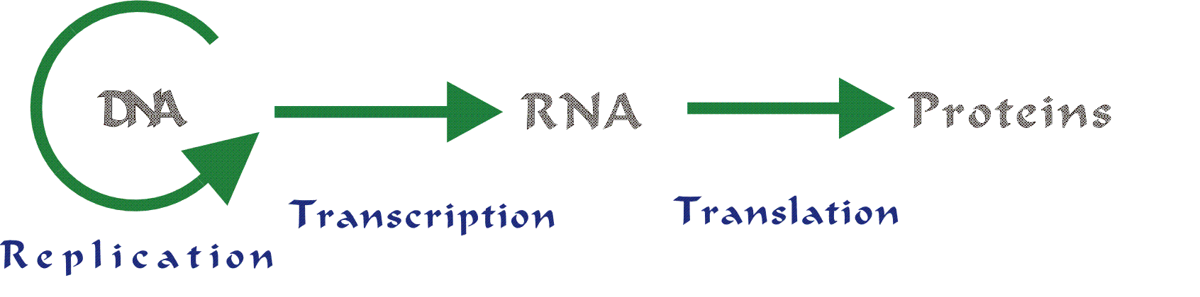
Consider the Central Dogma of Genetics:


The emergence of life for the first time on this planet constitutes the classic question of what came first; the chicken or the egg?! Did a self-replicating DNA system occur before transcription or translation evolved (the DNA World) or did a self-replicating RNA system first emerge (the RNA world) or did self-replicating protein system first emerge (the Protein World)…or did replication, transcription and translation emerge together all at once. (excuse me? that’s unlikely!).

In the early 1960s, scientists reckoned that proteins were the only polymer complicated enough to generate a catalytic self-replicating system (proto-life) inside “proteinoid” microspheres. Nucleic acids were considered later add-ons.

Crick (of Watson & Crick fame) together with Leslie Orgel proposed “Directed Panspermia” where intelligent life forms using space travel technology spread life throughout the universe. (Cue: theme music from Star Trek)

Francis Crick later regretted he had speculated so wildly in public. That theory was called exogenesis.
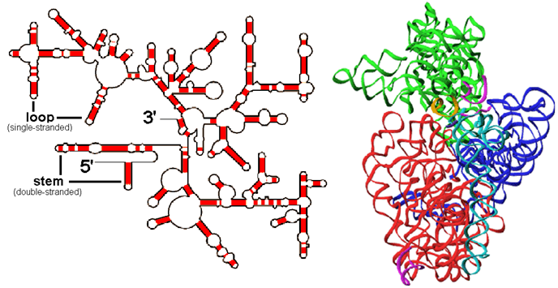
Francis Crick did redeem himself. Together with Carl Woese and Leslie Orgel, Francis Crick suggested that RNA (not protein) could have acted as the first self-replicating catalyst based on its ability to form complex secondary structures.

Consider the super-enzyme (our familiar ribosome) which is really auto-catalytic RNA with some extra added protein for stability. In fact, a ribosome can be considered the RNA used by other RNAs ultimately to make more RNAs (just as the chicken is one egg’s way ultimately of producing more eggs)
2D vs 3D structure of Ribosomal RNA both without protein.

Then two biochemists, Sidney Altman and Thomas Cech, independently discovered a kind of RNA that could edit out unnecessary parts of the message it carried before delivering it to the ribosome. Since RNA - ribonucleic acid - was acting like a type of protein known as an enzyme, Cech called his discovery a ribozyme. The two were awarded the Nobel Prize for Biochemistry in 1989.
Even if we accept this so-called “RNA-world” hypothesis; one still wonders how life could first emerge from a pre-biotic primordial soup. Three hypotheses contend:
- “Hot (or at least warmish) Primordial Soup” with clay or crystal surfaces to direct polymerization.
- “Life on Ice”
- “Panspermia”

A great mind addressed the problem a while ago: http://www.youtube.com/watch?v=gIjDAbY8tDQ

Before proceeding any further, distinguish ribozyme from ribosome: Link

Ribozyme – definition: ______________________________________________________________________
____________________________________________________________________________________

Ribosome – definition: ________________________________________________________________
____________________________________________________________________________________

Connection between ribozyme and ribosome explained: ____________________________________________
__________________________________________________________________________________________
__________________________________________________________________________________________
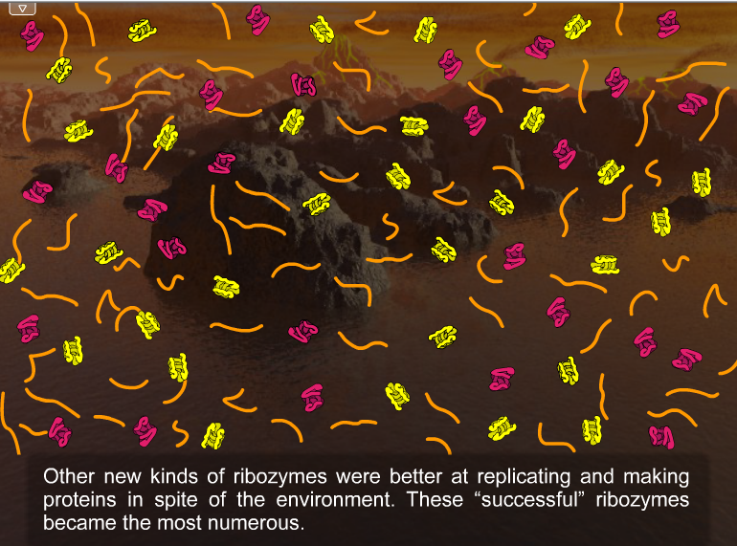
One of Biology’s “Big Ideas” is the notion that Evolution generates change over time. One mechanism for evolution is “Natural Selection”.

This elegant theory applies to not only to Finches on the Galapagos Island or to different colored moths in soot-covered England during the Industrial Revolution: Natural Selection can also happen with molecules in a “primordial soup”. (Link)

Indeed investigators have managed to produce “ribozymes” in the laboratory that are capable of catalyzing their own synthesis. That means the so-called chicken egg dilemma could be resolved by suggesting that a catalytic self-replicating “ribozyme” system replicated itself; while translation and replication evolved as later add-ons. Here is the paper that started this line of inquiry. link

1. Abiogenesis - Miller's Experiment (the first attempt to recreate “primordial soup”)
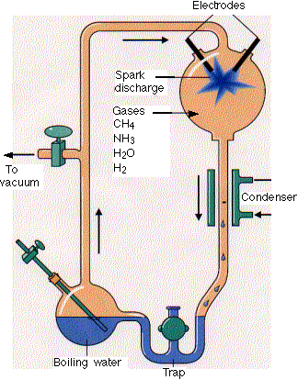
Stanley Miller, a graduate student in biochemistry, built the apparatus shown here. He filled it with
- water (H₂O
- methane (CH₄)
- ammonia (NH₃) and
- hydrogen (H₂)
- but no oxygen

Miller hypothesized that this mixture resembled the atmosphere of the early earth. (Some are not so sure.) The mixture was kept circulating by continuously boiling and then condensing the water.
The gases passed through a chamber containing two electrodes with a spark passing between them.
At the end of a week, Miller used paper chromatography to show that the flask now contained several amino acids as well as some other organic molecules.
In the years since Miller's work, many variants of his procedure have been tried. Virtually all the small molecules that are associated with life have been formed:
- 17 of the 20 amino acids used in protein synthesis, and
- all the purines and pyrimidines used in nucleic acid synthesis.
- But abiotic synthesis of ribose — and therefore nucleosides — has been much more difficult.
In fact Miller abandoned this approach because he could not make ribonucleotides. Is this still considered a problem? Explain:
____________________________________________________________________________________________________________________________________________________________________________________
One difficulty with the prebiotic soup theory is that it is now thought that the atmosphere of the early earth was not rich in __________________ and _____________________ (essential ingredients) as Miller supposed.
Identify two potential sources for long peptides in Earth’s “prebiotic soup” before life arose:
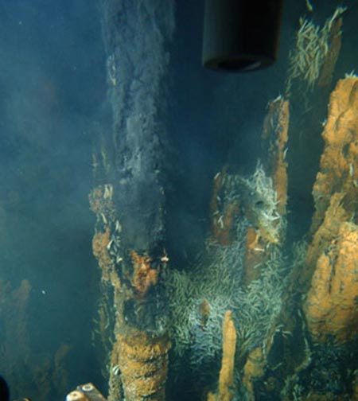
http://www.livescience.com/strangenews/041105_volcanic_peptides.html

____________________________________________________ &

_____________________________________________________

Any theory of abiogenesis must account for the homochirality problem”.

What is an entantiomer?
__________________________________________________________________________________________
__________________________________________________________________________________________

What is homochirality? __________________________________________________________________________
__________________________________________________________________________________________

Are amino acids’ entantiomers “left handed” or “right handed”? _______________________________
Are nucleic acids “left handed” or “right handed”? ________________________________________
Could enzymes mix and match different entantioimers? Why or why not; explain.
____________________________________________________________________________________________________________________________________________________________________________________
Miller appreciated the limitations of his fist experiments in 1953 (his first experiments were in fact just a first step in the correct direction).
Some more recent hypotheses improved on Miller’s first work.
http://www.astrobio.net/exclusive/3083/how-life-shatters-chemistrys-mirror

This articles makes two suggestions how homochirality could have risen. They are:
____________________________________________________________________________________________________________________________________________________________________________________
____________________________________________________________________________________________________________________________________________________________________________________

A 10% excess of one entantiomer is not much and would requires “amplification”. This article suggests just how such amplicfication could occur: http://www.ox.ac.uk/media/science_blog/110401.html Explain:
____________________________________________________________________________________________________________________________________________________________________________________

Miller came up with a radically different approach to his prebiotic abiogenesis hypothesis. Read the following article: Did Life Evolve in Ice? Funky properties of frozen water may have made life possible.

In late 1997, Stanley Miller lifted a glass vial from a cold, bubbling vat…
What temperature was the vat? What was in the vial? How long was it kept cold?
____________________________________________________________________________________________________________________________________________________________________________________

What did they find in the vial? Why were these results “better” than the 1953 experiment? (You will need to review the basic structure of monomers)
____________________________________________________________________________________________________________________________________________________________________________________

Why were scientists at first sceptical?
____________________________________________________________________________________________________________________________________________________________________________________
In your own words, explain “eutectic freezing”
____________________________________________________________________________________________________________________________________________________________________________________

What was the average temperature of the earth 4 billion years ago? ___________________________________
Why would that be? ________________________________________________________________________

Hauke Trinks noticed ice has a tendency to accumulate pollutants from the atmosphere and concentrate them in liquid pockets within the ice. By 2003, he had formulated a theory that ice was doing much more than just concentrating chemicals. Explain…____________________________________________________________
_________________________________________________________________________________________

Life’s earliest genetic material was probably __________.

Using ice, Biebricher managed to grow _______ molecules _____________ bases long.

Perhaps Biebricher was cheating (he prefers to use the word “mystery); Biebricher only obtained these long molecules when ________________________________________________________________________

Vlassov and his coworkers may have stumbled upon a solution to Biebricher’s mystery. What were their findings?___________________________________________________________________________________________________________________________________________________________________________

Can prokaryotic life exist in temperatures below freezing? Yes/No Explain
____________________________________________________________________________________________________________________________________________________________________________________

Could life arise elsewhere in our solar system? Where? ____________________________________________
__________________________________________________________________________________________
Read the following article: http://discovermagazine.com/2010/nov/31-deep-sapce-birthplace-life-cosmos
Define the new and improved version of the Panspermia hypothesis: __________________________________
__________________________________________________________________________________________

Observations of Saturn’s and Jupiter’s moons support the idea of Panspermia. Elaborate
____________________________________________________________________________________________________________________________________________________________________________________
How many organic molecules have we been able to discover in deep space?
____________________________________________________________________________________________________________________________________________________________________________________

How do Louis Allamandola’s experiments support the Panspermia hypothesis?
______________________________________________________________________________________________________________________________________________________________________________________________________________________________________________________________________________

Another hypothesis addressing the homochirality problem Final article to read: http://www.sciencedaily.com/releases/2011/01/110107145634.htm

Bearing in mind the Homochriality problem, explain which version of abiogenesis sound most likely in your opinion?
________________________________________________________________________________________________________________________________________________________________________
________________________________________________________________________________________________________________________________________________________________________
________________________________________________________________________________________________________________________________________________________________________
________________________________________________________________________________________________________________________________________________________________________
________________________________________________________________________________________________________________________________________________________________________
________________________________________________________________________________________________________________________________________________________________________
________________________________________________________________________________________________________________________________________________________________________
________________________________________________________________________________________________________________________________________________________________________

