Changes made to mRNA –pre-mRNA is post-transcriptionally modified in Eukaryotes .
Eukaryotic cells are under constant virus attack. One mechanism to prevent virus infection is to chop up invading viral RNA genomes with RNAases.
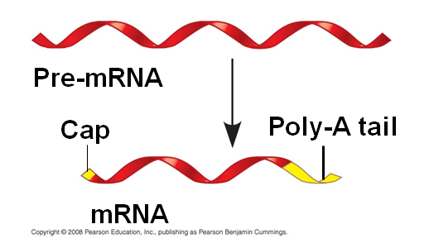
So how do the enzymes know how to tell the good mRNA apart from the invading virus versions? A 5` cap and a poly-A tail is added to the pre-message. These two changes prevent RNAases from destroying the eukaryotic cells’ own mRNA
Actually the poly-A tail is slowly nibbled away ensuring that any mRNA has a limited shelf-life. (essential to gene regulation)
Influenza virus comes with an enzyme that clips off and reattaches 5` caps from mRNAs to viral RNAs. (Now that is a Sneaky Virus!!!!)
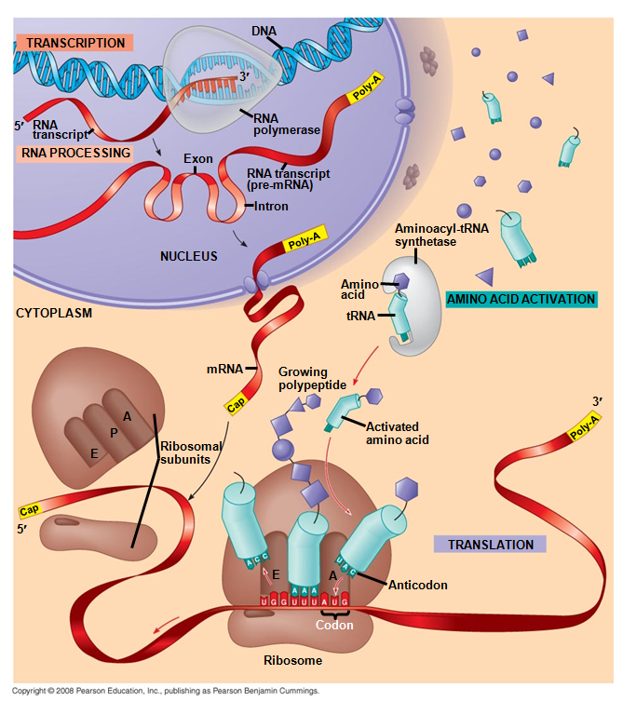
Introns “intervening sequences” are also spliced out making the mRNA much shorter than the original transcript, leaving behind a series of spliced exons “expressed sequences”.
(Archaebacteria also have introns and exons supporting the suggestion they were our evolutionary ancestors. Archaebacteria do not have Poly –A tails nor 5` caps )

The haploid human genome contains an estimated 20,000–25,000 protein-coding genes, far fewer than had been expected before its sequencing. In fact, only about 1.5% of the genome codes for proteins, while the rest is comprised of RNA genes, regulatory sequences, introns and (controversially) "junk" DNA. However, mixing and matching of introns and other post-translational modifications allow estimates of over 100 000 unique human proteins.
