Start with the chemical equation (unbalanced): H₂O + CO₂ → O₂ + C₆H₁₂O₆

In Photosynthesis - the first order of business is to produce high energy electrons and move these electrons via electron carriers to the Calvin Cycle where sugars are made.

Oxidation reduction in Biology is somewhat different than how students learn Redox Reactions in their Chemistry labs.

Link and more detailed explanation is found here:

http://www2.estrellamountain.edu/faculty/farabee/biobk/biobookenzym.html
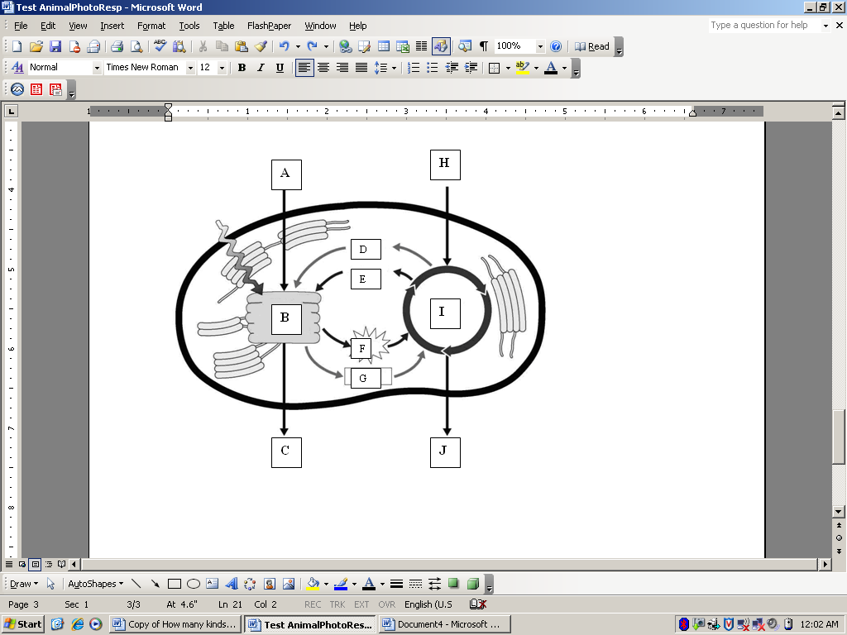
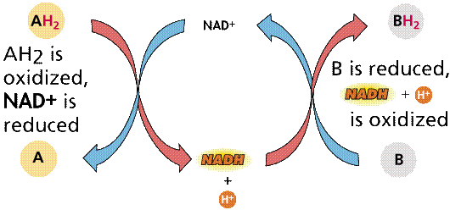
Without going into the minutia of redox reactions in Biological systems; tell students that high energy electrons cannot "cluster" or accumulate given the repulsive effect of their negative charge. Therefore their high energy is best transferred in the company of a positive charge.
Going back to
H₂0 + CO₂ → O₂ + C₆H₁₂O₆

The capture of energy takes place in the membranes of the Thylakoid discs. That means H’s are being stripped from H₂0 (which is oxidized) together with their now high energy electrons (due to the input of energy from light)

That means A= H₂O and C= O₂

However – and this is important: TWO complete cycles of electron carrier cycle are required to generate ONE molecule of O₂. This is important.

F & G = ATP & NADPH (reduced) carry the high energy electrons to build the growing Carbohydrate (CH₂O)_{n} in the stroma.

That means H= CO₂ & J = C₆H₁₂O₆

However, carbohydrates are multiples of (CH₂O). That means each carbon for the starting material of CO₂ also requires TWO turns of the electron carrier cycle: One turn to remove one of the O atoms thereby generating water (by condensation / reduction) and a second turn to add two H (along with high e⁻) to the original C in order to generate the carbohydrate (CH₂O).

With TWO successive turns of the electron carrier cycle, high electrons have been transferred to the new fuel (growing carbohydrate) and an intermediate has been oxidized to form water,

D & E = ADP + NADP⁺ … to complete the cycle.
Sugar accumulation is preferable to ATP since sugar stores better and has a longer shelf life.
How to get students to wrap their heads around the entire process? Draw and redraw the chloroplast several times in several orientations; i.e. draw the electron carriers in either clockwise or in counter-clockwise & the thylakoid discs/Calvin cycle alternatively on the left or on the right hand side. Students learn to correctly label the chemicals, structures and processes.

When students can correctly label all chemicals and structures regardless of orientation, move on to respiration which is the reverse of photosynthesis:
C₆H₁₂O₆ + O₂ → CO₂ + H₂0

Tell students that since cellular respiration is the reverse of photosynthesis – we therefore start with the breaking down Carbon based sugars in the Krebs Cycle (in the stroma) and end with the final transfer of electrons by reducing O₂ to H₂0 (membranes). Again the process is always identical – but only in reverse.

An evolutionary aside – Life began as photosynthetic fermenters, but as the toxic byproduct of O₂ built up in the atmosphere, life almost perished. Life adapted and managed to withstand the presence of Oxygen radicals by sacrificing sugar molecules. Since life was sacrificing valuable sugars anyways; mechanisms then evolved to harvest extra ATP as secondary add-ons.

Understanding the above explains why cellular respiration starts with glycolysis – the first step in fermentation. ( teach lactic acid and alcohol fermentation first)

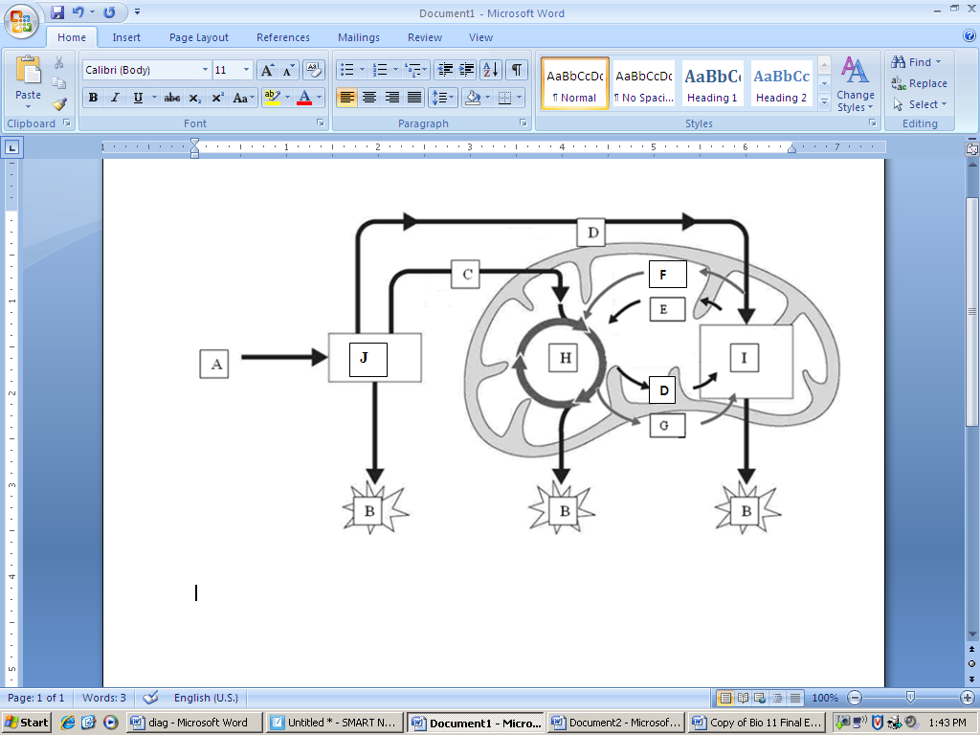
A is C₆H₁₂O₆ which is broken down to C= Pyruvate.

Pyruvate represents the intitial breakdown product of glucose – so remembering to do photosynthesis in reverse means CO₂ is generated by the Krebs Cycle.

The two new electron carriers are NADH (a mnemonic P = photosynthesis therefore NADP⁺ is in photosynthesis only) and FADH₂. These high energy electrons are carried to the membrane (remember – everything is still in reverse of photosynthesis) where high energy electrons are stripped from the electron carriers to produce ATP. (Do not forget the extra NADH generated by glycolysis in the cytoplasm) Note that ATP is produced three times during respiration. To follow the logic of Photosynthesis in reverse; I = the ETC in the cristae membranes and O₂ is being reduced to H₂O by the ETC.

That is the fast and dirty overview to be used as a first approximation to what is happening. I cannot emphasize how highlighting that photosynthesis and respiration are mirror image reverses of each other will aid student understanding.

Again draw a mitochondrion in various orientations: with the cristae and Krebs Cycle alternatively on the right or left and making the electron carriers flow clockwise or counter –clockwise. Students learn to correctly label the arrows and chemical compounds.

Students have an easier time of later mastering the detailed minutia of this story if they already have a “big picture” overview.

So, to extend this to AP Bio - just layer the sundry details of Oxidative phosphorylation, the Electron transport chain, the Electrochemical gradient, and ATP synthase upon this “big picture” story.

Feel free to cut and paste diagrams for quizzes.

